

Participant’s Guide

**Functional Skills Training**

ITES Functional

**ITES Functional Skills Training**

Facilitator’s Guide

|  |  |  |  |
| --- | --- | --- | --- |
| Version | Date | Author | Change Status |
| 1.0 | 26-06-2015 | Shweta |  |

**TABLE OF CONTENTS**

LEGEND 7

SESSION SCHEDULE 8

TOPIC 1 – SESSION INTRODUCTION 11

SUBTOPIC 1: PARTICIPANTS’ INTRODUCTION 11

SUBTOPIC 2: ICE BREAKER 13

TOPIC 2 – INTRODUCTION TO HTML 14

SUBTOPIC 1: WHY NEED HTML? 14

SUBTOPIC 2: IN THIS SESSION – SESSION OBJECTIVES16

SUBTOPIC 3: ASSUMPTIONS 17

SUBTOPIC 4: REQUIREMENTS­­­­­­­­ 18

SUBTOPIC 5: Frequently Asked Questions (FAQs) 21

TOPIC 3 – WHAT IS HTML 22

TOPIC 4 – BIRTH & GROWTH OF HTML 24

TOPIC 5 – VIEWING HTML ON THE WEB 26

TOPIC 6 – HTML COMPONENTS 27

SUBTOPIC 1: TAGS 27

SUBTOPIC 2: CONTAINER AND EMPTY TAGS 28

SUBTOPIC 3: ADDING HTML TAGS 30

SUBTOPIC 4: ELEMENTS AND NESTING 31

TOPIC 7 – PRIMARY TAGS 33

TOPIC 8 – RULES OF HTML 35

SUBTOPIC 1: SIMPLE RULES OF HTML WRITING/CODING 35

SUBTOPIC 2: CREATING A WEB PAGE IN HTML 38

SUBTOPIC 3: BASIC TEXT FORMATTING IN HTML 41

TOPIC 9 – USING HTML ATTRIBUTES AND TAGS 43

SUBTOPIC 1: SESSION INTRODUCTION 43

SUBTOPIC 2: ICE BREAKER 44

TOPIC 10 – HTML TAGS 45

SUBTOPIC 1: WHY HTML ATTRIBUTES & TAGS? 45

SUBTOPIC 2: DO YOU REMEMBER SOME HTML TAGS? 47

SUBTOPIC 3: IMPORTANT HTML TAGS 49

TOPIC 11 – HTML ATTRIBUTES 70

SUBTOPIC 1: WHAT ARE HTML ATTRIBUTES? 70

SUBTOPIC 2: IMPORTANT HTML ATTRIBUTES 71

SUBTOPIC 3: BASIC GUIDELINES 85

TOPIC 12 — USING ADVANCED HTML 86

SUBTOPIC 1: SESSION INTRODUCTION 86

SUBTOPIC 2: ICE BREAKER 87

TOPIC 13 — LOGICAL Vs. PHYSICAL TAGS 89

TOPIC 14 — ADVANCED HTML FORMATTING 91

SUBTOPIC 1: FONT 92

SUBTOPIC 2: FONT — Font Color 93

SUBTOPIC 3: UNDERLINE AND STRIKETHROUGH 94

SUBTOPIC 4: SUBSCRIPT AND SUPERSCRIPT 95

SUBTOPIC 5: PREFORMATTED TEXT 96

SUBTOPIC 6: BASE 97

SUBTOPIC 7: FORM — Creating Forms 98

SUBTOPIC 8: FORM — Components 100

SUBTOPIC 9: FORM — Text Input 101

SUBTOPIC 10: FORM – Larger Text Input 102

SUBTOPIC 11: FORM – Buttons 103

SUBTOPIC 12: FORM – Radio buttons 105

SUBTOPIC 13: FORM – Checkboxes 107

SUBTOPIC 14: FORMS – Selection boxes 108

SUBTOPIC 15: FORM – Hidden Fields 110

TOPIC 15: ADVANCED HTML EXTENSIONS 111

SUBTOPIC 1: FLOATING FRAMES 112

SUBTOPIC 2: PAGE BUTTONS 113

SUBTOPIC 3: BACK NAVIGATION BUTTON 114

SUBTOPIC 4: COLOR CHANGING BUTTON 115

SUBTOPIC 5: META TAGS 116

SUBTOPIC 6: MARQUEES 117

TOPIC 16 – FREQUENTLY ASKED QUESTIONS (FAQs) 118

SUBTOPIC 1: HOW TO APPLY STYLE TO SPECIFIC AREAS OF A WEB PAGE? 119

SUBTOPIC 2: HOW TO REMOVE COLORED BORDERS FROM PICTURES THAT ARE

BEING USED AS LINKS? 121

SUBTOPIC 3: HOW TO ADD LINK TO A PAGE SO THE USER CAN DOWNLOAD

YOUR FILES / SOFTWARE / ZIP FILES ETC.? 122

SUBTOPIC 4: HOW TO ADD LINK FOR PEOPLE TO SEND YOU EMAIL? 124

SUBTOPIC 5: HOW TO SHOW HTML TAGS/SYMBOLS ON A WEB PAGE? 125

TOPIC 17 – USING HTML5 126

SUBTOPIC 1: SESSION INTRODUCTION 126

SUBTOPIC 2: ICE BREAKER 127

TOPIC 18 – DOM AND HTML5 128

TOPIC 19 – HTML5 SEMANTIC ELEMENTS 129

SUBTOPIC 1: WHAT IS A SEMANTIC ELEMENT? 129

SUBTOPIC 2: NEW HTML5 SEMANTIC ELEMENTS 130

SUBTOPIC 3: SECTION ELEMENT 132

SUBTOPIC 4: ARTICLE ELEMENT 133

SUBTOPIC 5: NESTING ARTICLE AND SECTION ELEMENTS 134

SUBTOPIC 6: HEADER ELEMENT 135

SUBTOPIC 7: FOOTER ELEMENT 136

SUBTOPIC 8: NAVIGATION ELEMENT 137

SUBTOPIC 9: ASIDE ELEMENT 138

SUBTOPIC 10: FIGURE AND FIGURECAPTION ELEMENTS 139

TOPIC 20 – HTML FORM ELEMENTS 140

TOPIC 21 – HTML5 GRAPHIC ELEMENTS 144

SUBTOPIC 1: NEW HTML5 GRAPHIC ELEMENTS 144

SUBTOPIC 2: CANVAS ELEMENT 145

SUBTOPIC 3: SVG ELEMENT 147

SUBTOPIC 4: SVG CIRCLE 148

SUBTOPIC 5: SVG RECTANGLE 149

SUBTOPIC 6: SVG ROUNDED RECTANGLE 150

SUBTOPIC 7: SVG STAR 151

SUBTOPIC 8: SVG LOGO 152

SUBTOPIC 9: DIFFERENCES BETWEEN HTML5 CANVAS AND SVG ELEMENTS 153

TOPIC 22 – HTML5 MEDIA ELEMENTS 154

SUBTOPIC 1: NEW HTML5 MEDIA ELEMENTS 154

SUBTOPIC 2: AUDIO ELEMENT 155

SUBTOPIC 3: VIDEO ELEMENT 156

TOPIC 23 – HTML5 BEST CODING PRACTICES 158

TOPIC 24 – MODULE SUMMARY 161

SUBTOPIC 1: RECAP 161

SUBTOPIC 1: FINAL TIPS AND SUMMARIZATION 163

LAB EXERCISES 164

The following legend explains the various icons used in this guide.

LEGEND

|  |  |
| --- | --- |
| Icon | Description |
|  | Approximate duration of each section |
|  | Project course screen |
|  | Discussion |
|  | Group Activity |
|  | Activity |
|  | Student’s Guide |
|  | Important |

SESSION SCHEDULE

|  |  |  |
| --- | --- | --- |
| **Topic** | **Sub-topic** | **Duration in minutes** |
| 1. HTML | * Participants’ Introduction * Ice Breaker | 5 minutes |
| 1. Introduction to HTML | * Why Need HTML? * Session Objectives * Assumptions * Requirements * FAQs | 10 minutes |
| 1. What is HTML? | * HyperText and Markup Language | 5 minutes |
| 1. Birth and Growth of HTML | * HTML timeline | 10 minutes |
| 1. Viewing HTML on the Web | * Two Ways of Viewing HTML Pages on the Web | 15 minutes |
| 1. HTML Components | * Tags * Container and Empty Tags * Adding HTML Tags * Elements and Nesting | 20 minutes |
| 1. Primary Tags | * Four Primary Tags | 5 minutes |
| 1. Rules of HTML | * Simple Rules of HTML Writing/Coding * Creating a Web Page in HTML * Basic Text Formatting in HTML | 20 minutes |
| 1. Using HTML Attributes and Tags | * Session Introduction * Ice Breaker * Need for HTML Attributes/Tags? * In This Session – What You Will Learn | 5 minutes |
| 1. HTML Tags | * Do you remember some HTML Tags? * Important HTML Tags * Page Title, Head, and Body Tags * Paragraphs Tag * Line Break Tag * Emphasis Tag * Heading Tag * List Tag * Link Tag * Image Tag * Table Tag * Form Tag * Alphabetical List Of HTML Tags | 20 minutes |
| 1. HTML Attributes | * What are HTML Attributes? * Important HTML Attributes * The ***lang*** Attribute * The ***title*** Attribute * The ***href*** Attribute * The ***size*** Attribute * The ***alt*** Attribute * Lists of Global/Core, Event, and Extended Event Attributes | 20 minutes |
| 1. Using Advanced HTML | * Session Introduction * Ice Breaker * In This Session – What You Will Learn | 15 minutes |
| 1. Logical Vs. Physical Tags | * Difference between logical and physical tags | 5 minutes |
| 1. Block-level Vs. Inline Elements | * Difference Between Block-Level and Inline Elements | 5 minutes |
| 1. Advanced HTML Formatting | * Font * Font – Font Color * Underline and Strikethrough * Subscript and Superscript * Preformatted Text * Base * Form – Creating Forms * Form – Components * Form – Text Input * Form – Larger Text Input * Form – Buttons * Form – Radio Buttons * Form – Checkboxes * Form – Selection Boxes * Form – Hidden Fields | 20 minutes |
| 1. Advanced HTML Extensions | * Floating Frames * Page Buttons * Back Navigation Button * Color Changing Button * Meta Tags * Marquees | 20 minutes |
| 1. Frequently Asked Questions (FAQs) | * How to Apply Style to Specific Areas of a Web Page? * How to Remove Coloured Borders from Pictures That Are Being Used As Links? * How to Add Link to a Page So The User Can Download Your Files / Software / Zip Files, etc.? * How to Add Link for People to Send You Email? * How to Show HTML Tags/Symbols on a Web Page? | 20 minutes |
| 1. Using HTML5 | * Session Introduction * Ice Breaker * In This Session – What You Will Learn | 10 minutes |
| 1. HTML Versions | * HTML Versions Over the Years | 5 minutes |
| 1. DOM and HTML5 | - | 5 minutes |
| 1. HTML5 Semantic Elements | * What is a Semantic Element? * New HTML5 Semantic Elements * Section Element * Article Element * Nesting Article and Section Elements * Header Element * Footer Element * Navigation Element * Aside Element * Figure and Figure Caption Elements | 20 minutes |
| 1. HTML Form Elements | * New HTML5 Form Elements * Datalist Element * Keygen Element * Output Element |  |
| 1. HTML5 Graphic Elements | * New HTML5 Graphic Elements * Canvas Element * SVG Element * SVG Circle * SVG Rectangle * SVG Rounded Rectangle * SVG Star * SVG Logo * Differences between HTML5 Canvas and SVG Elements |  |
| 1. HTML5 Media Elements | * New HTML5 Media Elements * Audio Element * Video Element | 5 minutes |
| 1. HTML5 Best Coding Practices | * Best Coding Rules of HTML5 |  |
| 1. Summary | * Recap * Final Tips and Summarization | 10 minutes |
| 1. Check Your Understanding |  |  |
| **Total Duration** | |  |





SUBTOPIC 1: PARTICIPANTS’ INTRODUCTION

TOPIC 1 – HTML



1. **Share a funny fact…**

Each participant says his/her name and shares one funny fact. Start by giving an example. [*Hi, I am Farhan. One funny fact about me is that I always have breakfast twice on weekdays – once at home, and once when I reach office*.]  
  
OR,

1. **Who would you like to be?**

Each participant gives his/her name. They also say who they’d like to be if they woke up one day as another person. [“*Hi, I am Omar. If I were to wake up tomorrow as a different person, I’d like to be Lionel Messi (footballer, Barcelona).”]*

**Your Space:**

|  |
| --- |
|  |
|  |
|  |
|  |

## 

SUBTOPIC 2: ICE BREAKER

We all love to surf the Internet. Can you name some of your favourite Websites?

**Discussion**: What makes these sites so popular?

**Your Space:**

|  |
| --- |
|  |
|  |
|  |
|  |
|  |

# 

TOPIC 2 – INTRODUCTION TO HTML

SUBTOPIC 1: WHY NEED HTML?

* These days Web pages can display hundreds of different fonts, font sizes, colors, and even different language alphabets, such as English, Bengali, Hindi, Urdu, Spanish, Japanese, and Russian, etc.
* Web pages may also contain images, video clips, and background music.
* They may include drop-down menus, search boxes, or links to other pages.
* Some Websites even let visitors customize the page display according to their preferences and challenges, such as sight challenges, deafness, or color blindness.
* A Web page may often contain content boxes that move or scroll while the rest of the page remains static.
* To display any Web page with all its different features, a Web browser has to “read” the HTML codes written by Web designers.
* A typical Web page depends on several technologies that control whatever we see as end users, but most importantly, Web pages are “written” in HTML codes, without which there can be no Web pages.
* However, when you look at a Web page in a Web browser, you see the actual content and not the codes.

**Your Space:**

|  |
| --- |
|  |
|  |
|  |
|  |
|  |
|  |
|  |
|  |
|  |
|  |
|  |
|  |

## 

SUBTOPIC 2: IN THIS SESSION – SESSION OBJECTIVES

The learning objectives of this session are outlined here. This will help you understand what tasks you will be able to perform after completing this session.

* Inthis session, you will learn what is Hypertext Markup Language or HTML5 is,
* Birth and growth of HTML.
* Important HTML components, such as tags, elements, and nesting.
* The steps that you need to perform to view HTML on the Web.
* Finally, the rules of HTML writing or coding, so that you will be able to create a simple Web page using HTML codes.

|  |
| --- |
| **Your Space:** |
|  |
|  |

## 

SUBTOPIC 3: ASSUMPTIONS

* At the beginning of this session, it is assumed that you know nothing about HTML.
* However, it is safe to think that you do have some basic computer knowledge. Because obviously you wouldn't attend this training without having some basic knowledge about computers.
* And, the most important assumption here is that you are really interested in learning about HTML and coding for you is equal to fun!

**Your Space:**

|  |
| --- |
|  |
|  |
|  |

## 

## 

SUBTOPIC 4: REQUIREMENTS

Before learning about HTML, it is extremely important that you know what tools are required for HTML writing. To continue with your understanding of HTML, you will obviously need a personal computer.

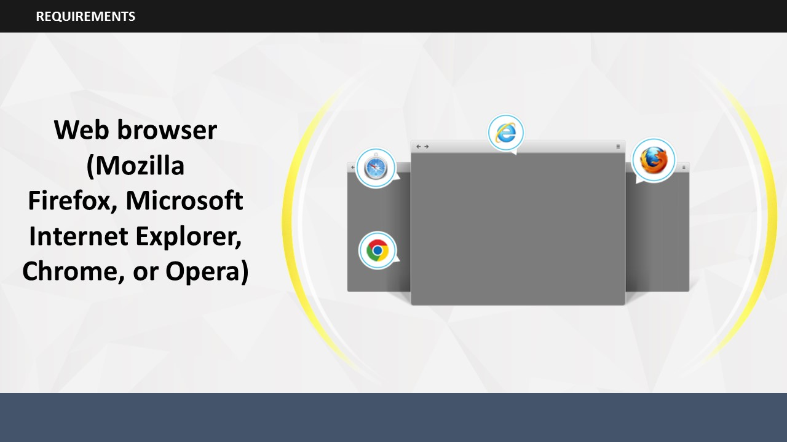

Along with a personal computer, you will also need a Web browser, such as Google Chrome, Mozilla Firefox, Internet Explorer, etc.

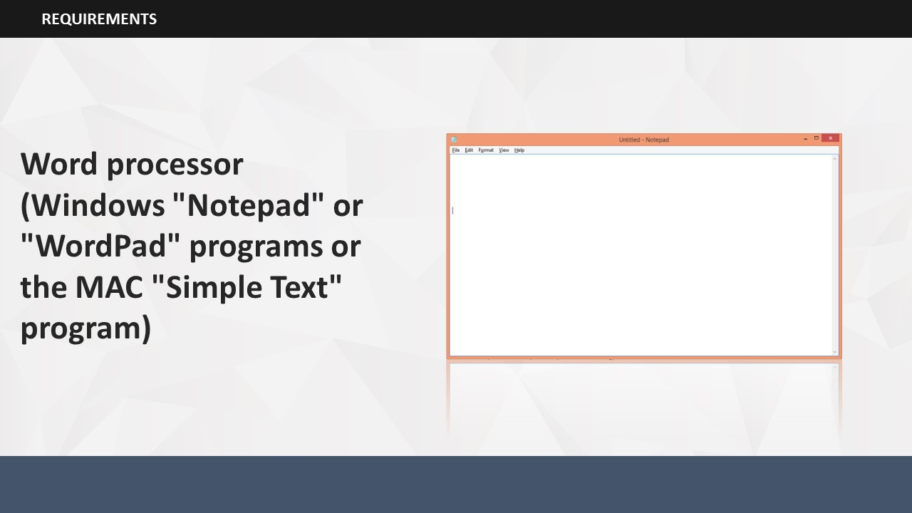

Supposing that you have a personal computer and a Web browser, the only thing needed now is a word processor. If you have access to Windows "Notepad" or "WordPad" programs or the MAC "Simple Text" program, you can use that to get started. Fortunately, HTML is written in plain text, which means that you don’t need any fancy software programs to create your HTML files.

**Your Space:**

|  |
| --- |
|  |
|  |
|  |
|  |
|  |
|  |
|  |
|  |
|  |
|  |

## 

SUBTOPIC 5: Frequently Asked Questions (FAQs)

Here are some of the commonly asked questions that may come to your mind about HTML. Go through these answers to clarify your doubts.

* My computer does not use the Windows operating system – can I use HTML on it?  
  Yes. HTML does not use any specific operating system platform. It works with simple text.
* Must I be logged onto the Internet to do this? More specifically, will learning this increase my Internet usage cost?  
  Neither. You will write or work offline.
* Do I need some sort of expensive program to help me write this?  
  No. You can write using Notepad or WordPad.
* Will I have to learn a completely new programming language like BASIC or FORTRAN?  
  No. HTML is not a programming language.

**Your Space:**

|  |
| --- |
|  |
|  |

# 

# It is important to understand what HTML means. Do you know what HTML means? HTML stands for HyperText Markup Language.

TOPIC 3 – WHAT IS HTML?

* HyperText is the text which contains links to other information including text, graphics, video, and sound.
* Markup Language is a computer language that is used to highlight certain elements within a document.

HTML is defined as the basic format or coding for language that is used to construct the Website pages on the World Wide Web.

**Your Space:**

|  |
| --- |
|  |
|  |
|  |
|  |
|  |

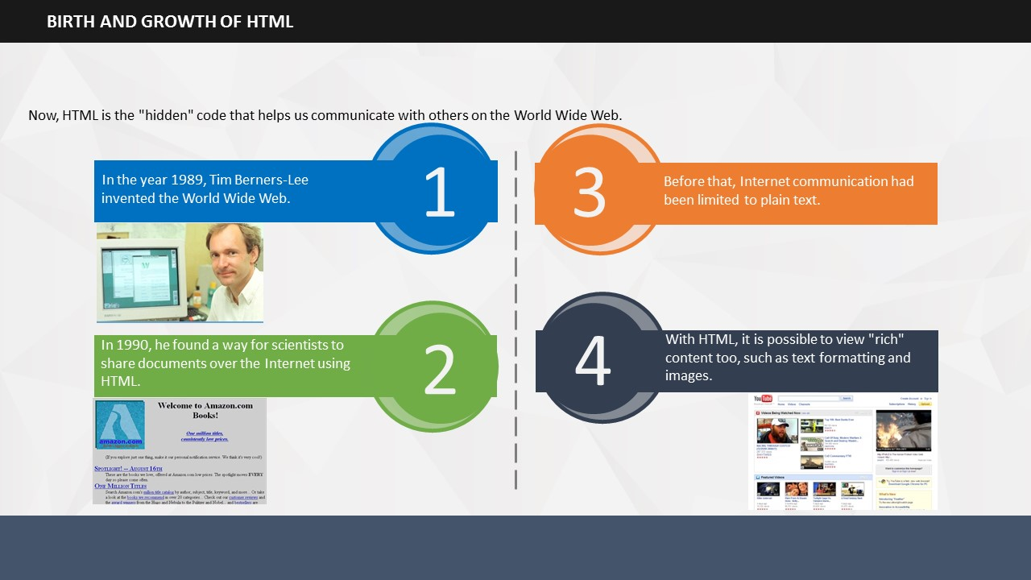

Imagine a world of Internet where every page would look like a boring notebook filled only with plain text — no images, no videos, no colorful tables or alphabets, and no hyperlinks! How boring would such a Web world be? Do you know who made sure that such a boring world of Internet would never exist, and that in its place we would have the most interesting and interactive Internet world in front of us? It was none other than Physicist Tim Berners-Lee!

TOPIC 4 – BIRTH AND GROWTH OF HTML

Here is a detailed account of the birth and growth of HTML.

* In the year 1989, Tim Berners-Lee invented the World Wide Web.
* In 1990, he found a way for scientists to share documents over the Internet using HTML.
* Before that, Internet communication had been limited to plain text.
* With HTML, it is possible to view "rich" content too, such as text formatting and images.
* Now, HTML is the "hidden" code that helps us communicate with others on the World Wide Web.

**Your Space:**

|  |
| --- |
|  |
|  |
|  |
|  |
|  |
|  |
|  |

# 

# 

TOPIC 5 – VIEWING HTML ON THE WEB

You can actually view HTML codes on the Web because most browsers allow the user to view the HTML of any Web page.

* In Firefox or Google Chrome, you need to press Ctrl + U to view the page source. Within seconds, you will see the hidden source code of that page.
* In Internet Explorer, you need to right click the page and click View Sourcein the options list.

**Your Space:**

|  |
| --- |
|  |
|  |
|  |
|  |

# 

# 

TOPIC 6 – HTML COMPONENTS

SUBTOPIC 1: TAGS

# Now that we have seen how a typical HTML document looks like on the Web, we will focus on the various components that are used to write HTML.

* When writing HTML, you add "tags" to the text to create a structure.
* These tags tell the browser how to display the text or graphics in the document.
* To understand the concept of tags, let us first look at an example of a document with a simple layout or structure.

**Your Space:**

|  |
| --- |
|  |
|  |
|  |
|  |

## 

SUBTOPIC 2: CONTAINER AND EMPTY TAGS

Now that we know what the major parts of any simple document are, let us understand how it can be presented in HTML. For that, first we need to learn about the various components that are used while writing HTML. We have already begun with the most important component, ‘Tags.’ Tags are used to mark a particular text in a document by using angled brackets. In the next module, you will learn about tags in detail. For now, let us simply focus on the basic concepts of HTML writing.

It is important to know that there are broadly two types of tags: container and empty.

The container tag always wraps around text or graphics and comes in pairs with an opening and a closing:

In this example, **<html>** is the opening tag and **</html>** is the closing tag.

Notice the forward slash (/) on the closing tag. This tells the browser that the tag has ended.

On the other hand, the empty tag stands alone. Empty tags do not have to be wrapped around text or graphics, do not come in pairs, and do not require a closing.

**Your Space:**

|  |
| --- |
|  |
|  |
|  |
|  |
|  |
|  |
|  |
|  |
|  |
|  |
|  |
|  |

## 

SUBTOPIC 3: ADDING HTML TAGS

Let us now try to achieve a similar layout as the Web browser document that we looked at earlier, by adding tags. Here is the same document with HTML tags added. However, all the tags are gone once you view the HTML created document on the Web browser. That’s because the tags tell the browser how to display files but do not show themselves.

**Your Space:**

|  |
| --- |
|  |
|  |
|  |
|  |
|  |
|  |

## 

## 

SUBTOPIC 4: ELEMENTS AND NESTING

Now that you have a basic idea about HTML tags, let us describe the other components, such as elements and nesting.

* The words/letters between two angled brackets are called elements. These are the coded commands within HTML. Elements tell the browser how to display the Web page.
* For example: <hr> tells the browser to display a horizontal rule; <br> tells the browser to skip a line.
* Usually elements containing content can also contain other elements. For example, the emphasis element "<b>" can be embedded within a paragraph element, to make a word or phrase bold.
* Placing one element inside another in the Web page structure is called nesting. You must have noticed in the earlier example how the tag <title> was nested inside the <head> tag, while the <head> and the <body> tags were nested inside <html>.

**Your Space:**

|  |
| --- |
|  |
|  |
|  |
|  |
|  |
|  |
|  |
|  |
|  |
|  |

# 

# 

TOPIC 7 – PRIMARY TAGS

Now that you know that to build any Web page, you will need four primary tags: <html>, <head>, <title> and <body>, let us understand about each tag in detail.

* <html>…</html>: Every HTML document begins and ends with the <html> tag. This tells the browser that the document is an html file. Remember, tags tell the browsers how to display information.
* <head>…</head>:The <head> tag contains the title of the document along with general information about the file, like the author, copyright, keywords and/or a description of what appears on the page.
* <title>…</title>: The <title> tag appears within the <head> tag and gives the title of the page. Try to make your titles descriptive, but not more than 10 words in length. The title appears at the very top of the browser page on the title bar.
* <body>…</body>:The main content of your page, such as your text, images, links, tables and so on are placed within the body tags.

**Your Space:**

|  |
| --- |
|  |
|  |
|  |
|  |
|  |
|  |
|  |
|  |
|  |

# 

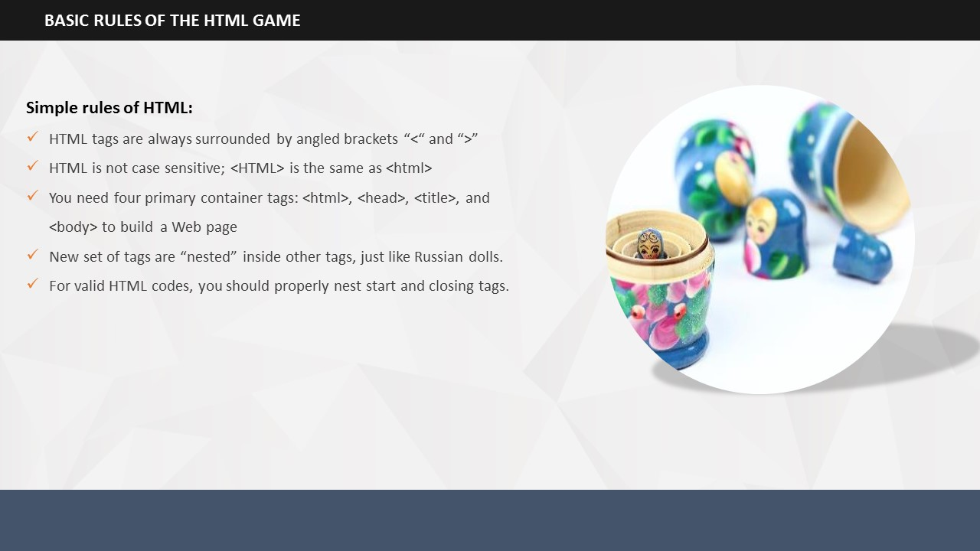

TOPIC 8 – RULES OF HTML

SUBTOPIC 1: SIMPLE RULES OF HTML WRITING/CODING

Before beginning to create a Web page using HTML components, there are certain rules that you need to be aware of in HTML creation too.

* HTML tags are always surrounded by what are called angled brackets < and >.
* HTML is not case sensitive. You can use either lowercase or uppercase. <HTML> is the same as <html>.
* To build any Web page you will need four primary container tags: <html>, <head>, <title>, and <body>.
* The <html> tag tells the browser that this is an HTML document. You must begin and end your files with this tag. The <head> tag contains general information like the title of your document. The <body> tag holds all your content: words, pictures, artwork and other stuff.
* Each new set of tags are nested inside other tags, just like those Russian dolls that you may have seen.
* To write valid HTML codes, you must properly nest start and closing tags, that is, write close tags in the opposite order from the start tags.

**Your Space:**

|  |
| --- |
|  |
|  |
|  |
|  |
|  |

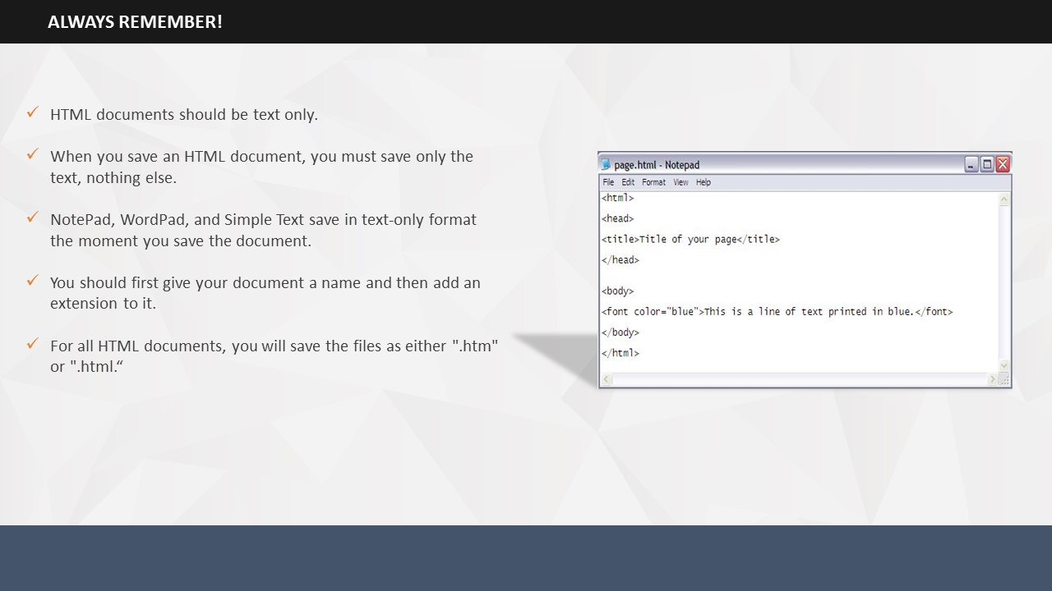

There are also certain other important points that you need to remember every single time you work on HTML.

* When you save your HTML document, you only want to save the text. NotePad, WordPad, and SimpleText already save in text-only format. So, if you use one of them as your word processor, you get the correct format simply by saving your document.
* You need to give a file extension to your HTML document. ".html" tells the computer that this file is an HTML document. All files used on the Web will always follow the format of *[name].[file_extension]*.

**Your Space:**

|  |
| --- |
|  |
|  |
|  |
|  |
|  |
|  |

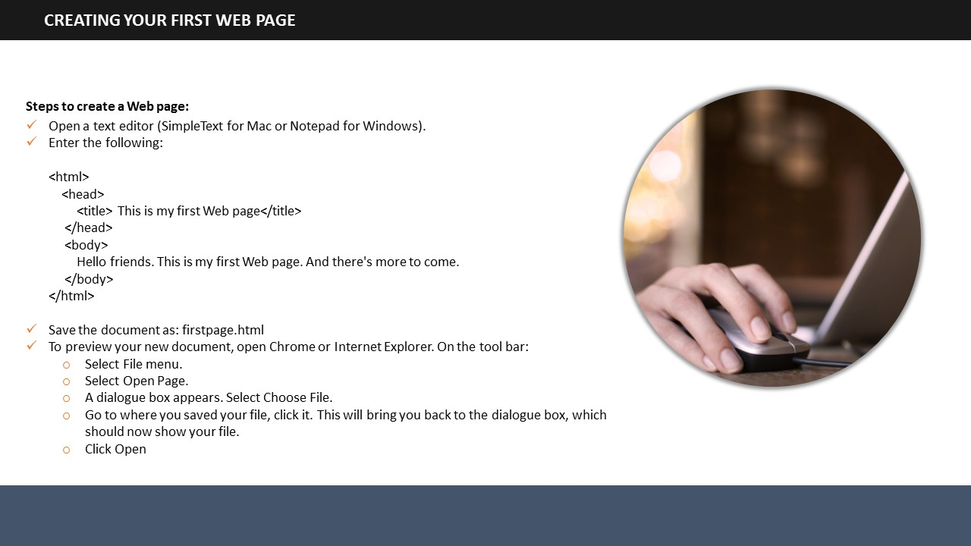

SUBTOPIC 2: CREATING A WEB PAGE IN HTML

Now that you’ve had a little taste of what it’s like to create an HTML document and are familiar with the basic rules of HTML writing, it is time to begin creating one from scratch.

Using the primary HTML tags, you are now ready to create your first Web page. Let us outline the various steps that you need to perform during the Web page creation process.

1. Open a text editor (SimpleText for Mac or Notepad for Windows)
2. Enter the following:

<html>  
<head>  
<title> This is my first web page</title>  
</head>  
<body>  
Hello friends. This is my first Web page. And there's more to come.  
</body>  
</html>

* Save the document as: *firstpage.html*. Your file can be saved as either an htm or html file. Remember to save your document on the computer in a place that you can find it again.
* To preview your new document:
  1. Open Chrome or Internet Explorer.
  2. On the tool bar (located near the top of the browser), first select **File** menu.
  3. Then select **Open Page**. A dialogue box appears.
  4. Select **Choose File**.
  5. Now, go to where you saved your file and click it. This will bring you back to the dialogue box, which should now be showing your file.
  6. Now, click **Open**.

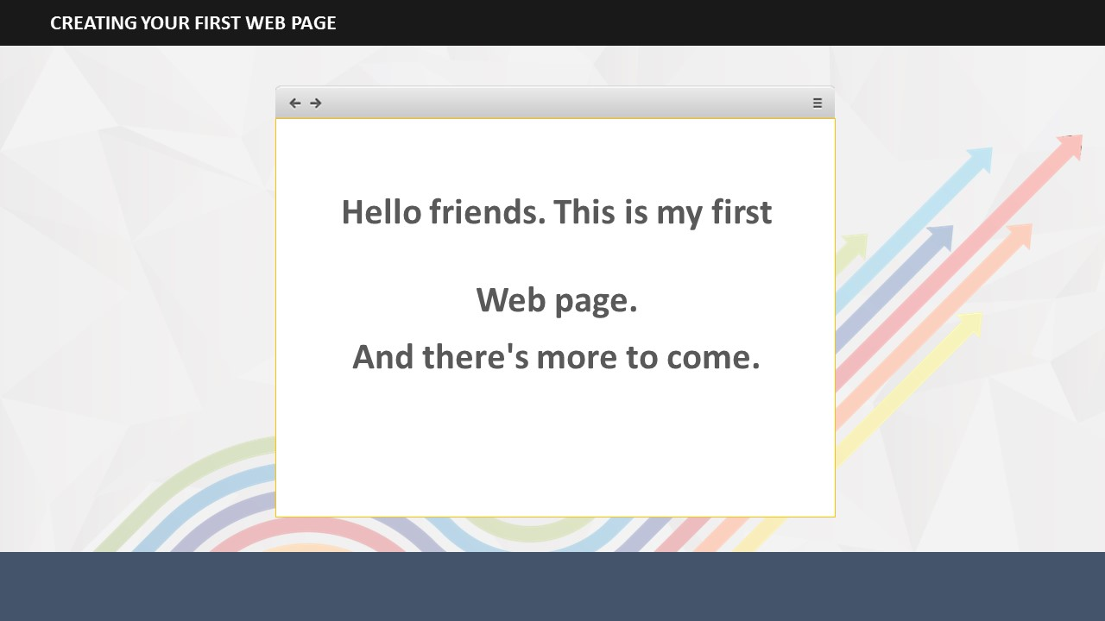

If all went as planned, your file should look like this in your browser. Congratulations! You have successfully completed your first Web page.

You can continue to build on this same page by adding few more tags that are discussed in the next page.

**Your Space:**

|  |
| --- |
|  |
|  |
|  |
|  |
|  |
|  |
|  |
|  |
|  |

## 

SUBTOPIC 3: BASIC TEXT FORMATTING IN HTML

While you are surfing on the Internet, you’ll notice that a Web page is made up of more than just plain words on a screen. There are headlines, paragraphs, graphics, colors and much more. It’s a lively and interesting place to be.

The other tags, such as headline, paragraph, line break, horizontal rule, bullets and numbering, and listed item will help you make your current page a lot more exciting.

* In HTML, bold copy is created by using the headline tag. There are six levels of headlines, ranging from **<h1>…</h1> to <h6>…</h6>**.
* Paragraph is a container tag and should have a beginning and an ending. Line break is an empty tag and stands alone. You can use the <br> tag to insert one or more blank lines.
* Lists come in a variety of forms with most either numbered or bulleted. The numbered lists are called **ordered lists**and the bulleted listsare **unordered lists**.
* Lists are nested. There is a tag that identifies the type of list, like numbered or bulleted. Then within that tag there is another tag that itemizes the list.

**Your Space:**

|  |
| --- |
|  |
|  |
|  |
|  |
|  |
|  |
|  |
|  |
|  |
|  |

**Project the ILT course.**

SUBTOPIC 1: SESSION INTRODUCTION

TOPIC 9 – USING HTML ATTRIBUTES AND TAGS

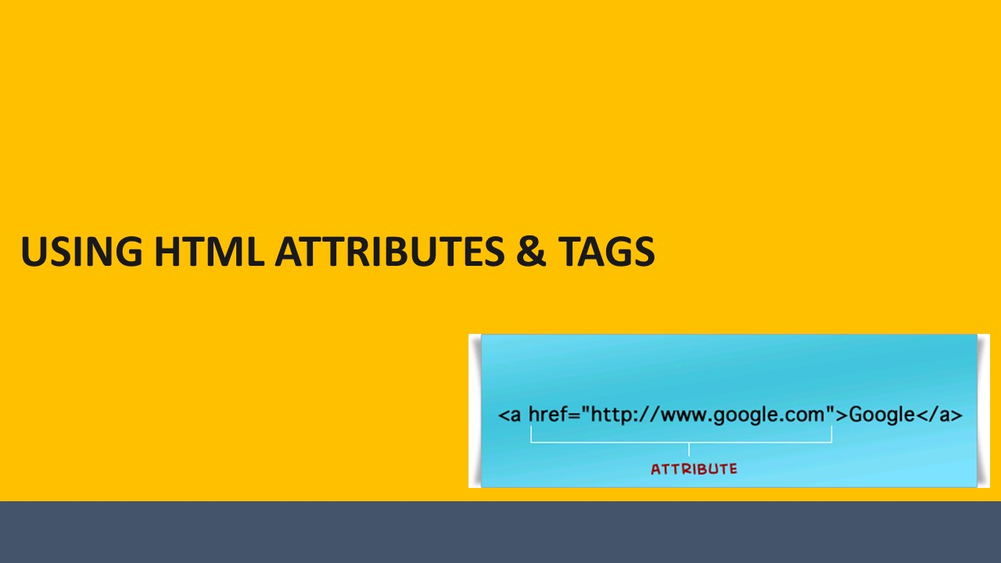

**Your Space:**

|  |
| --- |
|  |
|  |
|  |
|  |
|  |
|  |
|  |
|  |

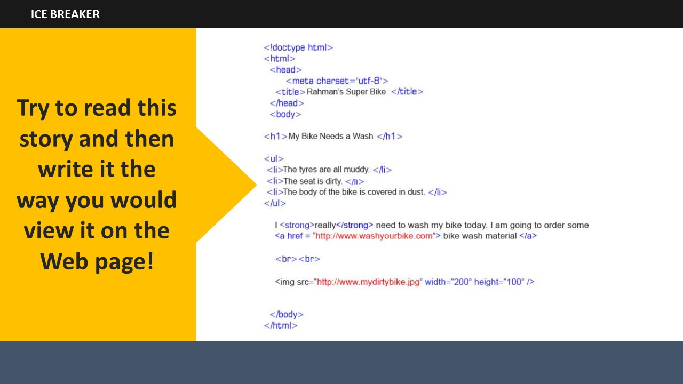 Now that you already have an idea about the basic tags that are used in HTML coding, let us try and figure out what the story is about. Work in teams and write the content the way it would appear on a Web page. Note that there are certain codes that may be new to you but you can still try and find out what the page would actually look like on the browser.

SUBTOPIC 2: ICE BREAKER

SUBTOPIC 3: NEED FOR HTML ATTRIBUTES/TAGS

**Your Space:**

|  |
| --- |
|  |
|  |
|  |
|  |
|  |
|  |

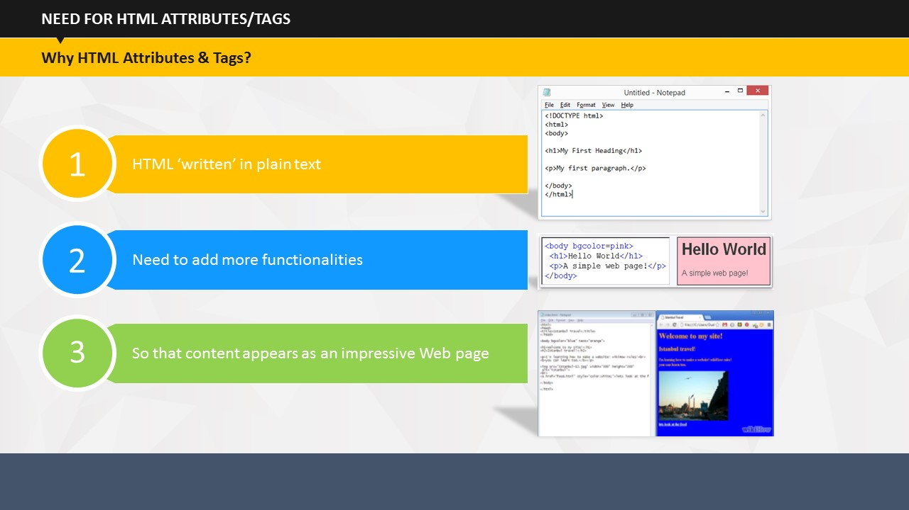

SUBTOPIC 1: WHY HTML ATTRIBUTES & TAGS?

TOPIC 10 – HTML TAGS

Although HTML is written in plain text, we need to add a bit more features to make it appear as an impressive Web page with various functionalities. We all know by now that HTML is written in plain text and appears like this (show the image). Now, when you add more functions to the plain text, the same content appears like this (show the second image). After you have added functionalities such as attributes and tags, the page appears as a very interesting and impressive Web page on the browser like this (show the third image).

**Your Space:**

|  |
| --- |
|  |
|  |
|  |
|  |
|  |
|  |
|  |
|  |
|  |
|  |
|  |
|  |

SUBTOPIC 2: DO YOU REMEMBER SOME HTML TAGS?

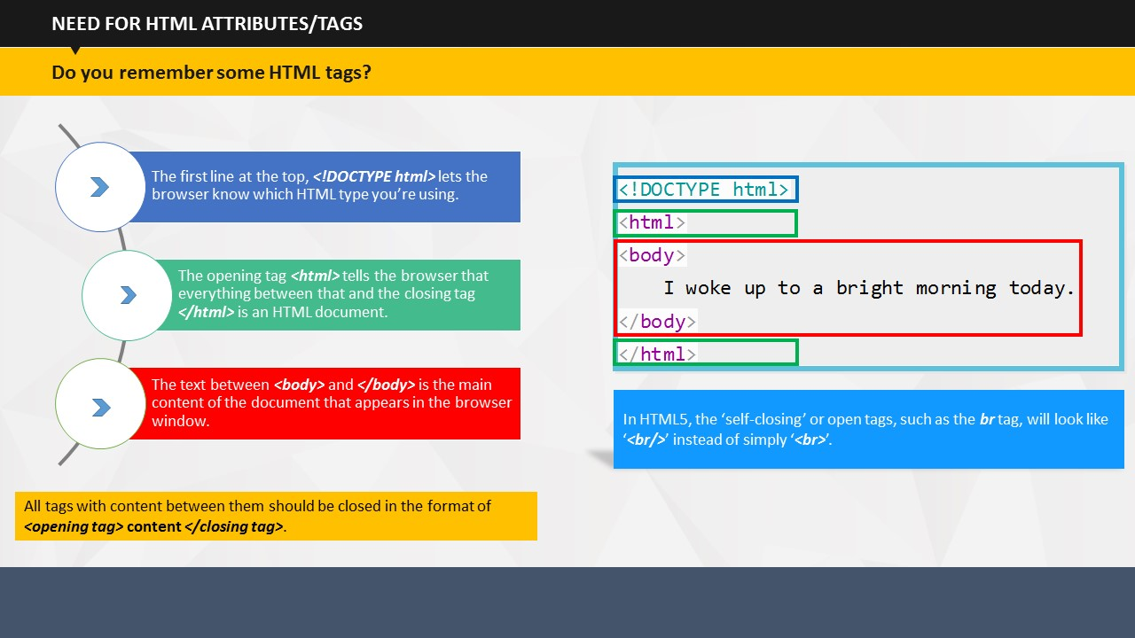

As you have learnt in the ‘Introduction to HTML’ module, the basic structure of an HTML document includes tags, which surround content and apply meaning to it.

The first line at the top, ***<!DOCTYPE html>*** lets the browser know which HTML type you’re using.

The opening tag ***<html>*** tells the browser that everything between that and the closing tag ***</html>*** is an HTML document.

The text between ***<body>*** and ***</body>*** is the main content of the document that appears in the browser window.

**Note:** All tags with content between them should be closed, in the format of ***<opening tag>* content *</closing tag>***.

**Note:** In HTML5, the ‘self-closing’ or open tags, such as the ***br*** tag, will look like ‘***<br/>***’ instead of simply ‘***<br>***’.

**Your Space:**

|  |
| --- |
|  |
|  |
|  |
|  |
|  |
|  |
|  |
|  |

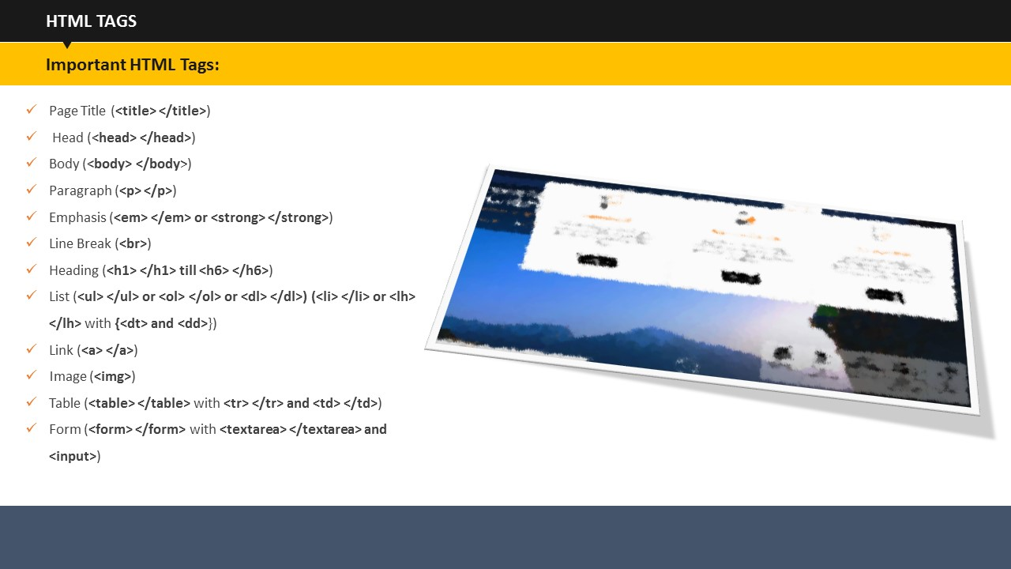

There are several important tags that you will use while ‘writing’ HTML for a Web page. In this session, we will look at some tags in detail along with examples. A detailed list of HTML tags is also provided in the participant’s guide.

SUBTOPIC 3: IMPORTANT HTML TAGS

Some important HTML tags are:

* Link
* Image
* Table
* Form
* Page Title
* Head
* Body
* Paragraph
* Emphasis
* Line Break
* Heading
* List

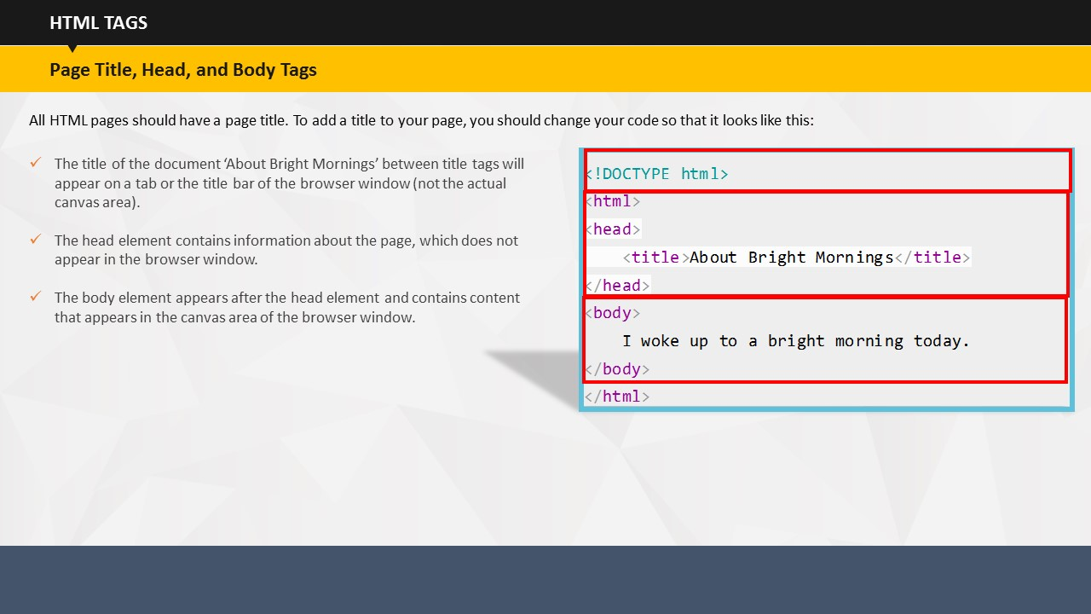

**Page Title, Head, and Body Tags**

All HTML pages should have a ***page title***. In this example:

* The title of the document ‘About Bright Mornings’ between title tags will appear on a tab or the title bar of the browser window. It will not appear in the actual canvas area of the Web page.
* The ***head*** element contains information about the page, which does not appear in the browser window.
* The ***body*** element appears after the head element and contains content that appears in the canvas area of the Web browser window.

**Your Space:**

|  |
| --- |
|  |
|  |
|  |
|  |

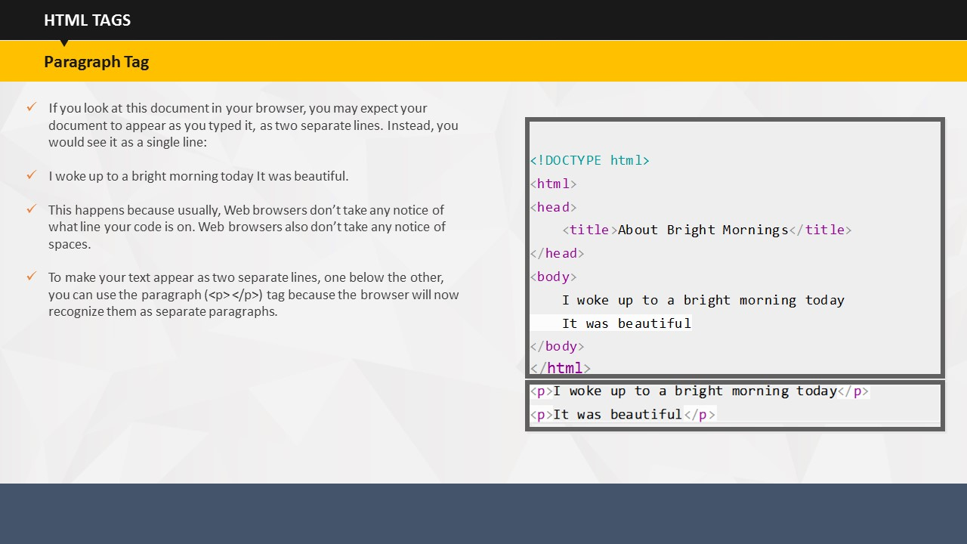

**Paragraph Tag**

Let us first explain the ***paragraph*** tag. If you look at this document in your browser, you may expect your document to appear as you typed it, as two separate lines. Instead, you would see the content appear as a single line.

This happens because usually, Web browsers don’t take any notice of what line your code is on. Web browsers also don’t take any notice of spaces.

To make your text appear as two separate lines, one below the other, you can use the ***paragraph*** tag because the browser will now recognize them as separate paragraphs.

**Your Space:**

|  |
| --- |
|  |
|  |
|  |
|  |
|  |
|  |
|  |

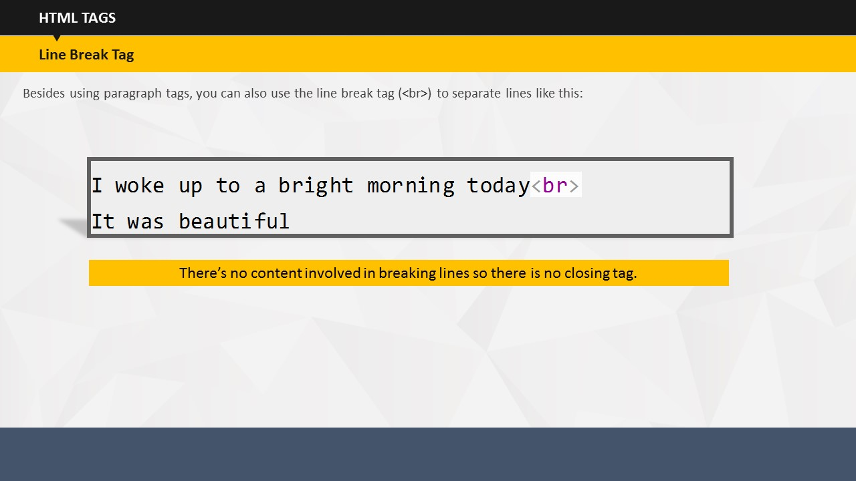**Line Break Tag**

Besides using ***paragraph*** tags, you can also use the ***line break*** tag (***<br>***) to separate two different lines.

**Note:** There’s no content involved in breaking lines so there is no closing tag.

**Your Space:**

|  |
| --- |
|  |
|  |
|  |
|  |
|  |
|  |

|  |
| --- |
|  |

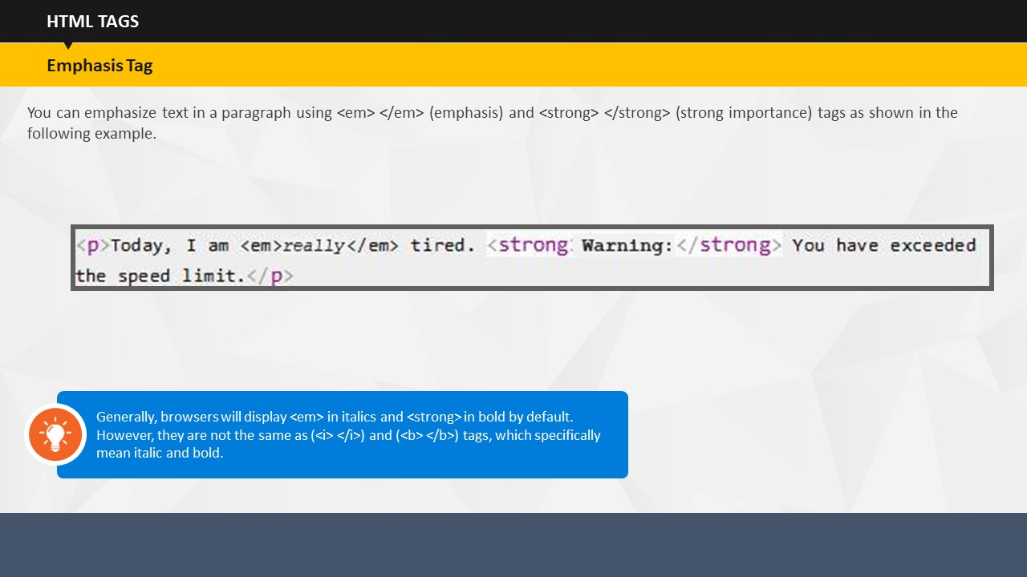**Emphasis Tag**

Let us now learn about the ***emphasis*** tag. You can emphasize text in a paragraph using emphasis and strong importance tags, as shown in the example.

**Note:** Generally, browsers will display ***emphasis tag*** in italics and ***strong*** tag in bold by default, but they are not the same as ***(<i> </i>)*** and ***(<b> </b>)*** tags, which specifically mean italic and bold.

**Your Space:**

|  |
| --- |
|  |
|  |
|  |
|  |
|  |
|  |
|  |

|  |
| --- |
|  |

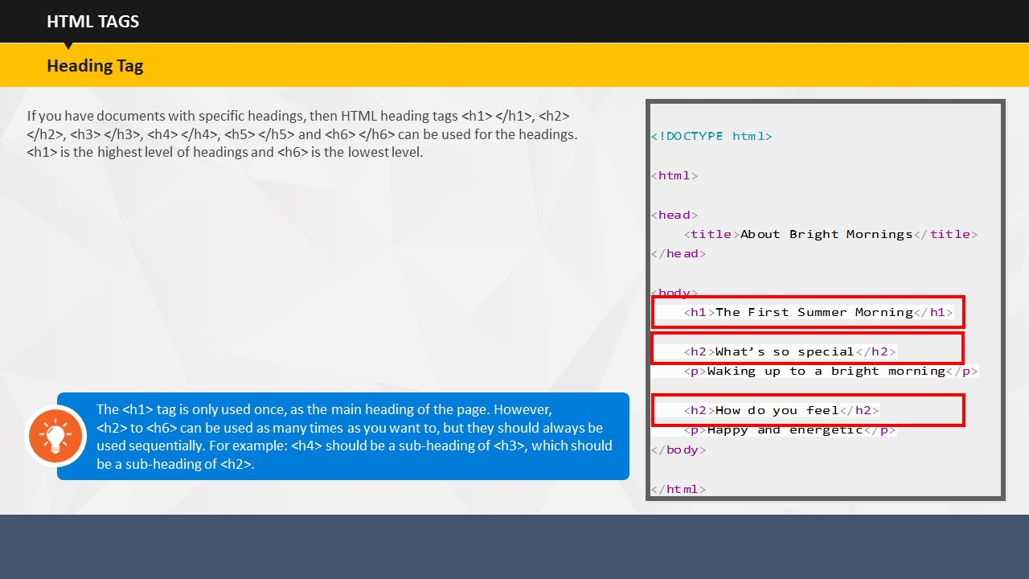 **Heading Tag**

 If you have documents with specific headings, then HTML ***heading*** tags <***h1> </h1>***, <***h2> </h2>***, <***h3> </h3>***, <***h4> </h4>***, <***h5> </h5>*** and <***h6> </h6>*** can be used for the headings. <***h1>*** is the highest level of headings and <***h6>*** is the lowest level.

**Note:** You can use the <***h1>*** tag only once, as the main heading of the page. However, you can use <***h2>*** to <***h6>*** as many times as you want to, but they should always be used in order. For example: <***h4>*** should be a sub-heading of <***h3>***, which should be a sub-heading of <***h2>***.

**Your Space:**

|  |
| --- |
|  |
|  |
|  |
|  |
|  |
|  |
|  |

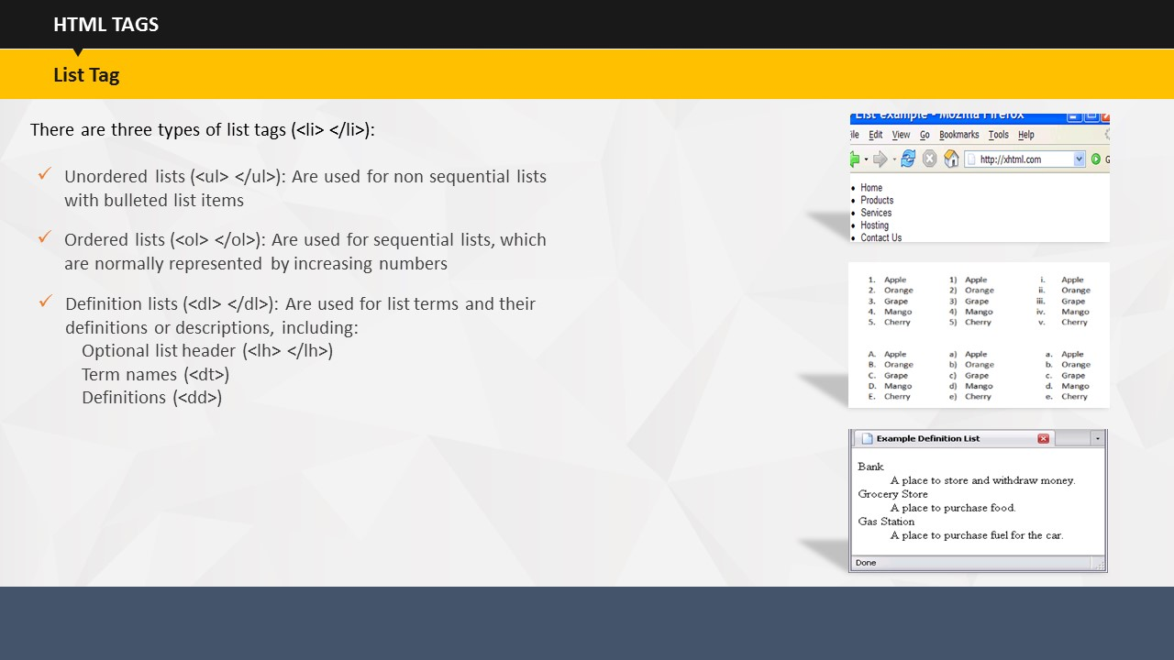

**List Tag**

We have already covered the ordered and unordered lists in the earlier module. We will look at the examples on each type of list and its respective tags on the next page.

There are three types of ***list*** tags:

* Unordered lists, which are used for non sequential lists with bulleted list items.
* Ordered lists, which are used for sequential lists that are normally represented by increasing numbers
* Definition lists, which are used for list terms and their definitions or descriptions, including:
  + Optional list header
  + Term names
  + Definitions

**Your Space:**

|  |
| --- |
|  |
|  |
|  |
|  |
|  |

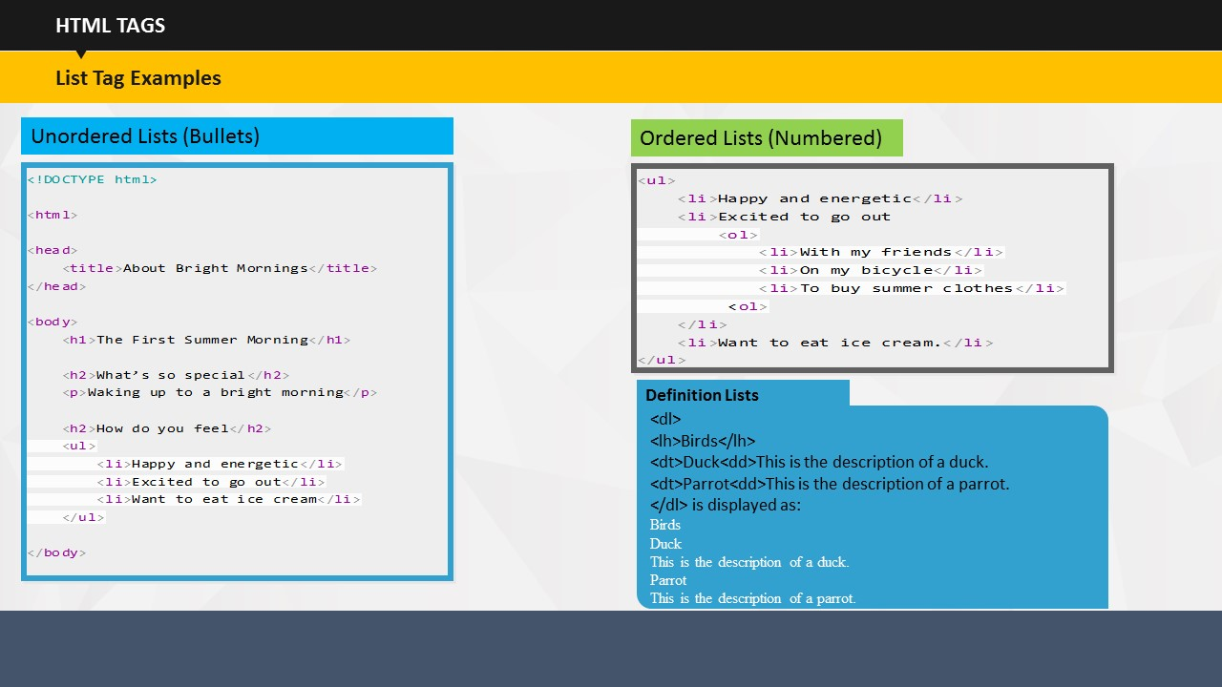

Here are different ***list*** tag examples on the screen.

Highlight the examples and ensure that the learners have a clear idea about the different tags that are used for different types of lists.

**Your Space:**

|  |
| --- |
|  |
|  |
|  |
|  |
|  |
|  |
|  |
|  |

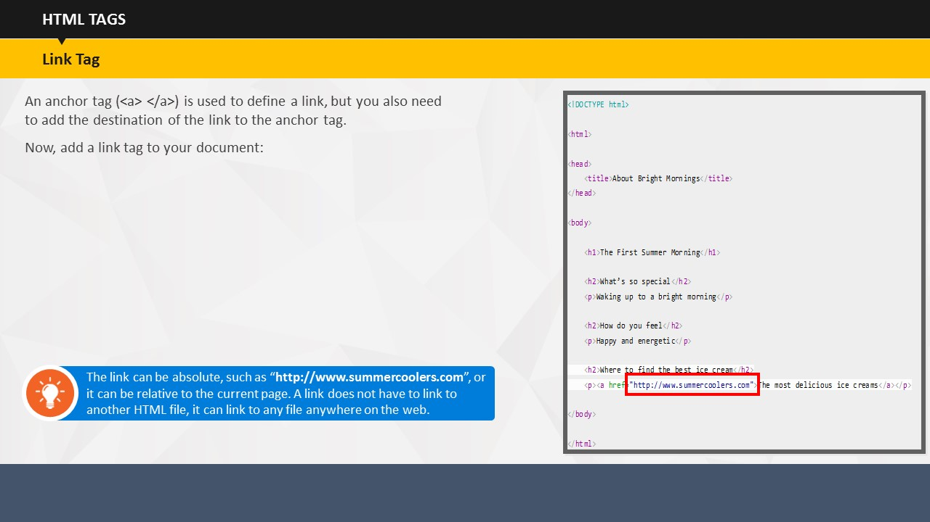

**Link Tag**

As you all know, an ***anchor*** tag is used to define a link, but you also need to add the destination of the link to the anchor tag. Now, when we add a link tag to your document, it looks like this.

 So far you’ve been making a stand-alone web page, which is great, but what makes the Internet so special is that it all linkstogether. The ***link*** tag enables you to add this feature to your Web page.

**Note:** The link can be absolute, such as “***http://www.summercoolers.com***”, or it can be relative to the current page. A link does not always have to link to another HTML file, it can link to any file anywhere on the web.

**Your Space:**

|  |
| --- |
|  |
|  |
|  |
|  |

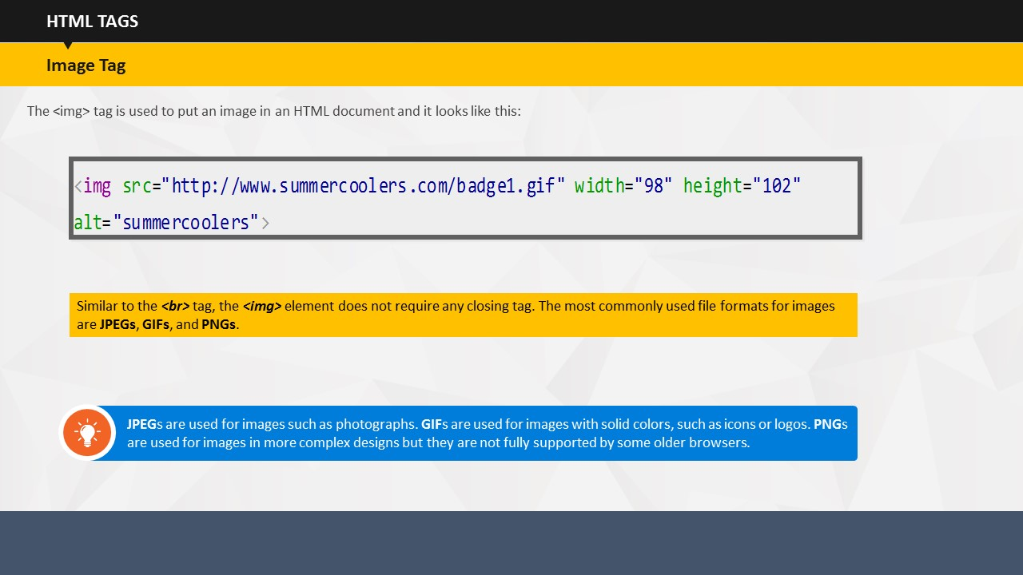

**Image Tag**

Your Web page may seem a little boring with all this text formatting. Of course, the Web is not just about text, it is a multimedia platform in which an image is the most common form of sparkle and energy.

The ***<img>*** tag is used to place an image in an HTML document. Here is how it looks in HTML.

**Note:** Similar to the ***line break*** tag, because the ***image*** element does not enclose any content, no closing tag is required. The most commonly used file formats used for images are **JPEGs**, **GIFs**, and **PNGs**. They are compressed formats, and have different uses.

**Note:** **JPEG**s are used for images such as photographs. **GIF**s are used for images with solid colors, such as icons or logos. **PNG**s are used for images in more complex designs but they are not fully supported by some older browsers.

**Your Space:**

|  |
| --- |
|  |
|  |
|  |
|  |
|  |

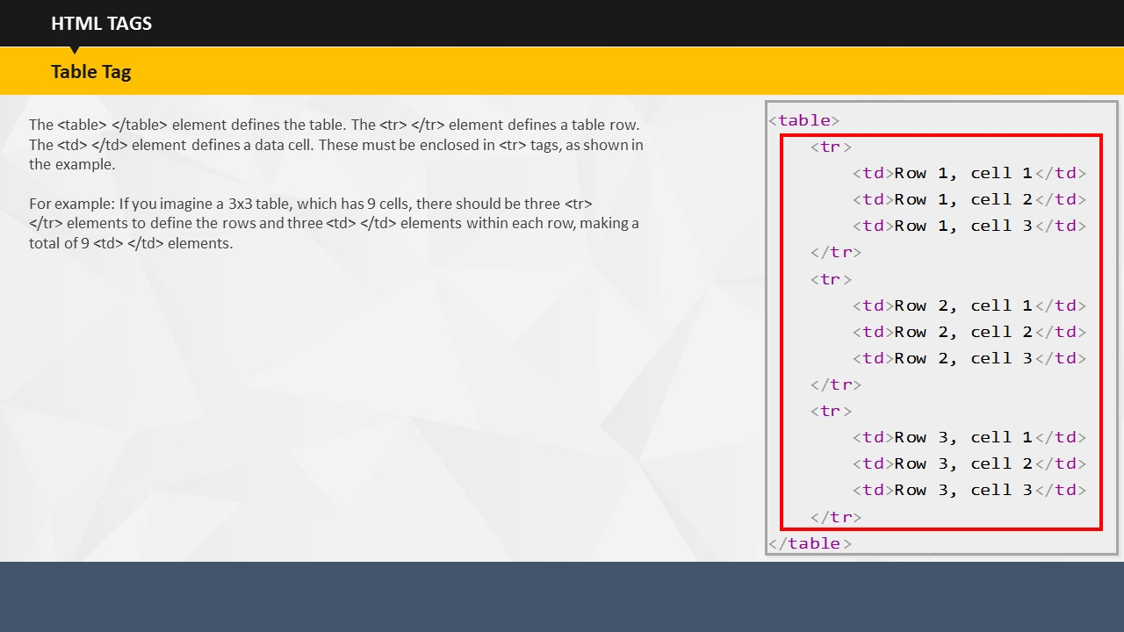

**Table Tag**

The ***table*** element defines the table. The ***<tr>*** element defines a table row. The ***<td>*** element defines a data cell. The ***<td>*** elements should be enclosed in <***tr>*** tags, as shown in the example.

Now, if you look at this 3x3 table, which has nine cells, there should be three ***<tr>*** elements to define the rows and three ***<td>*** elements within each of the rows, making a total of nine ***<td>*** elements.

**Your Space:**

|  |
| --- |
|  |
|  |
|  |
|  |
|  |
|  |
|  |
|  |

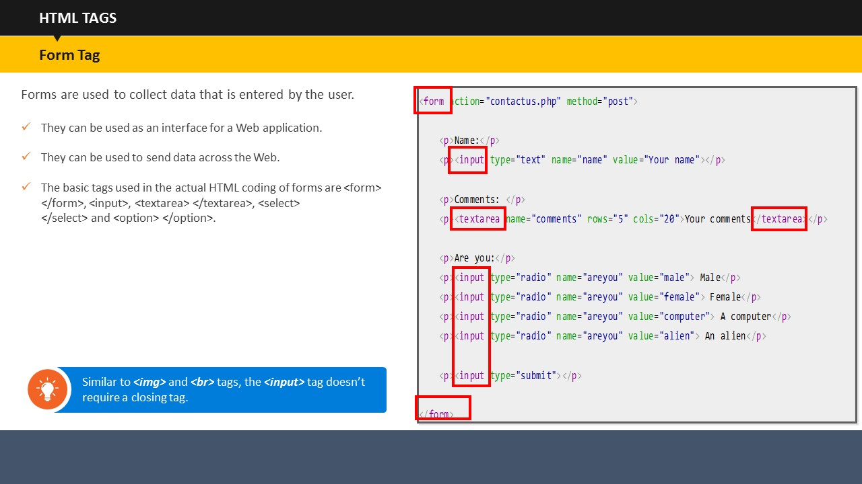

**Form Tag**

Forms are used to collect data that is entered by the user.

* They can be used as an interface for a Web application.
* They can be used to send data across the Web.
* The basic tags used in the actual HTML coding of forms are ***<form>***, ***<input>***, ***<textarea>***, ***<select>,*** and ***<option>***.



**Note:** Similar to ***<img>*** and ***<br>*** tags, the ***<input>*** tag, which doesn’t surround any content, doesn’t require a closing tag.

**Your Space:**

|  |
| --- |
|  |
|  |
|  |
|  |
|  |

|  |  |
| --- | --- |
| Tag | Description |
| <!--...--> | Defines a comment |
| <!DOCTYPE> | Defines the document type |
| <a> | Defines a hyperlink |
| <abbr> | Defines an abbreviation or an acronym |
| <acronym> | Not supported in HTML5. Use <abbr> instead. Defines an acronym |
| <address> | Defines contact information for the author/owner of a document |
| <applet> | Not supported in HTML5. Use <embed> or <object> instead. Defines an embedded applet |
| <area> | Defines an area inside an image-map |
| <article> | Defines an article |
| <aside> | Defines content aside from the page content |
| <audio> | Defines sound content |
| <b> | Defines bold text |
| <base> | Specifies the base URL/target for all relative URLs in a document |
| <basefont> | Not supported in HTML5. Use CSS instead. Specifies a default color, size, and font for all text in a document |
| <bdi> | Isolates a part of text that might be formatted in a different direction from other text outside it |
| <bdo> | Overrides the current text direction |
| <big> | Not supported in HTML5. Use CSS instead. Defines big text |
| <blockquote> | Defines a section that is quoted from another source |
| <body> | Defines the document's body |
| <br> | Defines a single line break |
| <button> | Defines a clickable button |
| <canvas> | Used to draw graphics, on the fly, via scripting (usually JavaScript) |
| <caption> | Defines a table caption |
| <center> | Not supported in HTML5. Use CSS instead. Defines centered text |
| <cite> | Defines the title of a work |
| <code> | Defines a piece of computer code |
| <col> | Specifies column properties for each column within a <colgroup> element |
| <colgroup> | Specifies a group of one or more columns in a table for formatting |
| <datalist> | Specifies a list of pre-defined options for input controls |
| <dd> | Defines a description/value of a term in a description list |
| <del> | Defines text that has been deleted from a document |
| <details> | Defines additional details that the user can view or hide |
| <dfn> | Represents the defining instance of a term |
| <dialog> | Defines a dialog box or window |
| <dir> | Not supported in HTML5. Use <ul> instead. Defines a directory list |
| <div> | Defines a section in a document |
| <dl> | Defines a description list |
| <dt> | Defines a term/name in a description list |
| <em> | Defines emphasized text |
| <embed> | Defines a container for an external (non-HTML) application |
| <fieldset> | Groups related elements in a form |
| <figcaption> | Defines a caption for a <figure> element |
| <figure> | Specifies self-contained content |
| <font> | Not supported in HTML5. Use CSS instead. Defines font, color, and size for text |
| <footer> | Defines a footer for a document or section |
| <form> | Defines an HTML form for user input |
| <frame> | Not supported in HTML5. Defines a window (a frame) in a frameset |
| <frameset> | Not supported in HTML5. Defines a set of frames |
| <h1> to <h6> | Defines HTML headings |
| <head> | Defines information about the document |
| <header> | Defines a header for a document or section |
| <hr> | Defines a thematic change in the content |
| <html> | Defines the root of an HTML document |
| <i> | Defines a part of text in an alternate voice or mood |
| <iframe> | Defines an inline frame |
| <img> | Defines an image |
| <input> | Defines an input control |
| <ins> | Defines a text that has been inserted into a document |
| <kbd> | Defines keyboard input |
| <keygen> | Defines a key-pair generator field (for forms) |
| <label> | Defines a label for an <input> element |
| <legend> | Defines a caption for a <fieldset> element |
| <li> | Defines a list item |
| <link> | Defines the relationship between a document and an external resource (most used to link to style sheets) |
| <main> | Specifies the main content of a document |
| <map> | Defines a client-side image-map |
| <mark> | Defines marked/highlighted text |
| <menu> | Defines a list/menu of commands |
| <menuitem> | Defines a command/menu item that the user can invoke from a popup menu |
| <meta> | Defines metadata about an HTML document |
| <meter> | Defines a scalar measurement within a known range (a gauge) |
| <nav> | Defines navigation links |
| <noframes> | Not supported in HTML5. Defines an alternate content for users that do not support frames |
| <noscript> | Defines an alternate content for users that do not support client-side scripts |
| <object> | Defines an embedded object |
| <ol> | Defines an ordered list |
| <optgroup> | Defines a group of related options in a drop-down list |
| <option> | Defines an option in a drop-down list |
| <output> | Defines the result of a calculation |
| <p> | Defines a paragraph |
| <param> | Defines a parameter for an object |
| <pre> | Defines preformatted text |
| <progress> | Represents the progress of a task |
| <q> | Defines a short quotation |
| <rp> | Defines what to show in browsers that do not support ruby annotations |
| <rt> | Defines an explanation/pronunciation of characters (for East Asian typography) |
| <ruby> | Defines a ruby annotation (for East Asian typography) |
| <s> | Defines text that is no longer correct |
| <samp> | Defines sample output from a computer program |
| <script> | Defines a client-side script |
| <section> | Defines a section in a document |
| <select> | Defines a drop-down list |
| <small> | Defines smaller text |
| <source> | Defines multiple media resources for media elements (<video> and <audio>) |
| <span> | Defines a section in a document |
| <strike> | Not supported in HTML5. Use <del> or <s> instead. Defines strikethrough text |
| <strong> | Defines important text |
| <style> | Defines style information for a document |
| <sub> | Defines subscripted text |
| <summary> | Defines a visible heading for a <details> element |
| <sup> | Defines superscripted text |
| <table> | Defines a table |
| <tbody> | Groups the body content in a table |
| <td> | Defines a cell in a table |
| <textarea> | Defines a multiline input control (text area) |
| <tfoot> | Groups the footer content in a table |
| <th> | Defines a header cell in a table |
| <thead> | Groups the header content in a table |
| <time> | Defines a date/time |
| <title> | Defines a title for the document |
| <tr> | Defines a row in a table |
| <track> | Defines text tracks for media elements (<video> and <audio>) |
| <tt> | Not supported in HTML5. Use CSS instead. Defines teletype text |
| <u> | Defines text that should be stylistically different from normal text |
| <ul> | Defines an unordered list |
| <var> | Defines a variable |
| <video> | Defines a video or movie |
| <wbr> | Defines a possible line-break |

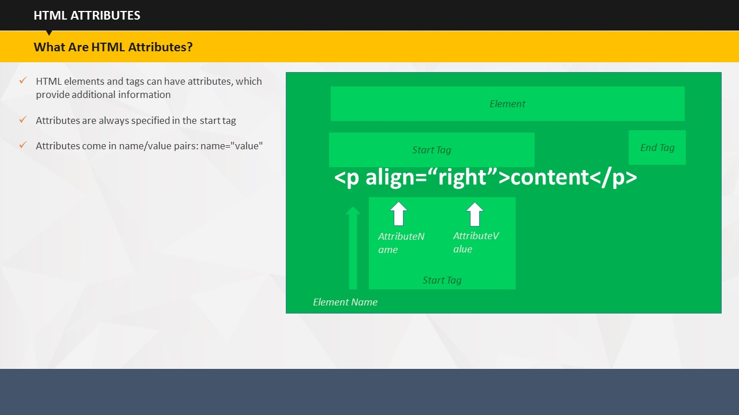

TOPIC 11 – HTML ATTRIBUTES

SUBTOPIC 1: WHAT ARE HTML ATTRIBUTES?

Now that you have learnt how to use HTML tags, it is important to know about HTML attributes. HTML tags can have attributes, which act as extra bits of information. Attributes appear inside the opening tag with their values placed inside quotation marks. In the ‘Introduction to HTML’ session, you learnt that the HTML element is everything from the start tag to the end tag. Attributes provide additional information about HTML elements by giving them meaning and background.

**Your Space:**

|  |
| --- |
|  |
|  |
|  |

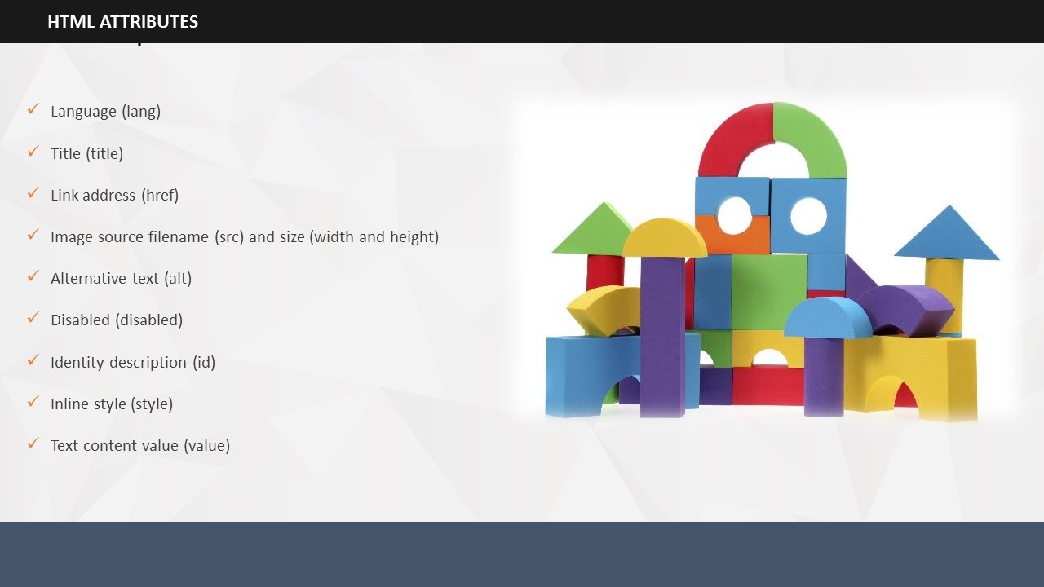

SUBTOPIC 2: IMPORTANT HTML ATTRIBUTES

There are several important attributes that you will use while ‘writing’ HTML for a Web page. In this session, we will look at some HTML attributes in detail along with examples. A detailed list of HTML core, event, and extended event attributes is also provided in the participant’s guide.

The important HTML attributes are:

* Language
* Title
* Link address
* Image source filename and size
* Alternative text
* Disabled
* Identity description
* Inline style
* Text content value

**Your Space:**

|  |
| --- |
|  |
|  |
|  |
|  |
|  |
|  |

Let us begin with the language attribute. The language on the Web page is declared in the ***lang*** attribute. It is important to declare a language for Web applications and search engines.

**Note:** The first two letters in the ***lang*** attribute specify the language. Here, ***en*** specifies the language. If there is a dialect, you can use two more letters. Here, ***UK*** is the dialect).

**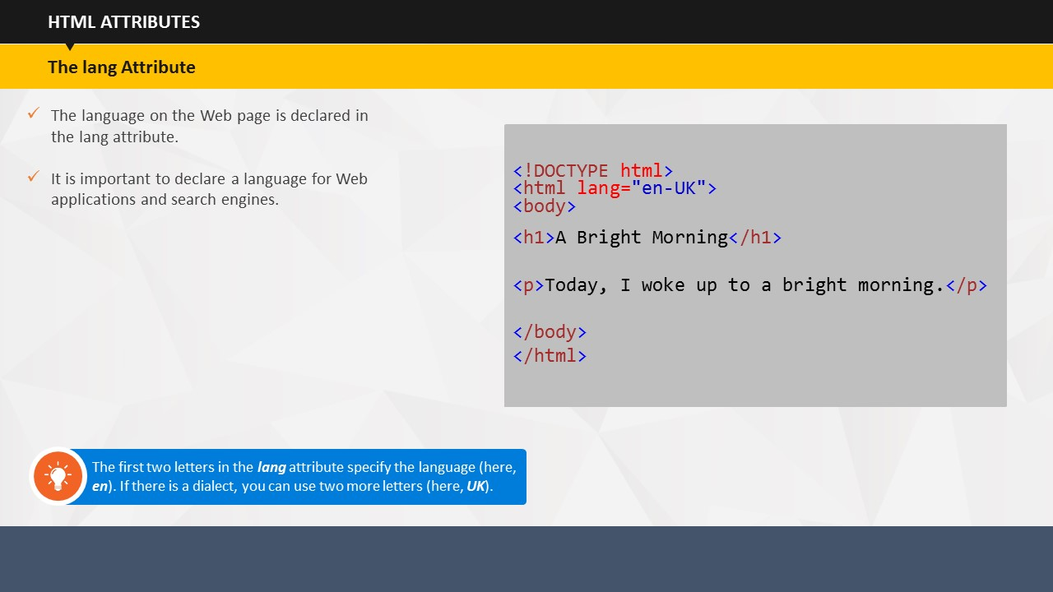****Your Space:**

|  |
| --- |
|  |
|  |
|  |
|  |
|  |
|  |

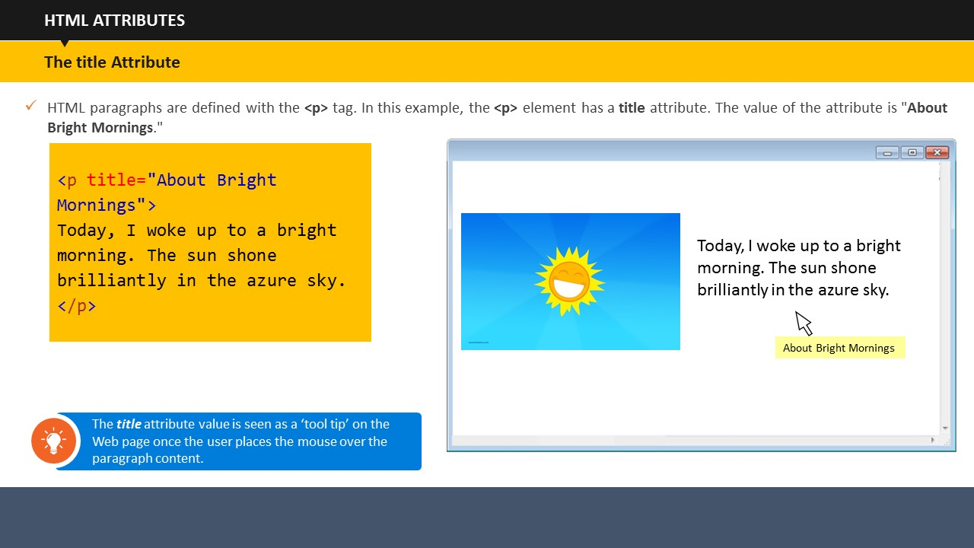

|  |
| --- |
|  |

As explained earlier, HTML paragraphs are defined with the **<p>** tag. In this example, the **<p>** element has a ***title*** attribute and the value of the attribute is *"****About Bright Mornings.****"*

**Note:** The ***title*** attribute value is seen as a ‘tool tip’ on the Web page once the user places the mouse over the paragraph content.

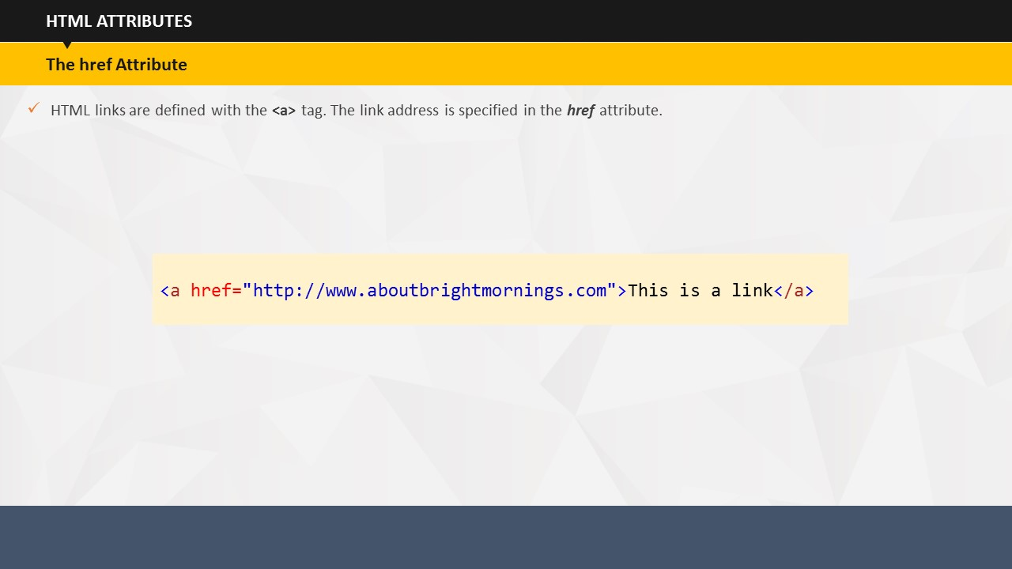**Your Space:**

|  |
| --- |
|  |
|  |
|  |
|  |
|  |
|  |

As explained earlier, HTML links are defined with the **<a>** tag. However, the link address is specified in the ***href*** attribute as seen in the given example.

**Your Space:**

|  |
| --- |
|  |
|  |
|  |

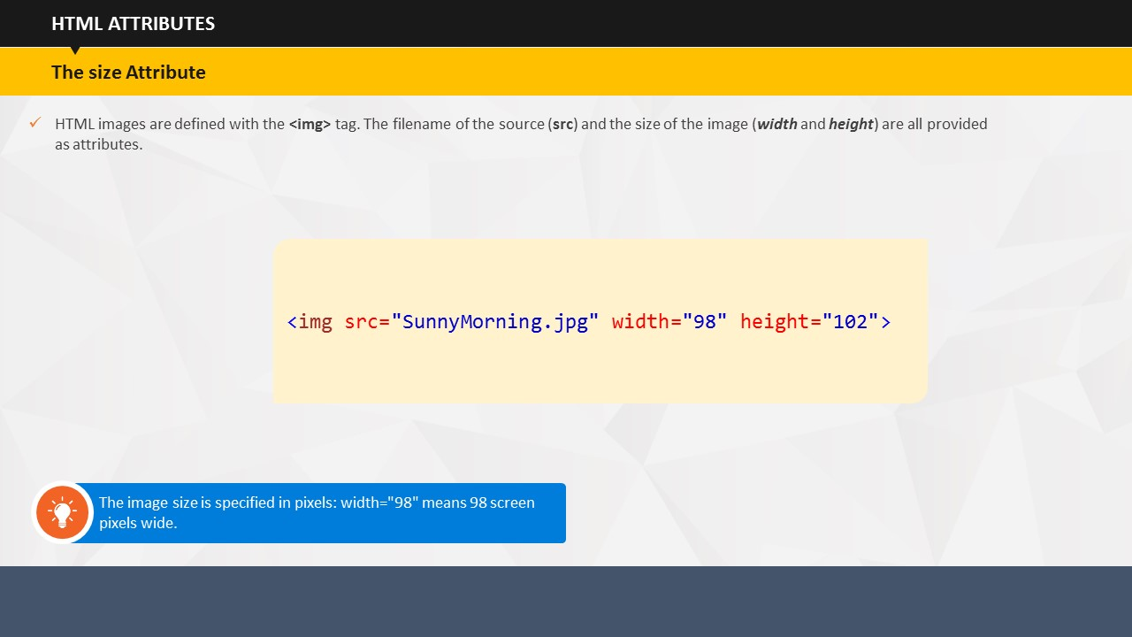

HTML images are defined with the **<img>** tag. The filename of the source (***src***) and the size of the image (***width*** and ***height***) are all provided as attributes.

**Note:** The image size is specified in pixels. Therefore, width="98" means 98 screen pixels wide.

**Your Space:**

|  |
| --- |
|  |
|  |
|  |
|  |

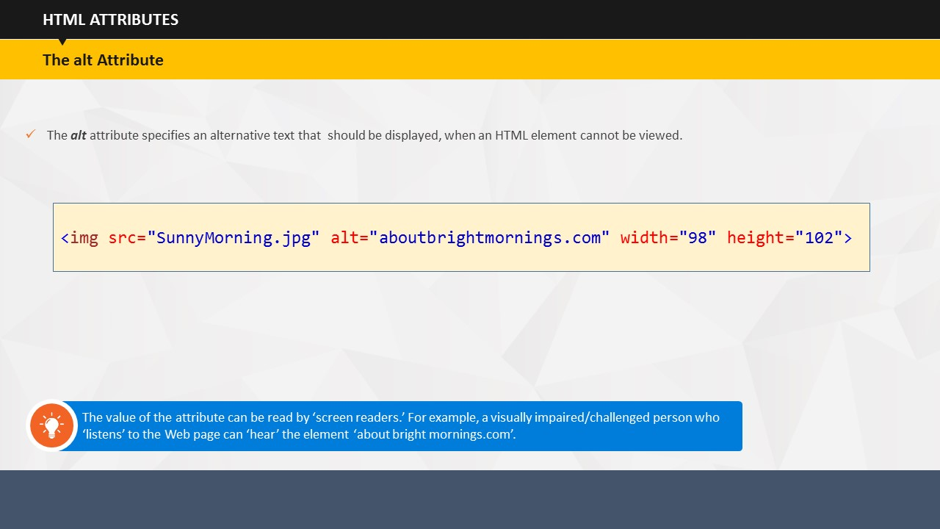

The ***alt*** attribute specifies an alternative text that should be displayed, when an HTML element cannot be viewed.

**Note:** The value of the attribute can be read by ‘screen readers.’ For example, a visually impaired/challenged person who ‘listens’ to the Web page can ‘hear’ the element ‘about bright mornings.com’.

**Your Space:**

|  |
| --- |
|  |
|  |
|  |

**List of Global/Core Attributes:**

|  |  |
| --- | --- |
| Global/Core Attribute | Description |
| disabled | Specifies that an input element should be disabled |
| alt | Specifies an alternative text for an image |
| href | Specifies the URL (web address) for a link |
| src | Specifies the URL (web address) for an image |
| id | Specifies a unique id for an element |
| style | Specifies an inline style for an element |
| title | Specifies extra information about an element (displayed as a tool tip) |
| value | Specifies the value (text content) for an input element |
| accesskey | Specifies a shortcut key to activate/focus an element |
| class | Specifies one or more class names for an element (refers to a class in a style sheet) |
| contenteditable | Specifies whether the content of an element is editable or not |
| contextmenu | Specifies a context menu for an element. The context menu appears when a user right-clicks on the element |
| data-* | Used to store custom data private to the page or application |
| dir | Specifies the text direction for the content in an element |
| class | Specifies one or more class names for an element (refers to a class in a style sheet) |
| contenteditable | Specifies whether the content of an element is editable or not |
| contextmenu | Specifies a context menu for an element. The context menu appears when a user right-clicks on the element |
| data-* | Used to store custom data private to the page or application |
| dir | Specifies the text direction for the content in an element |
| draggable | Specifies whether an element is draggable or not |
| dropzone | Specifies whether the dragged data is copied, moved, or linked, when dropped |
| class | Specifies one or more class names for an element (refers to a class in a style sheet) |
| contenteditable | Specifies whether the content of an element is editable or not |
| contextmenu | Specifies a context menu for an element. The context menu appears when a user right-clicks on the element |
| data-* | Used to store custom data private to the page or application |
| dir | Specifies the text direction for the content in an element |
| draggable | Specifies whether an element is draggable or not |
| dropzone | Specifies whether the dragged data is copied, moved, or linked, when dropped |
| hidden | Specifies that an element is not yet, or is no longer, relevant |
| lang | Specifies the language of the element's content |
| xml:lang | Specifies the language of the content inside this element in XHTML documents |
| spellcheck | Specifies whether the element is to have its spelling and grammar checked or not |
| tabindex | Specifies the tabbing order of an element |
| translate | Specifies whether the content of an element should be translated or not |

**List of Event Attributes:**

In addition to the global/core attributes, there are certain event attributes that are used to identify the moments at which certain actions take place, such as the moment when a user places the mouse over an element or presses a certain key.

|  |  |
| --- | --- |
| Event Attribute | Description |
| onblur | Captures the moment that this element loses focus |
| onchange | Captures the moment when the value of this element is changed |
| onclick | Captures a mouse click on the element |
| ondblclick | Captures a double mouse click on this element |
| onfocus | Captures the moment that this element receives focus, either via the cursor or keyboard navigation |
| onkeydown | Captures the event in which a key pressed down (but not released) while focus is on the element |
| onkeypress | Captures a key press while focus is on this element |
| onkeyup | Captures the moment at which a pressed key is released while focus is on the element |
| onload | Catches the point at which a page has completely loaded |
| onmousedown | Captures the pressing down of the mouse button while the cursor is positioned over the element |
| onmousemove | Captures a mouse movement within this element |
| onmouseout | Captures the movement of a cursor off an area covered by this element |
| onmouseover | Captures the movement of a cursor into an area covered by this element |
| onmouseup | Captures the release of a previously pressed mouse button while the cursor is over the element |
| onreset | Captures the moment that this form’s Reset button is activated |
| onselect | Captures the event in which the user selects, or highlights, text in the element |
| onsubmit | Captures the moment that the form element to which this attribute is applied is submitted |
| onunload | Catches the point at which a page has unloaded |

**List of Extended Event Attributes**

**Please Note:** If you use these events, they may not be supported by any browser other than Internet Explorer, therefore you should only use approved event attributes to ensure cross-browser compatibility.

|  |  |
| --- | --- |
| Extended Event Attributes | Description |
| onabort | Captures event triggered when user aborts image loading |
| onactivate | Captures event fired when object is set as active element |
| onafterprint | Captures event fired after user sets page to print |
| onafterupdate | Captures event fired after transfer of data to data provider |
| onbeforeactivate | Captures event fired just before element activated |
| onbeforecopy | Captures event fired just before user carries out copy function |
| onbeforecut | Captures event fired just before user carries out cut function |
| onbeforedeactivate | Captures event fired just before element deactivated |
| onbeforeeditfocus | Captures event fired before element focused for editing |
| onbeforepaste | Captures event fired just before paste operation |
| Onbeforeprint | Captures event fired before page prints |
| onbeforeunload | Captures event fired just before page unloads |
| onbeforeupdate | Captures event fired before transfer of data to data provider |
| onbounce | Captures event fired when marquee text bounces at edge |
| oncontextmenu | Captures event fired when user activates contextual menu |
| oncontrolselect | Captures event fired when user selects using CTRL |
| oncopy | Captures event fired when user carries out copy operation |
| oncut | Captures event fired when user carries out cut operation |
| ondataavailable | Captures event fired when data arrives from asynchronous source |
| ondatasetchanged | Captures event fired when data available/changed from data source |
| ondeactivate | Captures event fired when element deactivated |
| ondrag | Captures event fired during a drag operation |
| ondragend | Captures event fired when user stops dragging |
| ondragenter | Captures event fired when user drags object onto target |
| ondragleave | Captures event fired when user drags object out of target |
| ondragover | Captures event fired while user drags object over drop target |
| ondragstart | Captures event fired when user starts dragging |
| ondrop | Captures event fired when user releases mouse button during drag-drop |
| onerror | Captures event fired when document errors occur |
| onerrorupdate | Captures event fired when data transfer cancelled |
| onfilterchange | Captures event fired when page filter changes state or finishes |
| onfinish | Captures event fired when looping marquee finishes |
| onfocusin | Captures event fired just before element receives focus |
| onfocusout | Captures event fired just before element loses focus |
| onhelp | Captures event fired when user brings up help topics |
| onlayoutcomplete | Captures event fired when print or print preview process completed |
| onlosecapture | Captures event fired when object loses mouse capture |
| onmouseenter | Captures event fired when mouse pointer moves into object |
| onmouseleave | Captures event fired when mouse pointer moves out of object |
| onmousewheel | Captures event fired when mouse wheel is used |
| onmove | Captures event fired when user moves window |
| onmoveend | Captures event fired when user stops moving editable element |
| onmovestart | Captures event fired when user starts moving editable element |
| onpaste | Captures event fired when copied/cut content is pasted |
| onpropertychange | Captures event fired when a property of an element changes |
| onreadystatechanged | Captures event fired when ready state has changed for an object |
| onresize | Captures event fired when an object is resized |
| onresizeend | Captures event fired when user has finished resizing object |
| onresizestart | Captures event fired when user starts resizing object |
| onrowenter | Captures event fired when bound data row changes |
| onrowexit | Captures event fired just before data-bound row values changed |
| onrowsdelete | Captures event fired when dataset rows are about to be deleted |
| onrowsinserted | Captures event fired when dataset rows are inserted |
| onscroll | Captures event fired when element content scrolls |
| onselectionchange | Captures event fired when selection state of document changes |
| onstart | Captures event fired when a looped marquee begins/restarts lop |
| onstop | Captures event fired when user presses browser stop button |
| ontimeerror | Captures event fired when time-specific error occurs |

**Your Space:**

|  |
| --- |
|  |
|  |
|  |
|  |
|  |
|  |
|  |

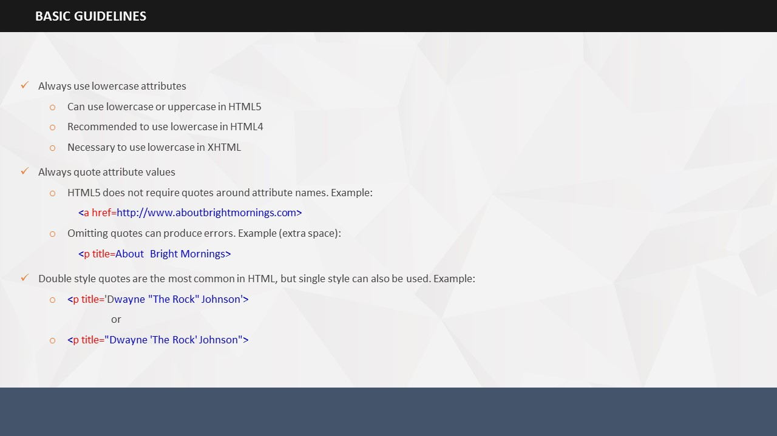

SUBTOPIC 3: BASIC GUIDELINES



TOPIC 12 — USING ADVANCED HTML

SUBTOPIC 1: SESSION INTRODUCTION

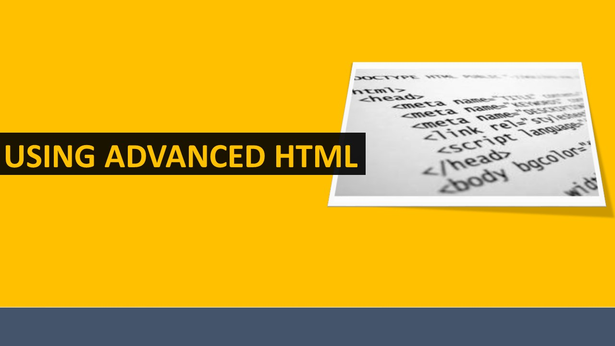Project the ILT course.

**Your Space:**

|  |
| --- |
|  |
|  |
|  |
|  |
|  |

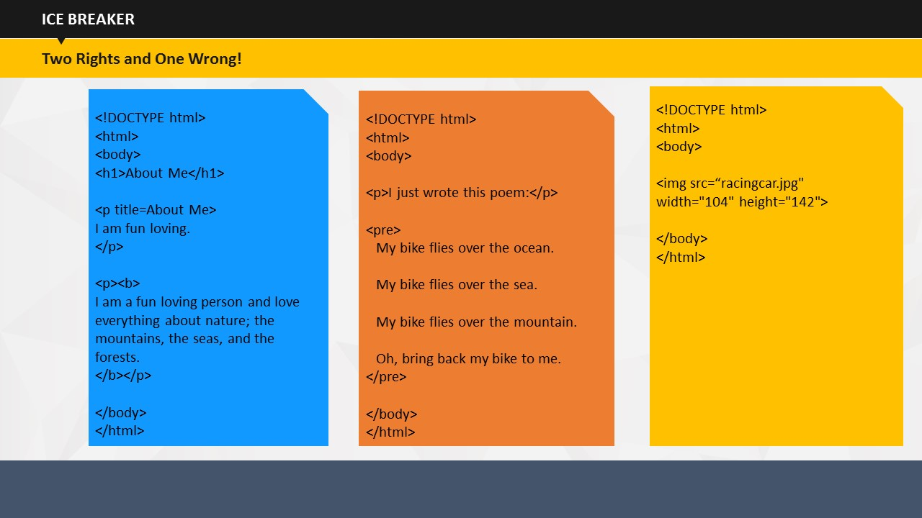

**Say:** Now that you already have an idea about the various attributes and tags that are used in HTML coding, let us try and figure out which of the following coding is incorrect. Work in teams and try to find out the content with incorrect coding.

SUBTOPIC 2: ICE BREAKER

**Do:** Divide the students into teams and ask them to find out the incorrect one. Tell that two coding documents are right and one is wrong. They have to find the wrong one. The team that finds out the incorrect coding document first, wins.

**Your Space:**

|  |
| --- |
|  |
|  |
|  |
|  |
|  |
|  |
|  |
|  |

## 

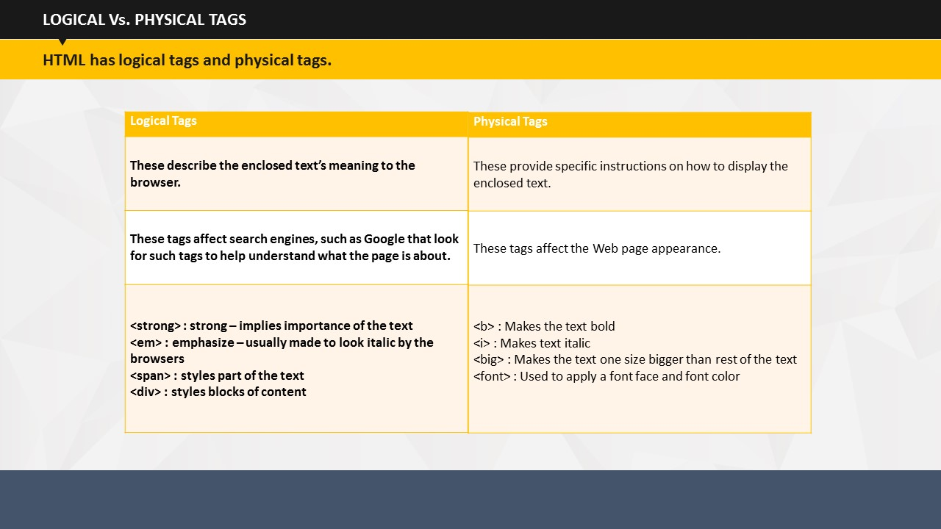

TOPIC 13 – LOGICAL Vs. PHYSICAL TAGS

It is very important that you know about the different features of logical and physical tags because it is one of the basic concepts in HTML.

* Logical tags describe the enclosed text’s meaning to the browser.
* These tags affect search engines, such as Google that look for such tags to help understand what the page is about.
* The examples of logical tags are:
* ***<strong>*** : strong, which implies importance of the text
* ***<em>*** : emphasize, which is usually made to look italic by the browsers
* ***<span>***, which styles part of the text
* ***<div>***, which styles blocks of content
* Physical tags provide specific instructions on how to display the enclosed text.
* These tags affect the Web page appearance.
* The examples of physical tags are:
* ***<b>***, whichmakes the text bold
* ***<i>***, whichmakes text italic
* ***<big>***, whichmakes the text one size bigger than rest of the text
* ***<font>***, which is used to apply a font face and font color

**Your Space:**

|  |
| --- |
|  |
|  |
|  |
|  |
|  |

# 

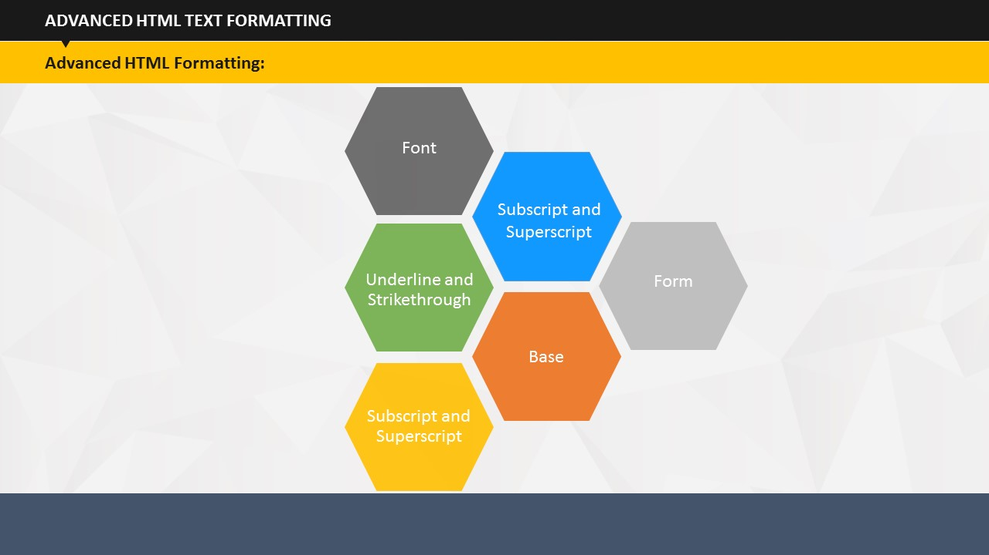

# 

TOPIC 14 – ADVANCED HTML FORMATTING

You already have a basic idea of how HTML pages work, and how to do basic coding in HTML. With basic HTML knowledge you can develop a Web site. But to take advantage of many of the advanced features and to make pages fully compatible, it is useful to learn advanced coding in HTML. This involves learning advanced HTML text formatting, which includes Font, Underline and Strikethrough, Subscript and Superscript, Preformatted text, Base, and Form.

**Your Space:**

|  |
| --- |
|  |
|  |
|  |
|  |
|  |
|  |
|  |

## 

SUBTOPIC 1: FONT

The font tag is the most used HTML tag as it allows you to specify the color, size, and font of text. It provides a very easy way to change the look of the page. The basic use of the font tag involves setting a font. For example, by using the codes shown on the screen, the font size is set at 16 and is put in the Comic Sans MS font, if available or the Arial font next. If neither of these exists, then it uses the Web browsers' default font.

Do: This is just an example, you can substitute these names for whatever font you want and can specify as many of them as you like in your order of preference. You simply need to separate them by a comma.

**Do:** Advise the learners not to use any strange or unique font because the person loading the page also needs to have the font installed for it to show up.

**Your Space:**

|  |
| --- |
|  |
|  |
|  |

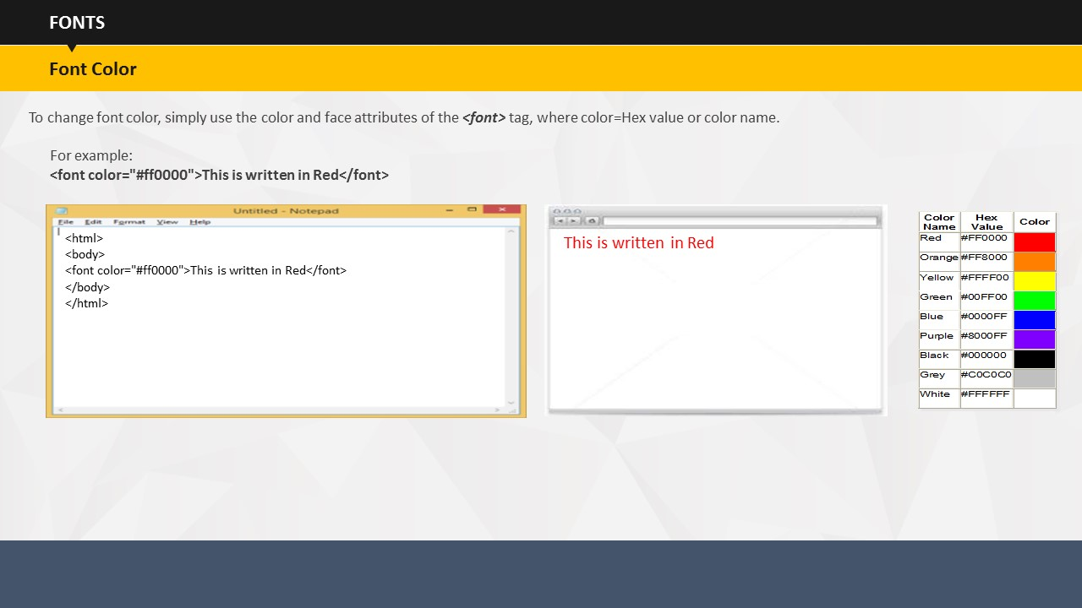

SUBTOPIC 2: FONT — Font Color

To make colored text, you need to simply use the ***color*** and ***face*** attributes of the ***<font>*** tag, where color=Hex value or color name as shown in the table on the screen.

**Your Space:**

|  |
| --- |
|  |
|  |
|  |
|  |
|  |
|  |

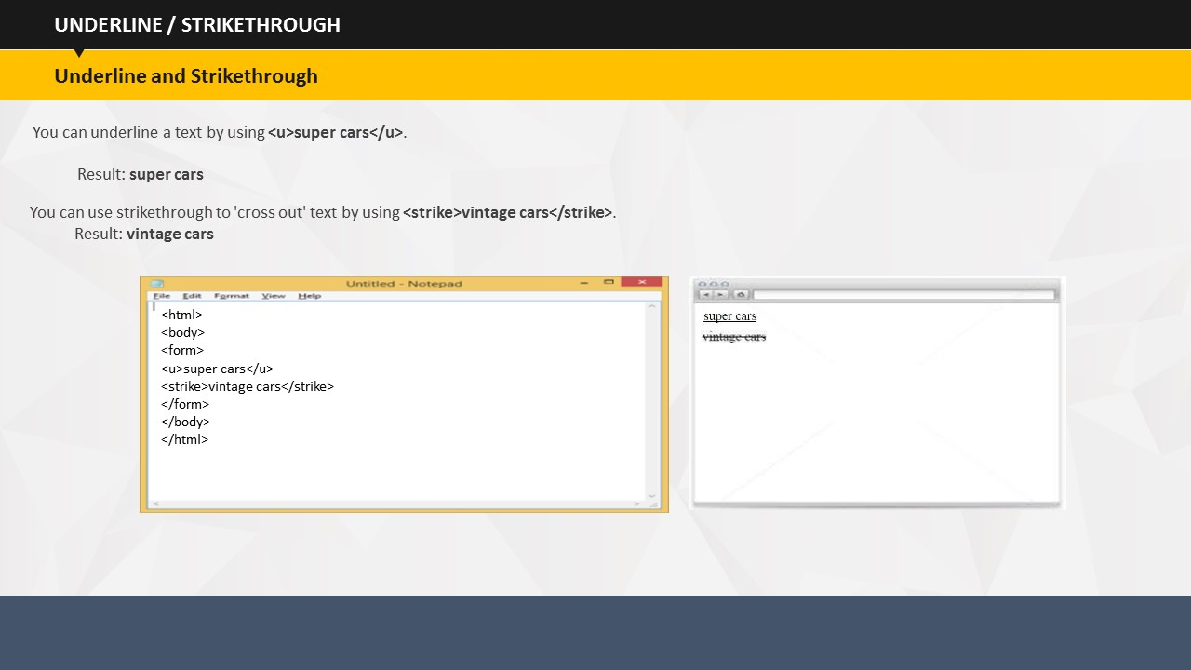

Another method of controlling or changing how your text appears, other than changing the size, color, and font is to apply other standard text formats to it. You can underline a text by using the given code (***<u>super cars</u>***). However, you should not use this too often because it can often be confused with links on the page. You can use strikethrough, although it is not common, to 'cross out' text by using the given code (***<strike>vintage cars</strike>***).

SUBTOPIC 3: UNDERLINE AND STRIKETHROUGH

**Your Space:**

|  |
| --- |
|  |
|  |
|  |
|  |
|  |
|  |
|  |

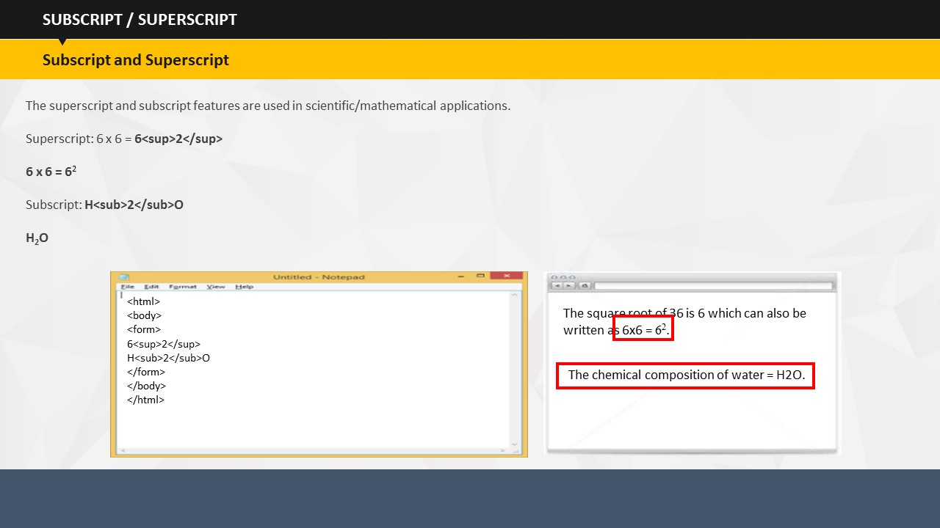

SUBTOPIC 4: SUBSCRIPT AND SUPERSCRIPT

Web pages can also display subscript and subscript text. Superscript makes the text appear slightly above the line and subscript makes the text appear slightly below the line. However, it is only commonly used in scientific/mathematical applications.

**Your Space:**

|  |
| --- |
|  |
|  |
|  |
|  |
|  |
|  |

# 

As learnt in the earlier session, HTML has been designed in such a manner that it ignores multiple spaces in documents. For example, if you enter two standard spaces it is displayed as one. To display pre-formatted content, such as tables written in plain text, you can use the ***<pre>*** tag, which stands for preformatted text. This tag will display the text exactly as it appears in the source document.

SUBTOPIC 5: PREFORMATTED TEXT

**Your Space:**

|  |
| --- |
|  |
|  |
|  |
|  |
|  |
|  |

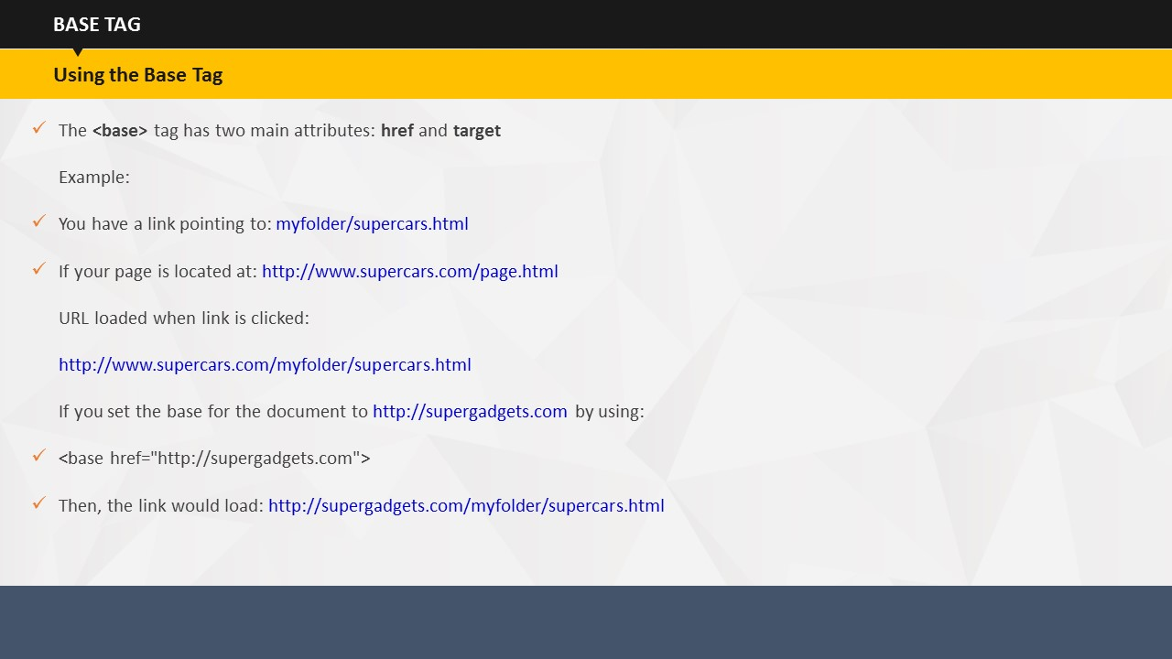

SUBTOPIC 6: BASE

The ***<base>*** tag has two main attributes, ***href*** and ***target***.  
  
The ***href*** attribute tells the browser what the base URL for the page is and can then be used to correctly interpret relative hyperlinks.

This also applies to images and any other relative document URLs. The ***<base>*** tag is placed in the ***<head>*** section of your HTML and would be carried out using the given code (***<base href="http://supergadgets.com">***)  
  
This tag can be very useful if a page is accessed from multiple domain names or if you need to put an already created page on another server. Hence, you would not have to update all your links; you would just need to update the ***<base>*** of the document.

**Your Space:**

|  |
| --- |
|  |
|  |
|  |

SUBTOPIC 7: FORM — Creating Forms

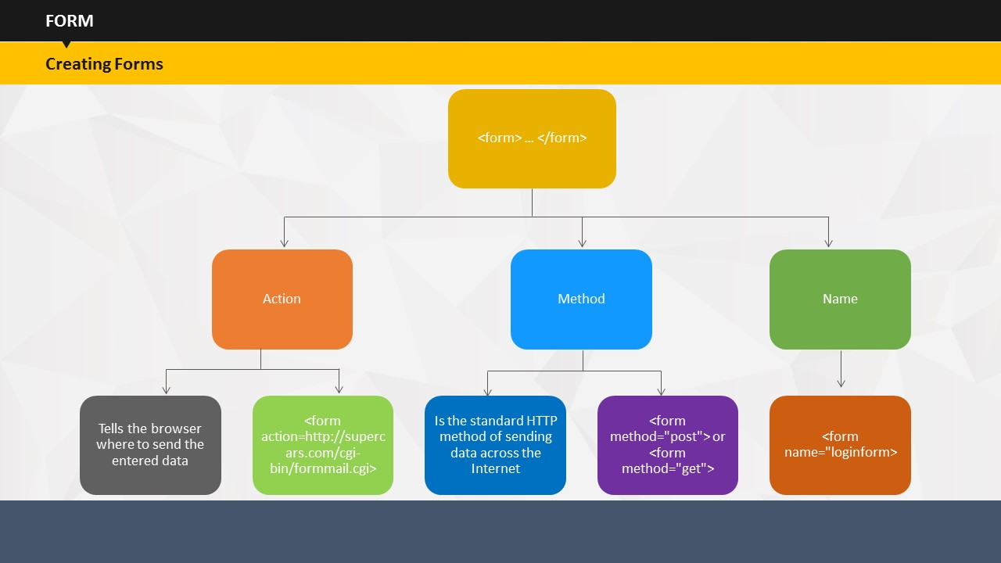

In the earlier session, you have already seen the attributes and tags that are used to create forms in HTML. We will now look at creating forms using advanced HTML.

In HTML, the first thing you should do is to define a form as a whole. This is done using the ***<form></form>*** tags. The entire content inside form tags will be part of that particular form. You can have as many sets of ***<form>*** tags as you need on a single Web page. For example, to provide a login form and a signup form on the same page as long as they are not nested.

You define a form using the tags: ***<form></form>*** with three attributes: ***Action***, ***Method***, and ***Name****.*

1. The ***action*** attribute of a form tells the browser where to send the entered data, in this case, the entered data needs to be sent to the file at ‘http://supercars.com/cgi-bin/formmail.cgi.’ This file will then be responsible for handling the data.
2. The ***method*** attribute implies the standard HTTP method of sending data across the Internet either through POST or through GET. The GET method puts the data into the URL of the next page, so that it is visible in the browser's address. The POST method sends data in a special data stream making it invisible in the browser and far more secure than GET. By default, a form will submit using GET unless you specify the method.
3. Apart from the ***method*** and ***action*** attributes, you may also need to use the ***name*** attribute as displayed on the screen. **(*<form name="loginform">*** )

**Your Space:**

|  |
| --- |
|  |
|  |
|  |
|  |
|  |
|  |
|  |
|  |
|  |
|  |
|  |
|  |
|  |

## 

An HTML form is similar to a paper form. You are presented with a number of sections of a page where you must input information. There are various ways to enter data, including typing it in, selecting it from a list and ticking boxes. There are groups of items and single items that are all put together in one large form and the HTML tells the browser where to return it to.

SUBTOPIC 8: FORM — Components

Now that we know which tags and attributes are used to create forms, we will now learn the basic format of an HTML form, including how to structure the form, how to submit and reset the form, and how to get basic inputs. HTML offers a huge number of other input options. You will learn how to create a basic form in HTML with textboxes, checkboxes, selection boxes, radio buttons etc.

**Your Space:**

|  |
| --- |
|  |
|  |
|  |
|  |
|  |
|  |

## 

SUBTOPIC 9: FORM — Text Input

The most basic type of input in a form is the standard textbox, which allows the user to enter text and then sends this data to the processing script when the form is submitted. Nearly all input options use the same basic ***<input>*** tag which is combined with a number of attributes to provide different input types on your form.

The ***name*** attribute allows you to give the textbox a name with which you can refer to the data later. It should be entered without spaces or special characters, but it is important that each item on the form is given a different name.

The ***value*** attributeallows you to set an initial value for your textbox, which can be changed by the user.

**Your Space:**

|  |
| --- |
|  |
|  |
|  |
|  |
|  |

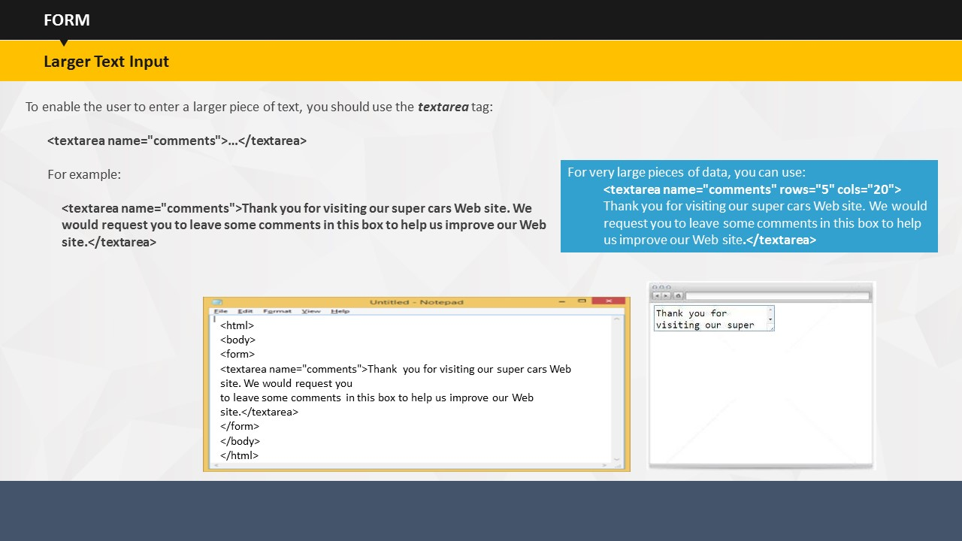

SUBTOPIC 10: FORM – Larger Text Input

Although textbox offers a useful way of getting content inputs from a user, it has certain limitations. The user can only enter one line, which is quite limited in length. If you want to get more than just a few words from a user, you should use the flexible <***textarea>*** tag. As with any form element, you must specify a name to it. Here, we are using the name ‘comments’.

You may have noticed that, unlike the standard text box and button, ***<textarea>*** has a closing tag. One of the useful features of textboxes is that they will wrap text for you, and also provide scrollbars if the entire text is too long to fit in the box. If you expect users to enter large content, you will want to have a larger box than the default one. HTML allows you to make this possible with the columns and rows attributes. These allow you to set the number of columns and rows in your textbox so that users can enter large content in it.

**Your Space:**

|  |
| --- |
|  |
|  |
|  |

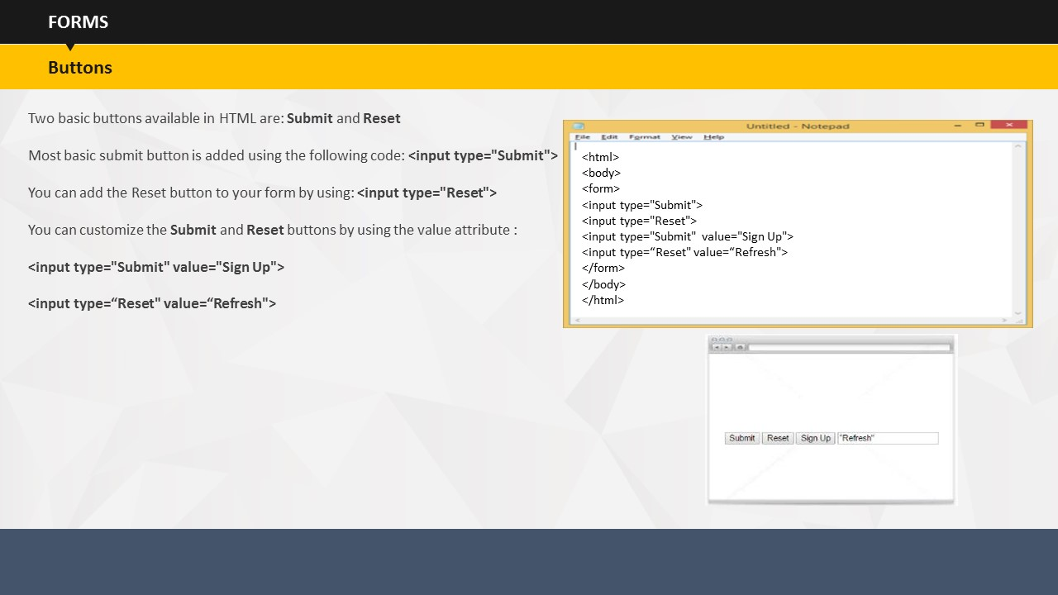

SUBTOPIC 11: FORM – Buttons

Now that the user has entered some data into a form, you will need a way to enable them to send it on to the next page. This is where the buttons feature comes in. HTML creates the **Submit** and **Reset** buttons and makes them available for the users. **Submit** is used most commonly. Basically, when you place a **Submit** button, a button appears on the page which, when clicked by the user, tells the browser to send the form data to the URL which you defined in the action part of the form tag.

You can have as many **Submit** buttons in a single form as you like. For example, many Websites provide an **I Agree** button at the top or bottom of a long page of terms and conditions, but all **Submit** buttons in a single form will do the same thing.

Besides the **Submit** button, you can also add a **Reset** button to your form. When clicked by the user, this button resets the form to its original state usually by clearing all values. However, in case the ***value*** attribute is being set for an input option, it will also restore the original values that you set.

**Your Space:**

|  |
| --- |
|  |
|  |
|  |
|  |
|  |
|  |
|  |
|  |
|  |

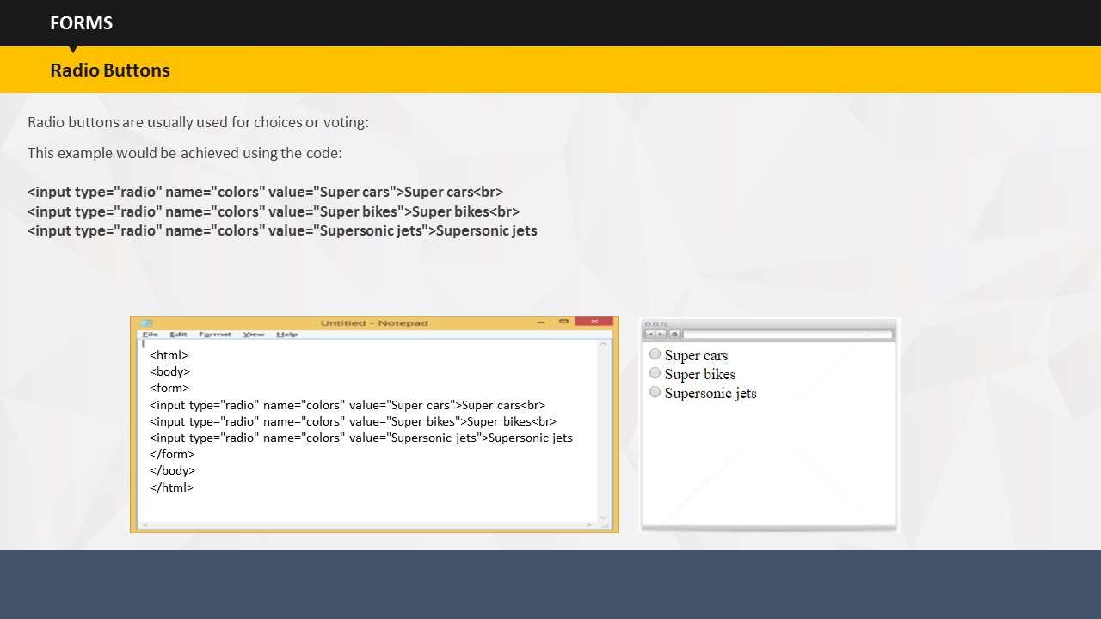

SUBTOPIC 12: FORM – Radio buttons

Usually **Radio** buttons are used for choices, such as voting. They are placed in groups where only one button can be selected at a time. Similar to other form elements, radio buttons use the standard ***<input>*** tag, and the type is set to 'radio'. Unlike other elements, radio buttons are not named individually, but are based on their group. For example, with text boxes you may have one called 'name' and one called 'password' but for radio buttons to work correctly, all the buttons in a group must have the same name.

When submitted, the form will give the name of the group, followed by the value set for the selected button, as its output. If you want multiple radio button sets in one form, you should give the other set a different name. All buttons that have the same name and are in the same form will be grouped.

**Your Space:**

|  |
| --- |
|  |
|  |
|  |
|  |
|  |
|  |
|  |
|  |

|  |
| --- |
|  |

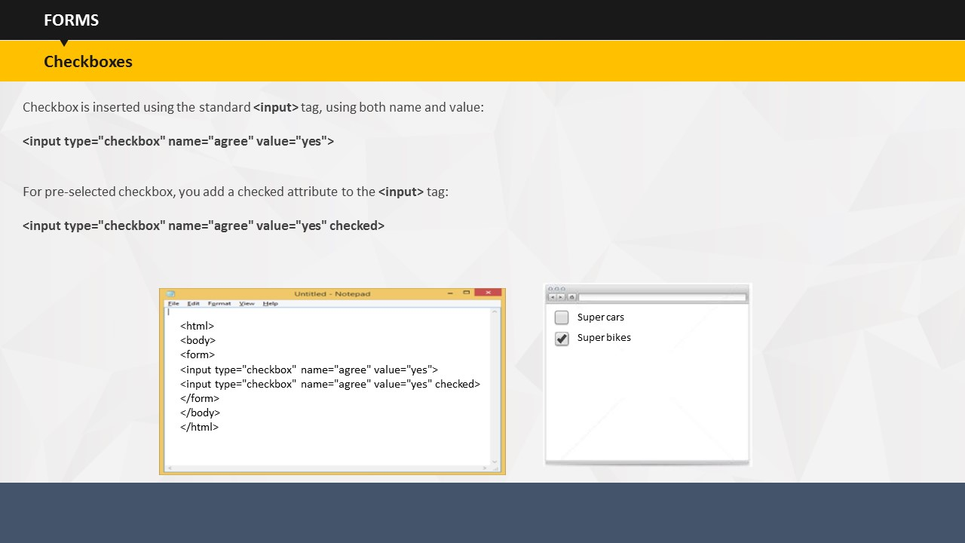

SUBTOPIC 13: FORM – Checkboxes

Unlike radio buttons, checkboxes are either on or off and are not grouped. The user can select as many or as few of them as you want. When a form containing a checkbox is submitted, the browser will only send the textbox name and value if it is selected. It will ignore the checkbox if it is not selected.

Even if you preset the box as checked, the user will have full control over the checkbox and can check and uncheck its value. However, it is more likely that the user will not care to uncheck it and will leave it checked.

**Your Space:**

|  |
| --- |
|  |
|  |
|  |
|  |

|  |
| --- |
|  |

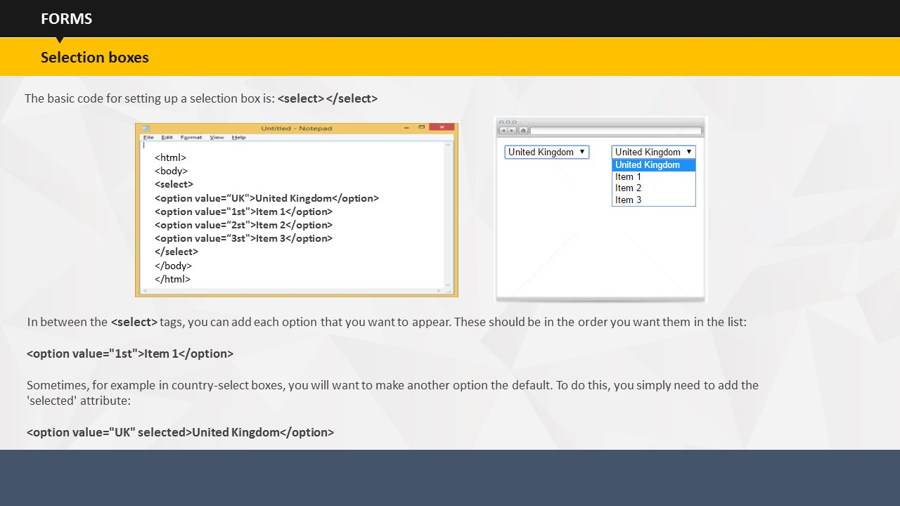Selection boxes allow you to provide a list of options from which you can choose one. This is useful for an entry such as country, where you don't want the user to be able to enter text freely. Similar to any other form tag, you can add the ***name*** attribute, so that you can access the form data later. In between the ***<select>*** tags, you can add each option that you want to appear for selection. These options should be in the same order as you want them in the list. There is no limit to the number of items you can add in the selection list because the browser will adjust the box accordingly. You can put in any value you want; it need not be sequential or related to the use of the option.

SUBTOPIC 14: FORMS – Selection boxes

You should enter the text that you want to appear in the selection list between the ***<option></option>*** tags. The selection box will automatically resize according to the entered text.  
  
By default, the first option is displayed when no selection is made. In many cases, this is acceptable. Usually, 'Please Make Your Selection' is put there and a value is assigned to it which can later be detected as an invalid input. But sometimes, for example in country selection boxes, you may want to make another default option. To do this, you simply need to add the ***selected*** attribute.

**Your Space:**

|  |
| --- |
|  |
|  |
|  |
|  |
|  |
|  |
|  |

## 

## 

SUBTOPIC 15: FORM – Hidden Fields

You can add a hidden field to your form, which will simply send a name and value with the form data. Nothing appears on the screen, nothing shows on the HTML page, and the user is not given the chance to change its value.

**Your Space:**

|  |
| --- |
|  |
|  |
|  |
|  |
|  |
|  |
|  |

# 

TOPIC 15 – ADVANCED HTML EXTENSIONS

You already have a basic idea of how HTML pages work, and how to do basic coding in HTML. Although, with basic HTML knowledge you can develop a Web site, to take advantage of many of the advanced features, and to make pages fully compatible, it is useful to learn about the components of advanced HTML extensions.

**Your Space:**

|  |
| --- |
|  |
|  |
|  |
|  |
|  |
|  |
|  |

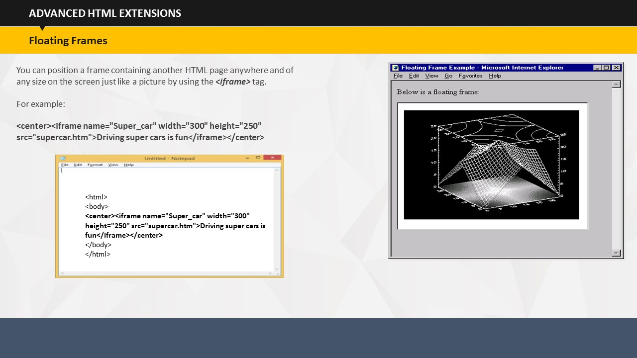

SUBTOPIC 1: FLOATING FRAMES

You can position a frame containing another HTML page anywhere and of any size on the screen just like a picture by using the ***<iframe>*** tag.

**Your Space:**

|  |
| --- |
|  |
|  |
|  |
|  |
|  |
|  |

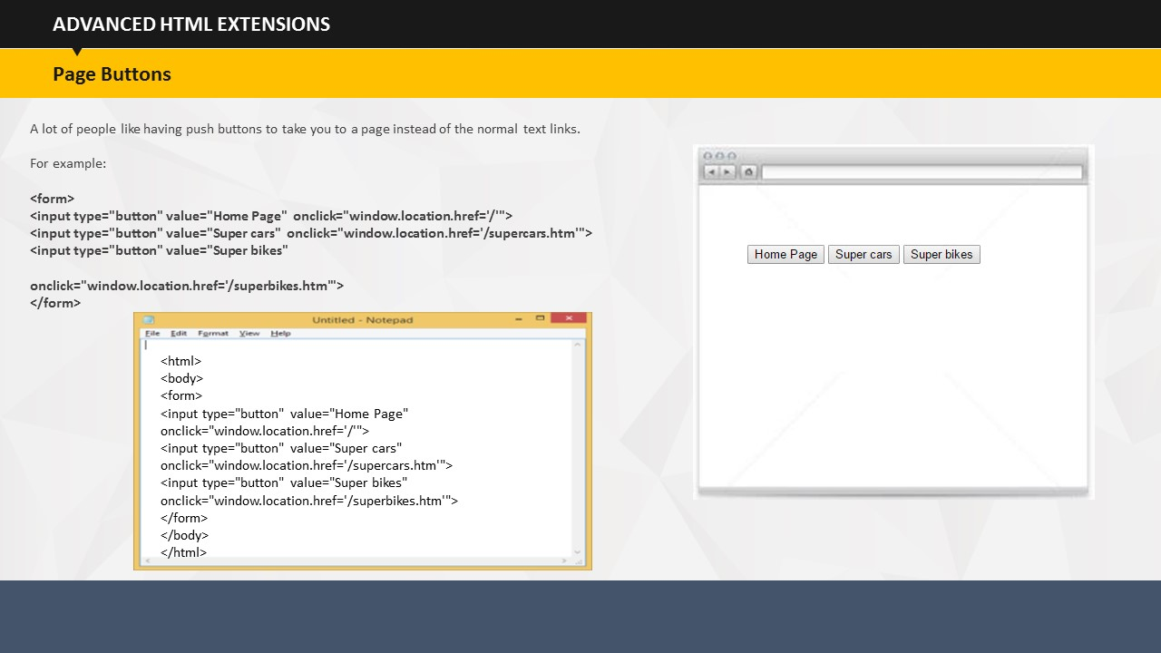

SUBTOPIC 2: PAGE BUTTONS

You can create push buttons to take you to a page instead of the normal text links.

**Your Space:**

|  |
| --- |
|  |
|  |
|  |
|  |
|  |
|  |
|  |

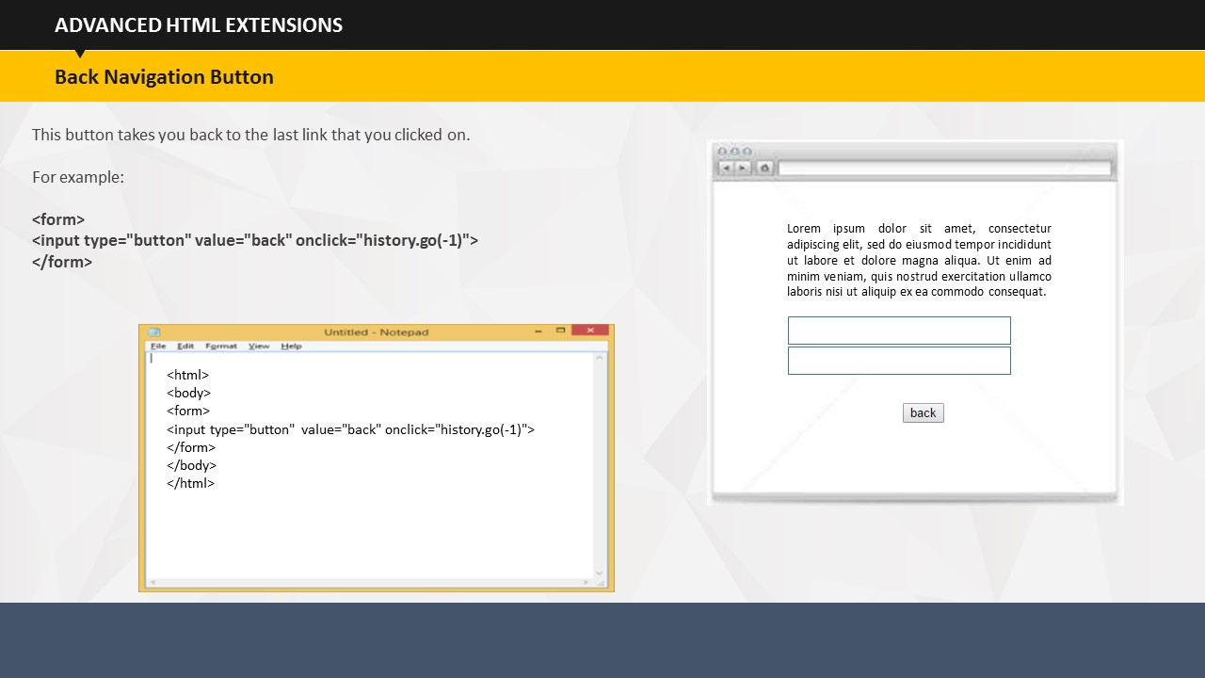

SUBTOPIC 3: BACK NAVIGATION BUTTON

The back navigation button takes you back to the last link that you clicked, even if that link was on the same page. If you click it again, it will take you back to another link.

**Your Space:**

|  |
| --- |
|  |
|  |
|  |
|  |
|  |
|  |
|  |

## 

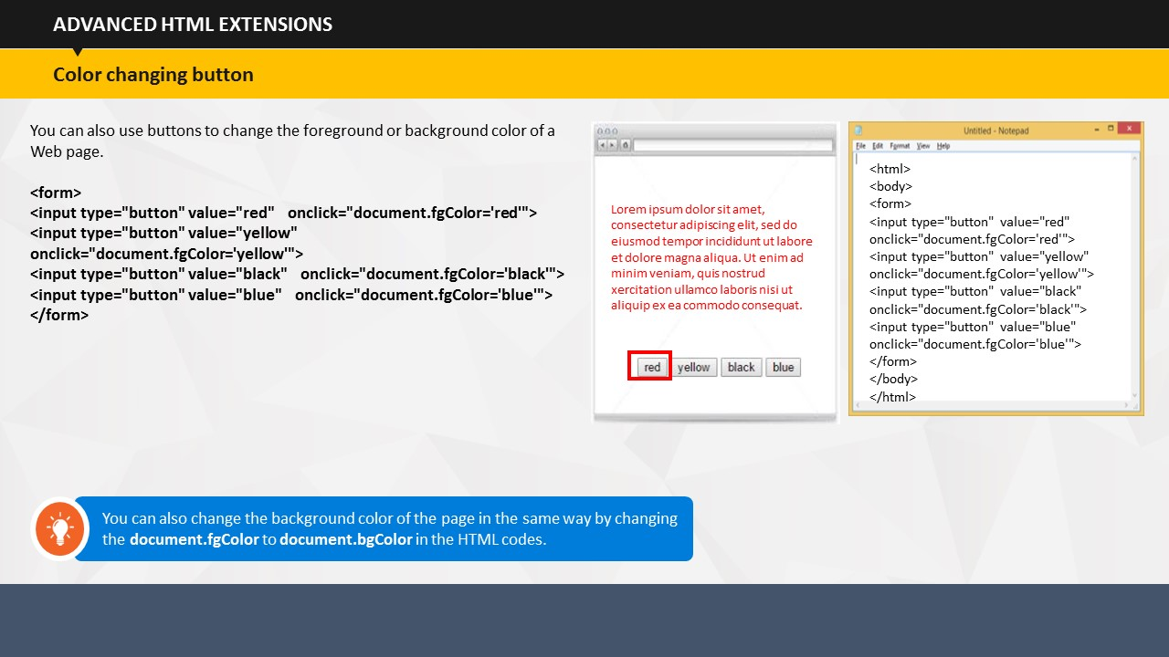

SUBTOPIC 4: COLOR CHANGING BUTTON

You can also change the foreground or background color of the page by using color changing buttons.

**Your Space:**

|  |
| --- |
|  |
|  |
|  |
|  |
|  |
|  |
|  |

## 

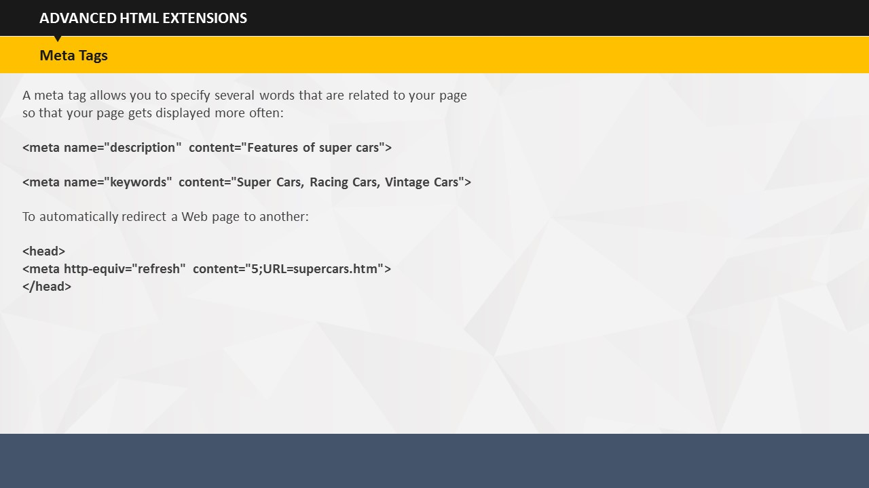

SUBTOPIC 5: META TAGS

During search engine indexing, instead of showing the first few words of your page which are often not important, you can set the description for your site by using <***meta>*** tags. You must place all ***<meta>*** tags between ***<head></head>*** at the top of the page and should include this description tag on every page. You can include several ***<meta>*** tags on each page.

***<Meta>*** tag allows you to specify several words that are related to your page. When someone enters these words into a suitable search engine, your page will have more chance of getting displayed.

On some Web sites, you may have noticed that after a few seconds, it automatically redirects you to another page. As shown in the example, the ***content*** attribute is the number of seconds that the browser waits before refreshing the page while the ***url*** attribute is the full URL of the page which you want to be loaded.

**Your Space:**

|  |
| --- |
|  |
|  |
|  |

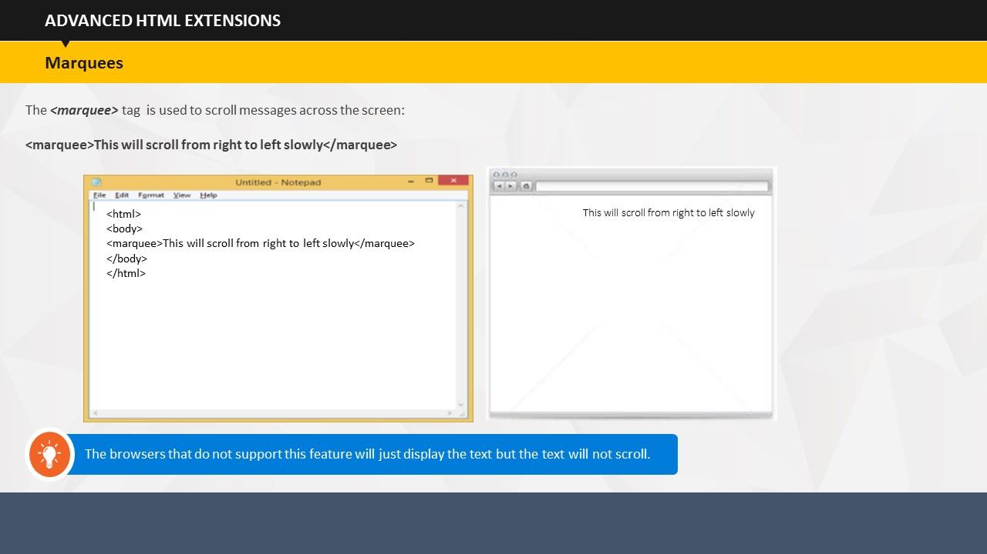

SUBTOPIC 6: MARQUEES

The ***<marquee>*** tag is similar to the ***<blink>*** tag which can be used to scroll or move messages across the screen. The manner in which the text scrolls or moves on the screen can be varied by changing the ***action*** attribute between the tags.

**Your Space:**

|  |  |
| --- | --- |
|  | |
|  | |
|  | |
|  | |
|  | |
|  |
|  |

# 

TOPIC 16 – FREQUENTLY ASKED QUESTIONS (FAQs)

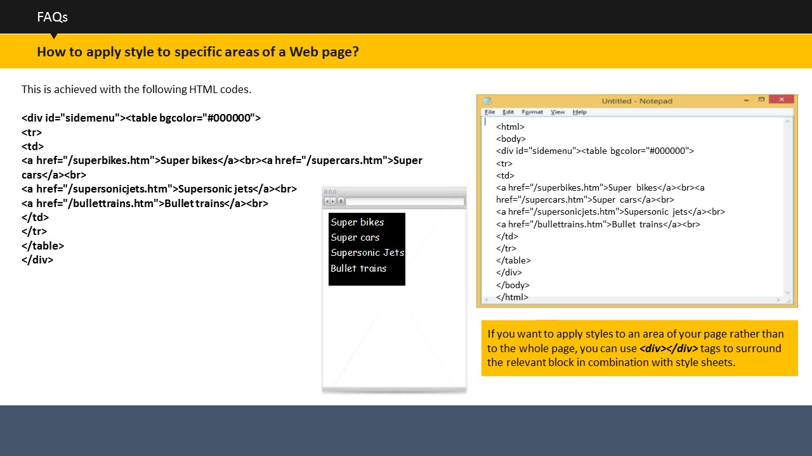

SUBTOPIC 1: HOW TO APPLY STYLE TO SPECIFIC AREAS OF A WEB PAGE?

If you want to apply styles to an area of your page rather than to the whole page, you can use ***<div></div>*** tags along with style sheets. To do this, you surround the related block with ***<div></div>*** tags and then reference these tags in the style sheet.

For example, you want to have some white links on a black background, and also want the links to be in a smaller Comic Sans MS font. However, you only want to apply this change to the links within a particular block. You want the rest of the links on the page to be in the default color. The example on the screen shows what the result looks like after applying the given HTML codes. During coding, the ***<div>*** is given the name 'sidemenu,' which means that it will apply to the side menu on the Web page.

**Your Space:**

|  |
| --- |
|  |
|  |
|  |
|  |
|  |
|  |
|  |

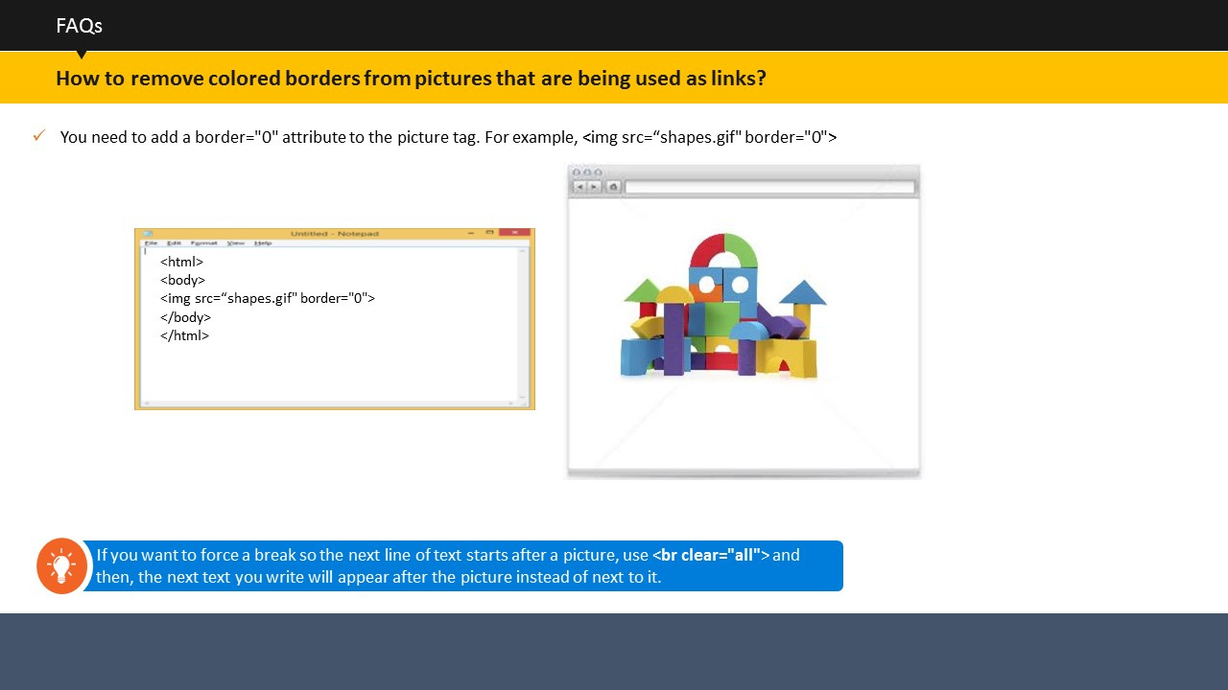

SUBTOPIC 2: HOW TO REMOVE COLORED BORDERS FROM PICTURES THAT ARE BEING USED AS LINKS?

If you wish, you can remove colored borders from pictures that are being used as links. To do so, you need to add a border="0" attribute to the picture tag. Also, if you want to force a break so the next line of text starts after a picture, you can use ***<br clear="all">*** and then, the next text you write will appear after the picture instead of appearing beside it.

**Your Space:**

|  |
| --- |
|  |
|  |
|  |
|  |
|  |

## 

SUBTOPIC 3: HOW TO ADD LINK TO A PAGE SO THE USER CAN DOWNLOAD YOUR FILES / SOFTWARE / ZIP FILES ETC.?

If you want to add link to a page so the user can download your files / software / zip files etc., all you have to do is simply upload it to your site as you would with any HTML or picture file. Next, include a normal link to it. For example, if your file is called superbikers.zip and the file size is 250Kb, then you would include the link as shown in the example on the screen.

Always compress any files that you upload. The files will be quicker for the user to download and all the files can be stored in a single compressed archive. Hence, even if your program consists of hundreds of files, the user only has to download only one.

Always include the size of the file in KB or Mb so that the person downloading the file knows how long it will take to download the file.

Always have an explanation of what the file does so that the user can see what the file will actually do before downloading it.

**Your Space:**

|  |
| --- |
|  |
|  |
|  |
|  |
|  |
|  |
|  |

|  |
| --- |
|  |

## 

SUBTOPIC 4: HOW TO ADD LINK FOR PEOPLE TO SEND YOU EMAIL?

To add email links, you need to use the ***mailto:*** attribute in an ***anchor*** tag. The basic usage is to simply include the email address.

The screen shows an example where the link creates an email with multiple recipients in the 'To:' line and also one recipient in each of the 'cc:' and 'bcc:' lines.

**Your Space:**

|  |
| --- |
|  |
|  |
|  |
|  |
|  |
|  |
|  |

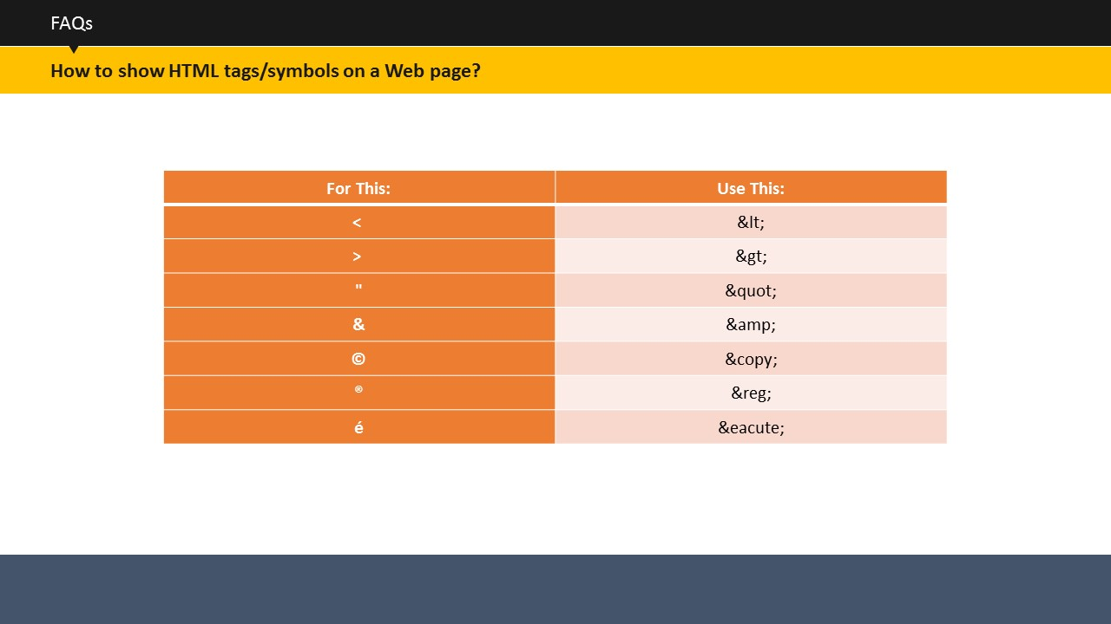

SUBTOPIC 5: HOW TO SHOW HTML TAGS/SYMBOLS ON A WEB PAGE?

If you want HTML tags to be displayed on your page such as <b>Bold</b> without the word being printed as Bold, then you need to substitute the HTML symbols for certain special codes as shown on the screen.

**Your Space:**

|  |
| --- |
|  |
|  |
|  |
|  |
|  |
|  |
|  |



SUBTOPIC 1: SESSION INTRODUCTION

TOPIC 17 – USING HTML5

**Project the ILT course**.

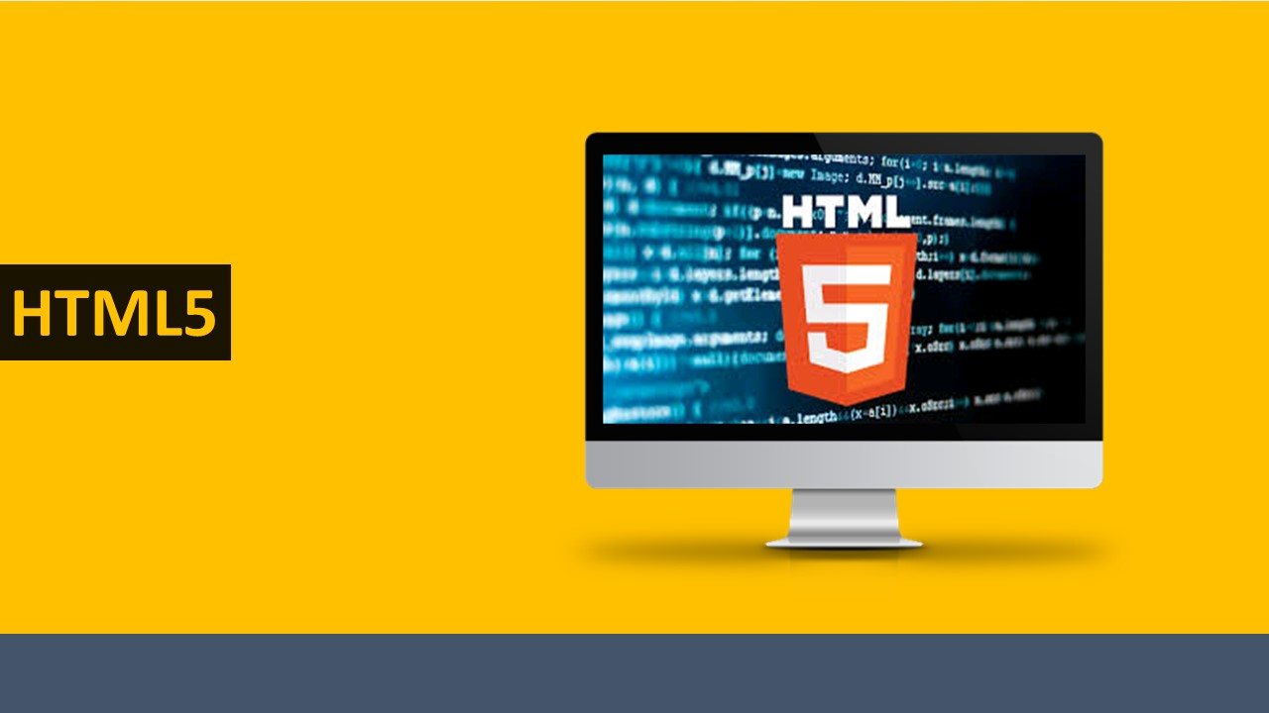

**Your Space:**

|  |
| --- |
|  |
|  |
|  |
|  |
|  |
|  |

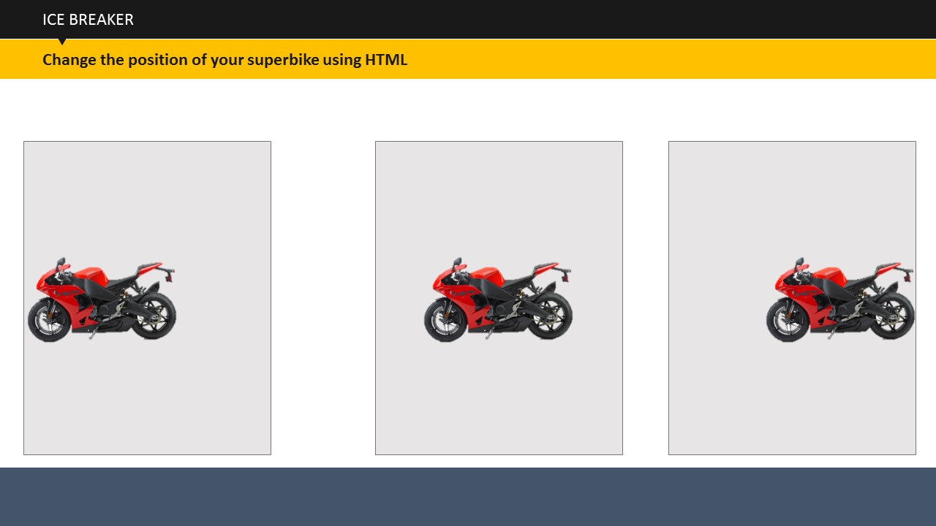

SUBTOPIC 2: ICE BREAKER

Write in your respective teams, the correct codes for changing the position of the superbikes. The team that finishes first with the correct answer, wins.

**Your Space:**

|  |
| --- |
|  |
|  |
|  |
|  |
|  |
|  |
|  |

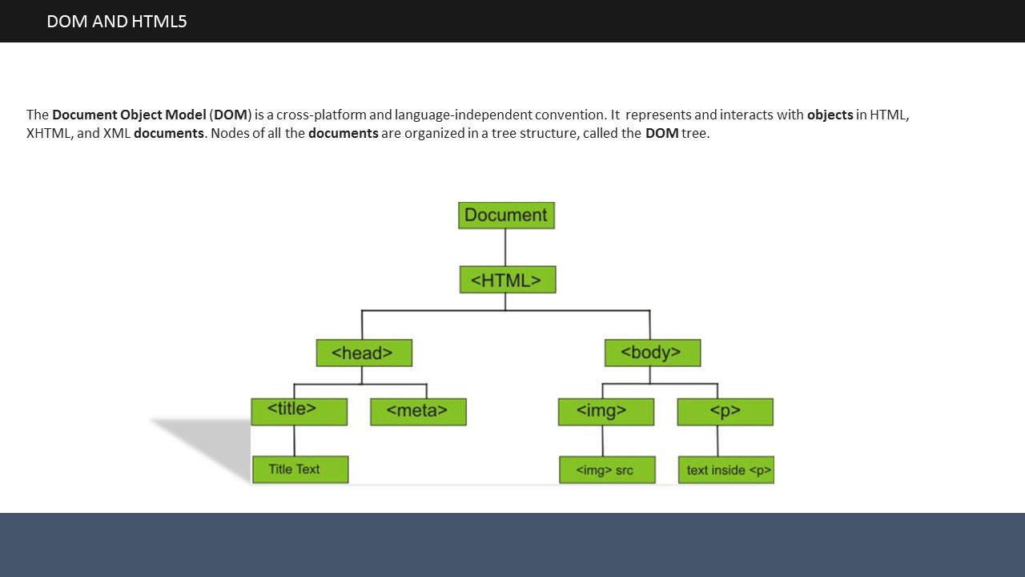

# 

Topic 18 – DOM AND HTML5

The Document Object Model (DOM) is a cross-platform and language-independent convention. It represents and interacts with objects in HTML, XHTML, and XML documents. Nodes of all the documents are organized in a tree structure, called the DOM tree.

**Your Space:**

|  |
| --- |
|  |
|  |
|  |
|  |
|  |
|  |

SUBTOPIC 1: WHAT IS A SEMANTIC ELEMENT?

TOPIC 19 – HTML 5 SEMANTIC ELEMENTS

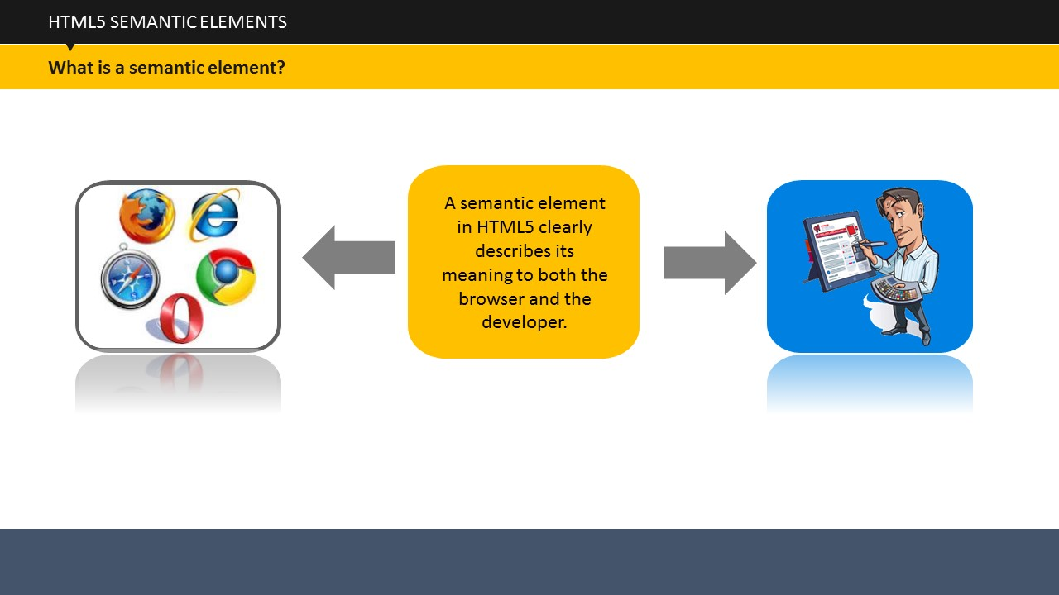

A semantic element describes its meaning to both the browser and the developer.

***<form>***, ***<table>***, and ***<img>*** are examples of semantic elements, which clearly define their content.

***<div>*** and ***<span>*** are examples of non semantic elements, which tell us nothing about their content.

For better document structure and layout, HTML5 offers several new semantic elements.

**Your Space:**

|  |
| --- |
|  |
|  |
|  |
|  |

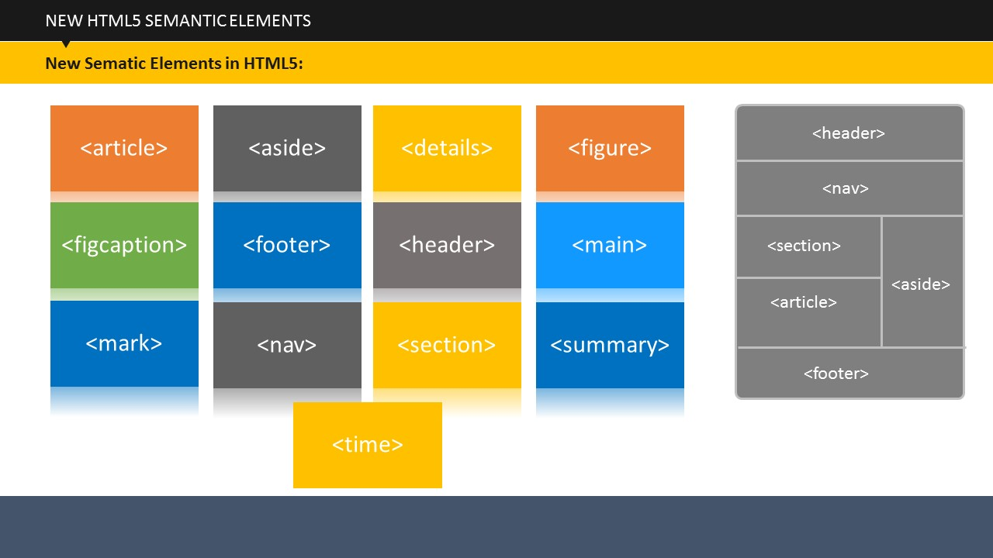

SUBTOPIC 2: NEW HTML5 SEMANTIC ELEMENTS

HTML5 offers new semantic elements to define different parts of a web page:

***<article>***: Defines an article in the document

***<aside>***: Defines content aside or separately placed from the page content

***<details>***: Defines additional details that the user can view or hide

***<figure>***: Defines content, such as illustrations, diagrams, photos, code listings, etc.

***<figcaption>***: Defines a caption for a ***<figure>*** element

***<footer>***: Defines a footer for the document or a section

***<header>***: Defines a header for the document or a section

***<main>***: Defines the main content of a document

***<mark>***: Defines marked or highlighted text

***<nav>***: Defines navigation links in the document

***<section>***: Defines a particular section in the document

***<summary>***: Defines a visible heading for a ***<details>*** element

***<time>***: Defines a date or time

**Your Space:**

|  |
| --- |
|  |
|  |
|  |
|  |
|  |
|  |

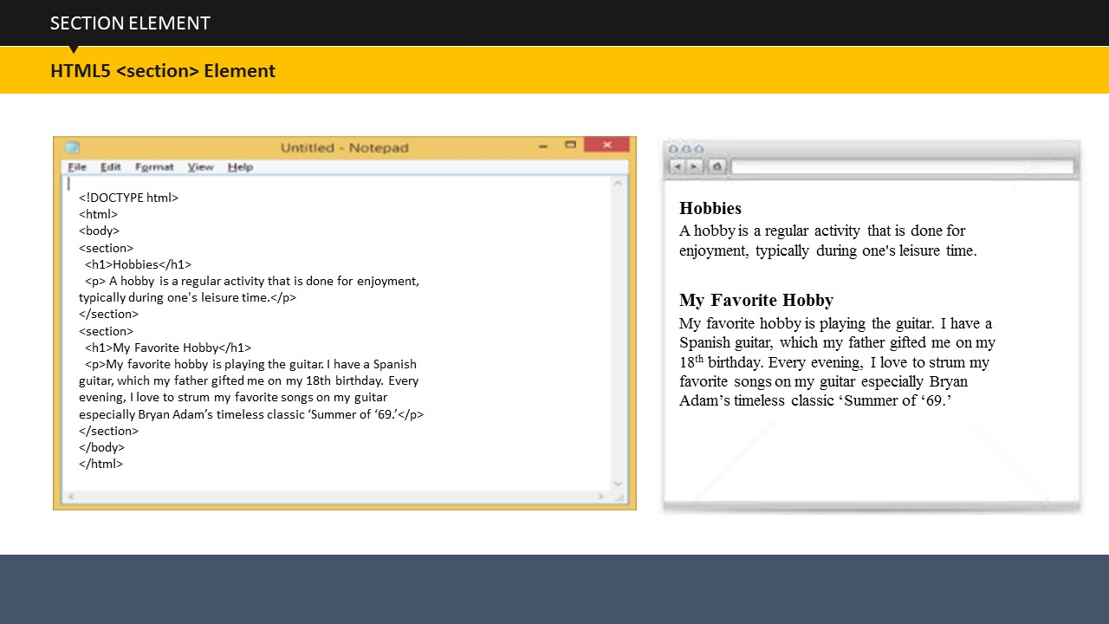

SUBTOPIC 3: SECTION ELEMENT

As stated earlier, the ***<section>*** element defines a particular section in a document. A section is the grouping of content, usually with a heading. A Web site's home page could be divided into sections for introduction, content, and contact information.

**Your Space:**

|  |
| --- |
|  |
|  |
|  |
|  |
|  |
|  |

SUBTOPIC 4: ARTICLE ELEMENT

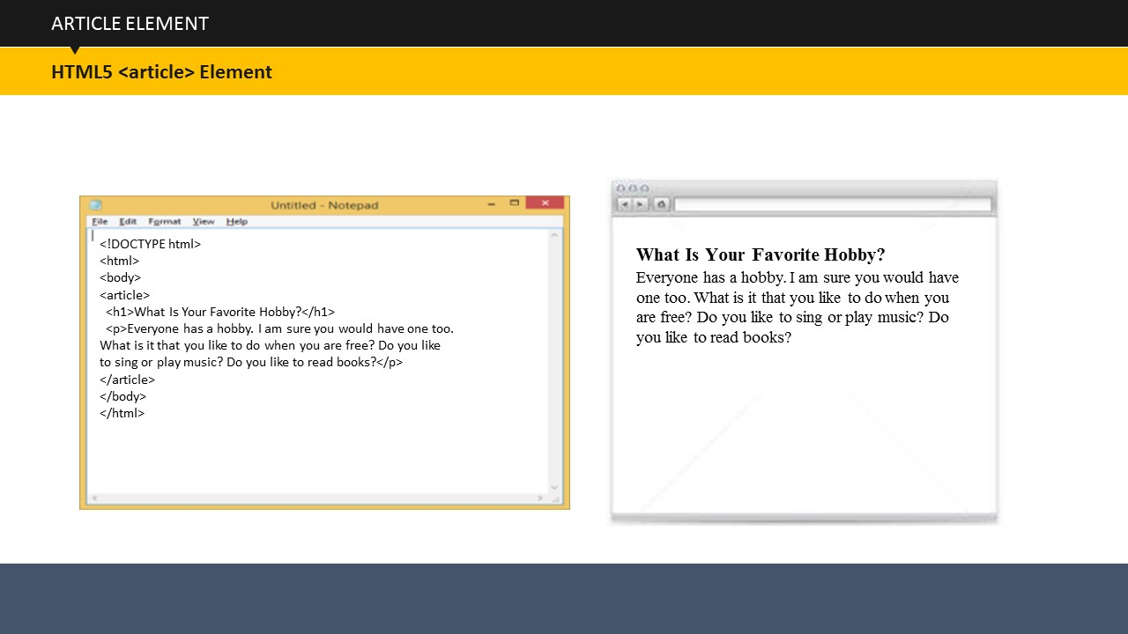

The ***<article>*** element specifies independent, self-contained content. An article is complete and meaningful on its own, and can be read independently from the rest of the Web site. The ***<article>*** element can be used in Blogs, Discussion Forums, and Newspaper Articles on the Web sites.

**Your Space:**

|  |
| --- |
|  |
|  |
|  |
|  |
|  |
|  |

SUBTOPIC 5: NESTING ARTICLE AND SECTION ELEMENTS

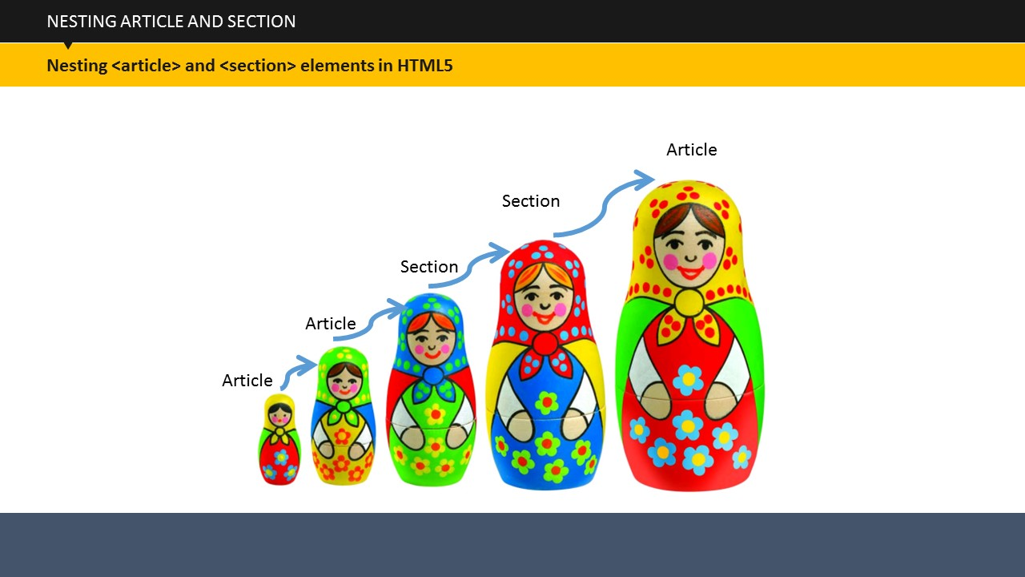

In HTML5, the ***<article>*** element defines a complete, meaningful chunk of related elements while the ***<section>*** element is defined as a chunk of related elements. For example, in a newspaper, the research **articles** in the science **section** have a technical papers **section** in each **article**.

**Your Space:**

|  |
| --- |
|  |
|  |
|  |
|  |
|  |
|  |

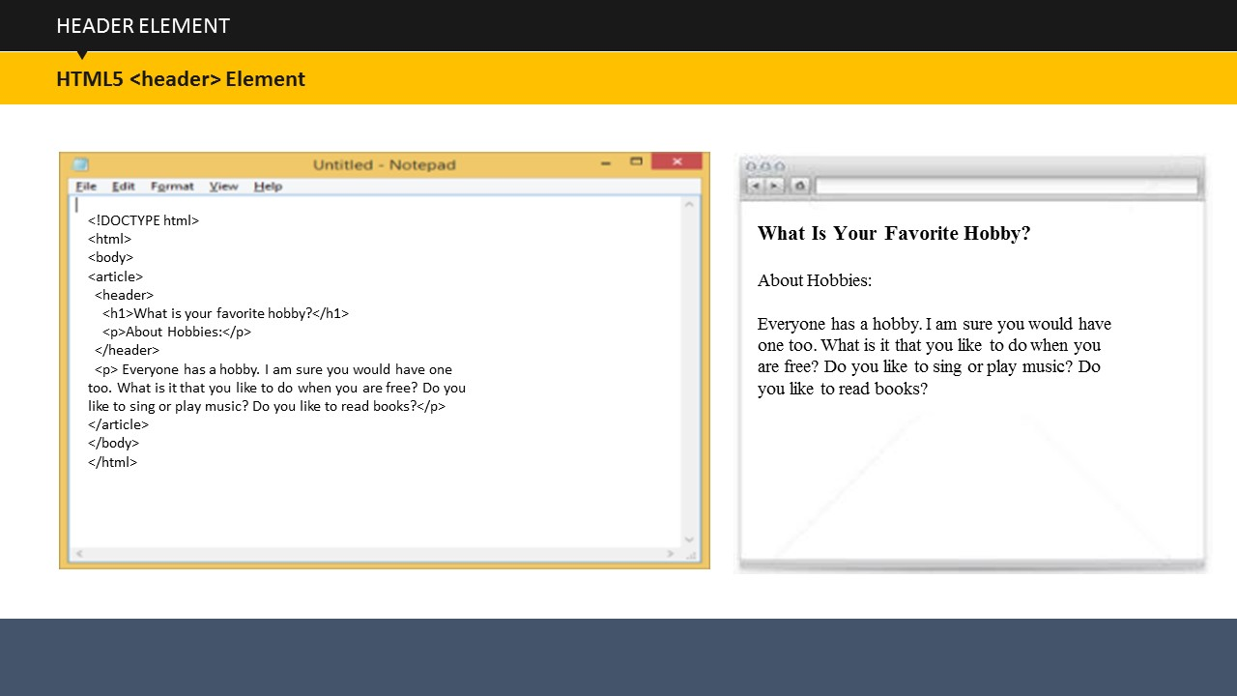

SUBTOPIC 6: HEADER ELEMENT

The ***<header>*** element defines header for a document or section. The ***<header>*** element can be used as a holder for introductory content. You can have several ***<header>*** elements in a single document.

**Your Space:**

|  |
| --- |
|  |
|  |
|  |
|  |
|  |

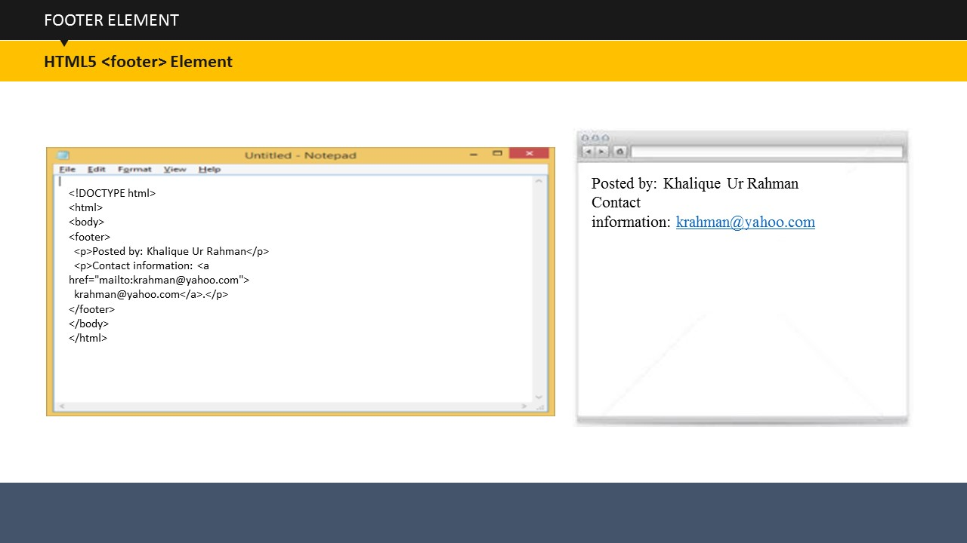

SUBTOPIC 7: FOOTER ELEMENT

The ***<footer>*** element defines footer for a document or section. A ***<footer>*** element contains information about its containing element. A footer usually contains copyright information, terms of use links, contact or author information, etc. You can have several ***<footer>*** elements in a single document.

**Your Space:**

|  |
| --- |
|  |
|  |
|  |
|  |
|  |

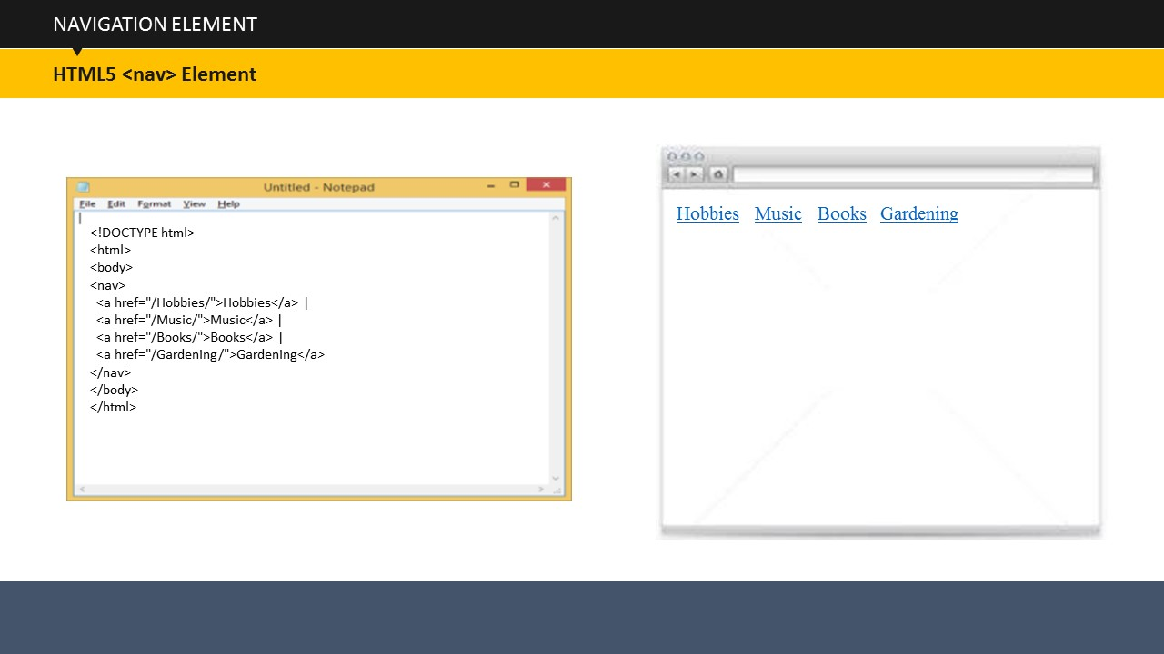

The ***<nav>*** element specifies a group of navigation links. The ***<nav>*** element is used for large chunks of navigation links. All links in a document should not be inside a ***<nav>*** element.

SUBTOPIC 8: NAVIGATION ELEMENT

**Your Space:**

|  |
| --- |
|  |
|  |
|  |
|  |
|  |

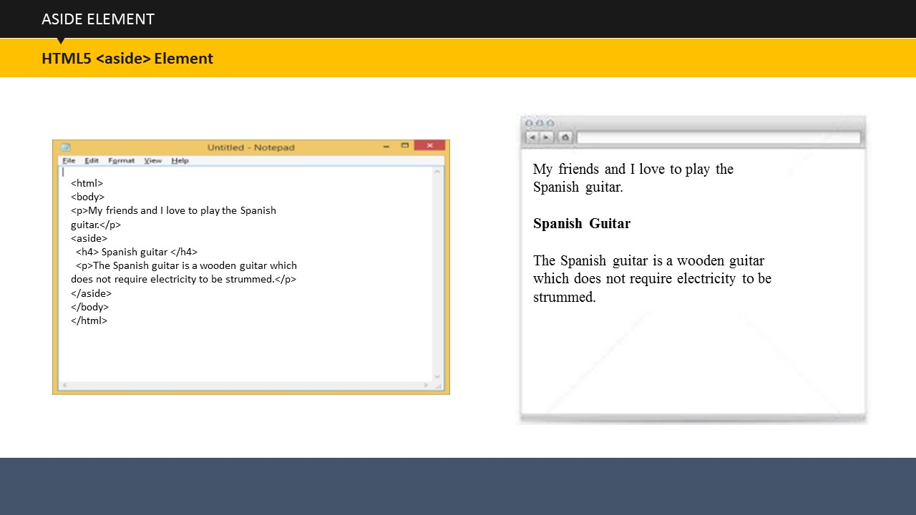

The ***<aside>*** element specifies some content away from the content it is placed within (similar to a sidebar). You need to ensure that the aside content is related to the content around it.

SUBTOPIC 9: ASIDE ELEMENT

**Your Space:**

|  |
| --- |
|  |
|  |
|  |
|  |
|  |

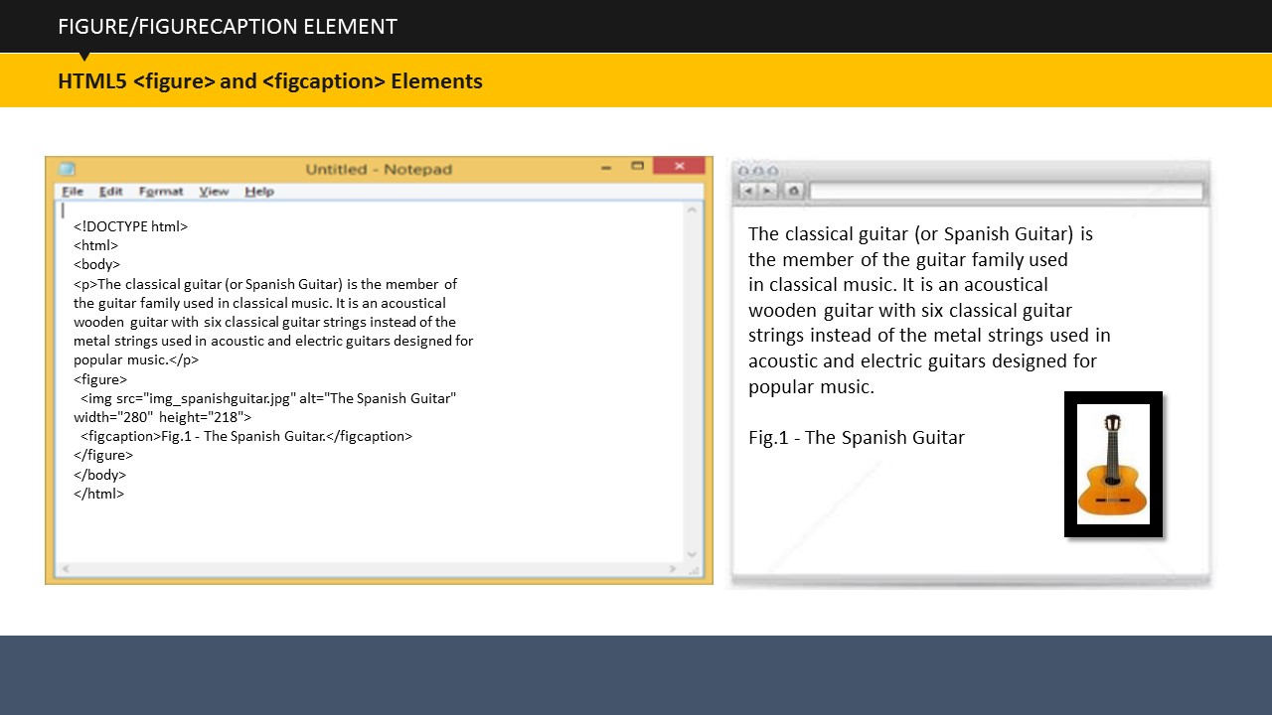

SUBTOPIC 10: FIGURE AND FIGURECAPTION ELEMENTS

It is common to see captions with images in books and newspapers. The caption is used to add a visual explanation to an image. With HTML5, images and captions can be grouped together using ***<figure>*** elements. Here, the ***<img>*** element defines the image and the ***<figcaption>*** element defines the caption of that image.

**Your Space:**

|  |
| --- |
|  |
|  |
|  |
|  |

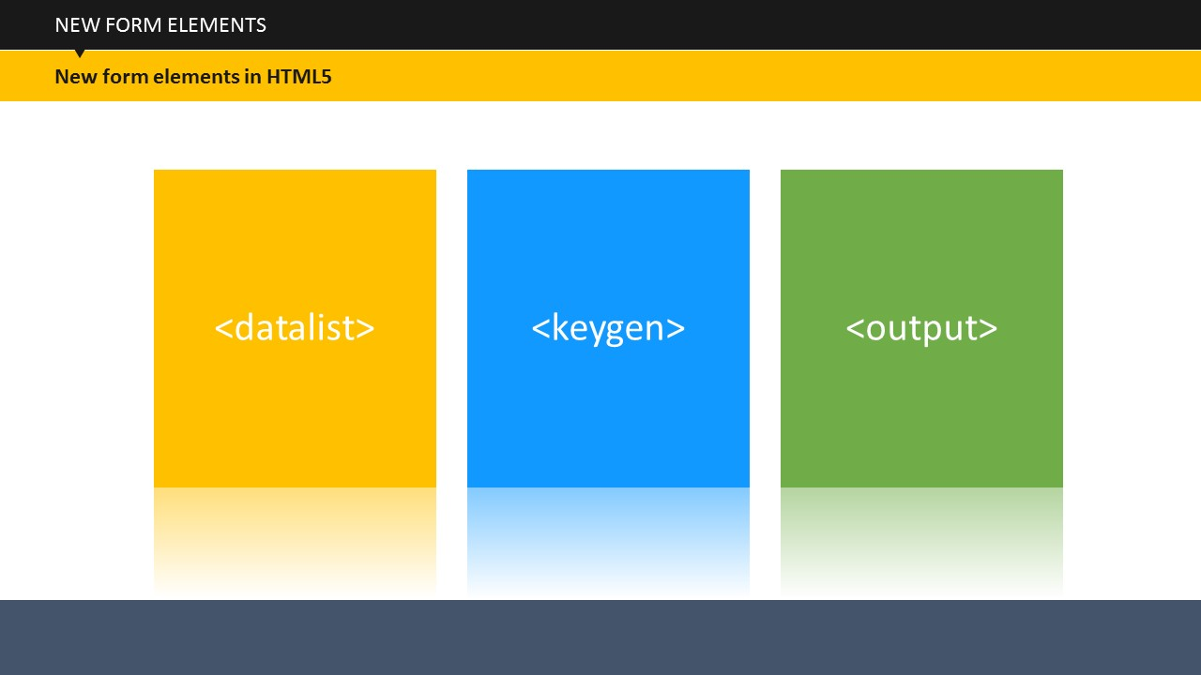

TOPIC 20 – HTML FORM ELEMENTS

***<datalist>***, ***<keygen>***, and ***<output>*** are the new form elements in HTML5. ***<datalist>*** defines pre-defined options for input controls; ***<keygen>*** defines a key-pair generator field (for forms); and ***<output>*** defines the result of a calculation. Let us now look at each element in detail.

**Your Space:**

|  |
| --- |
|  |
|  |
|  |

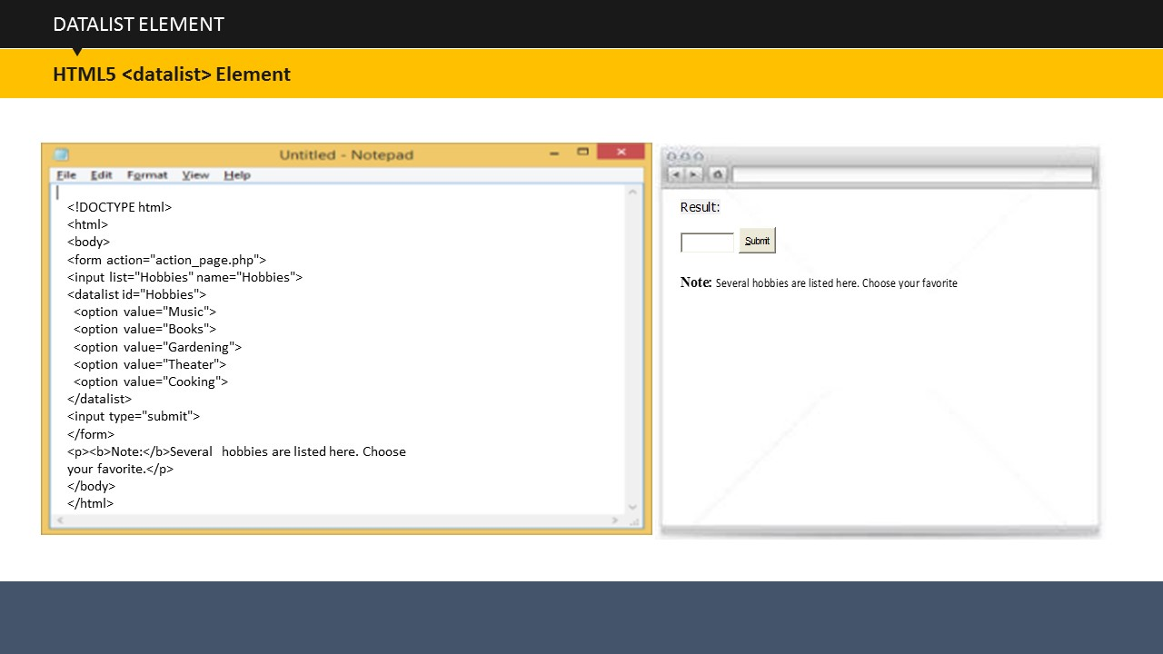

**Datalist Element**

The ***<datalist>*** element in a form defines a list of pre-defined options for an ***<input>*** element. When this element is added, users are able to view a drop-down list of pre-defined options as they input any data in the form. Always remember that the ***list*** attribute of the ***<input>*** element should refer to the ***id*** attribute of the ***<datalist>*** element.

**Your Space:**

|  |
| --- |
|  |
|  |
|  |
|  |
|  |
|  |

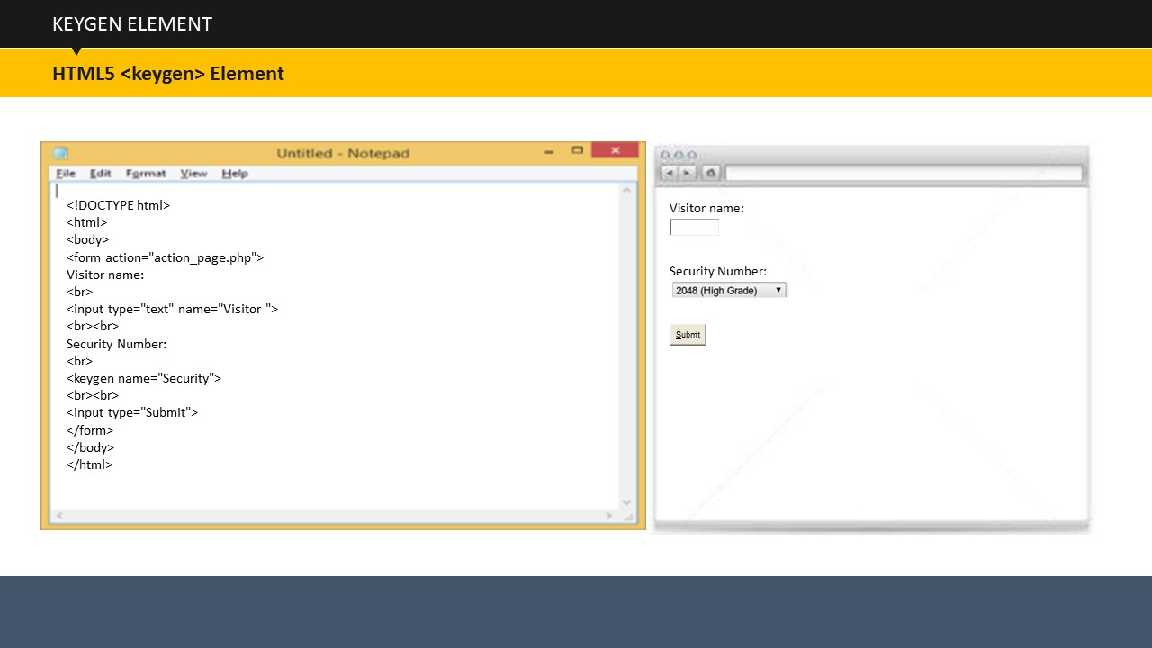

**Keygen Element**

The ***<keygen>*** element is used to provide a safe and secure way to authenticate users filling a form. The ***<keygen>*** element specifies a key-pair generator field in a form. When the form is submitted, two keys are generated, one private and one public. The private key is stored locally, and the public key is sent to the server. The public key could be used to generate a client certificate to authenticate the user in the future.

**Your Space:**

|  |
| --- |
|  |
|  |
|  |
|  |
|  |

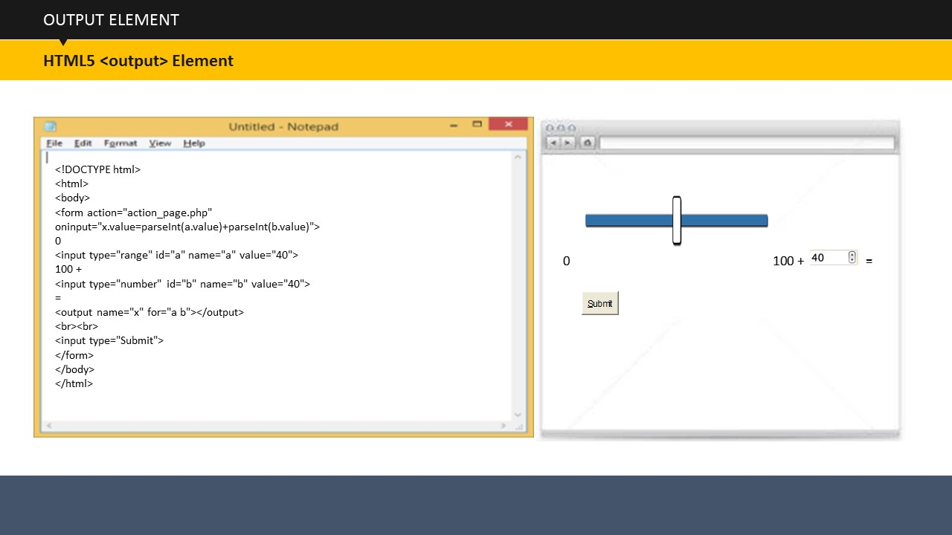

**Output Element**

The ***<output>*** element specifies the result of a calculation. In this example, a calculation is performed and the result is shown in an ***<output>*** element.

**Your Space:**

|  |
| --- |
|  |
|  |
|  |
|  |
|  |

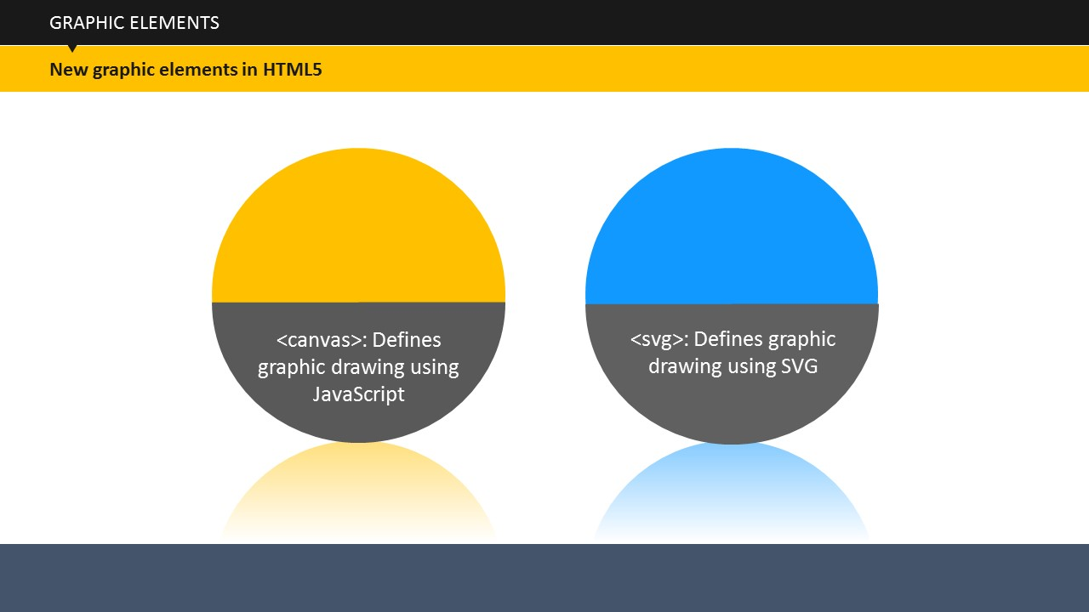

TOPIC 21 – HTML5 GRAPHIC ELEMENTS

SUBTOPIC 1: NEW HTML5 GRAPHIC ELEMENTS

***<canvas>*** and ***<svg>*** are the two new graphic elements in HTML5. ***<canvas>*** defines graphic drawing using JavaScript while ***<svg>*** defines graphic drawing using Scalable Vector Graphics. SVG is actually an image format for 2D graphics with interactivity and animation support.

**Your Space:**

|  |
| --- |
|  |
|  |
|  |
|  |
|  |

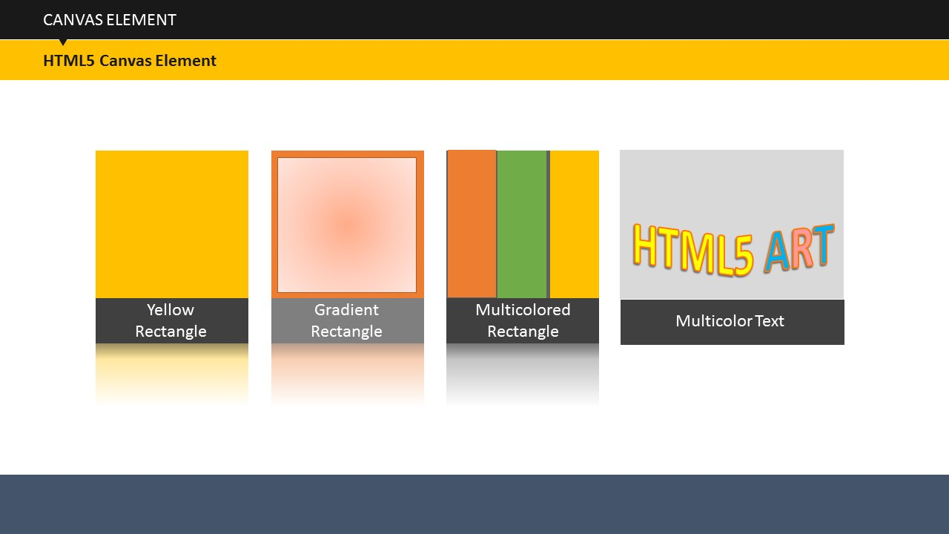

SUBTOPIC 2: CANVAS ELEMENT

The HTML5 ***<canvas>*** element is used to draw graphics on a web page. The graphic on the screen is created with ***<canvas>***. It shows four elements: a yellow rectangle, a gradient rectangle, a multicolor rectangle, and a multicolor text. The HTML5 ***<canvas>*** element is used to draw graphics via scripting. The ***<canvas>*** element is only a holder for graphics. Actually, the graphics are drawn using a script such as JavaScript. We will learn about JavaScript later. The ***<canvas>*** element can use several methods for drawing circles, boxes, paths, text, and adding other images.

**CANVAS ELEMENT EXAMPLE**

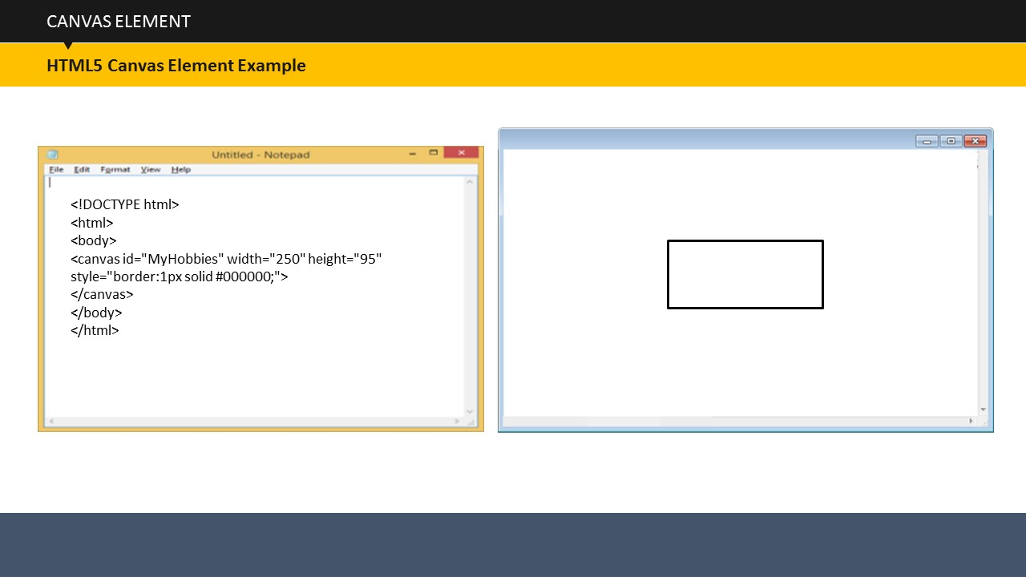

A canvas is a rectangular area on an HTML page. By default, a canvas has no border and no content.

Always specify ***id***, ***width****,* and ***height*** attributes to define the size of the canvas. You can use the ***style*** attribute to add a border.

**Your Space:**

|  |
| --- |
|  |
|  |
|  |
|  |
|  |

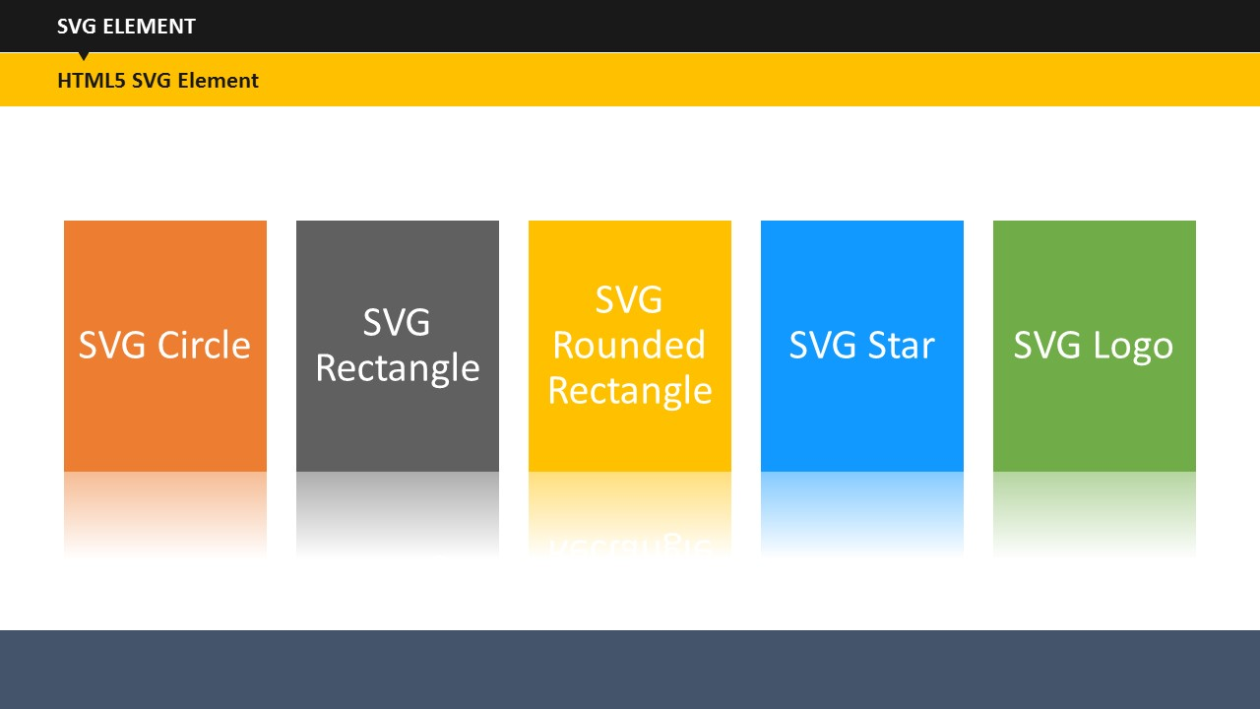

SUBTOPIC 3: SVG ELEMENT

The ***<svg>*** element, which is introduced in HTML5, is a holder for SVG graphics. Similar to the ***<canvas>*** element, SVG too has several methods for drawing circles, boxes, paths, text, and other graphic images. Let us now look at some SVG graphics examples.

**Your Space:**

|  |
| --- |
|  |
|  |
|  |
|  |
|  |

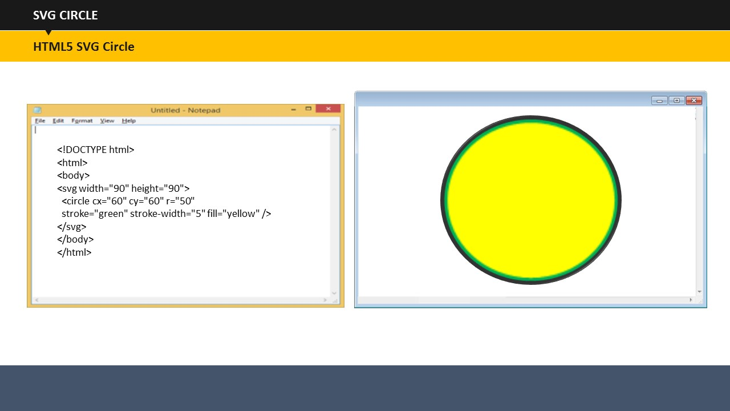

SUBTOPIC 4: SVG CIRCLE

**Your Space:**

|  |
| --- |
|  |
|  |
|  |
|  |

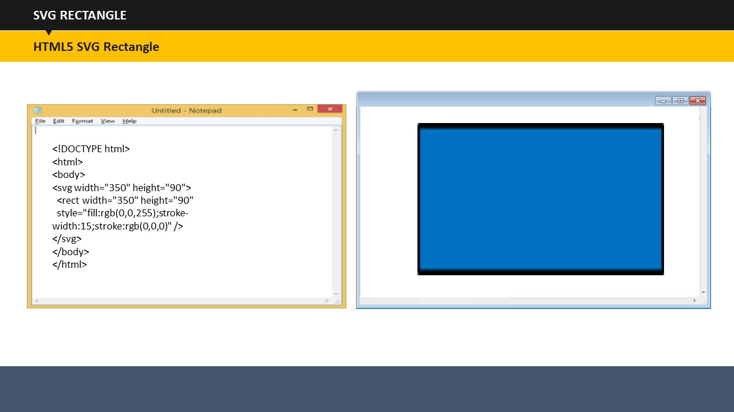

SUBTOPIC 5: SVG RECTANGLE

**Your Space:**

|  |
| --- |
|  |
|  |
|  |
|  |

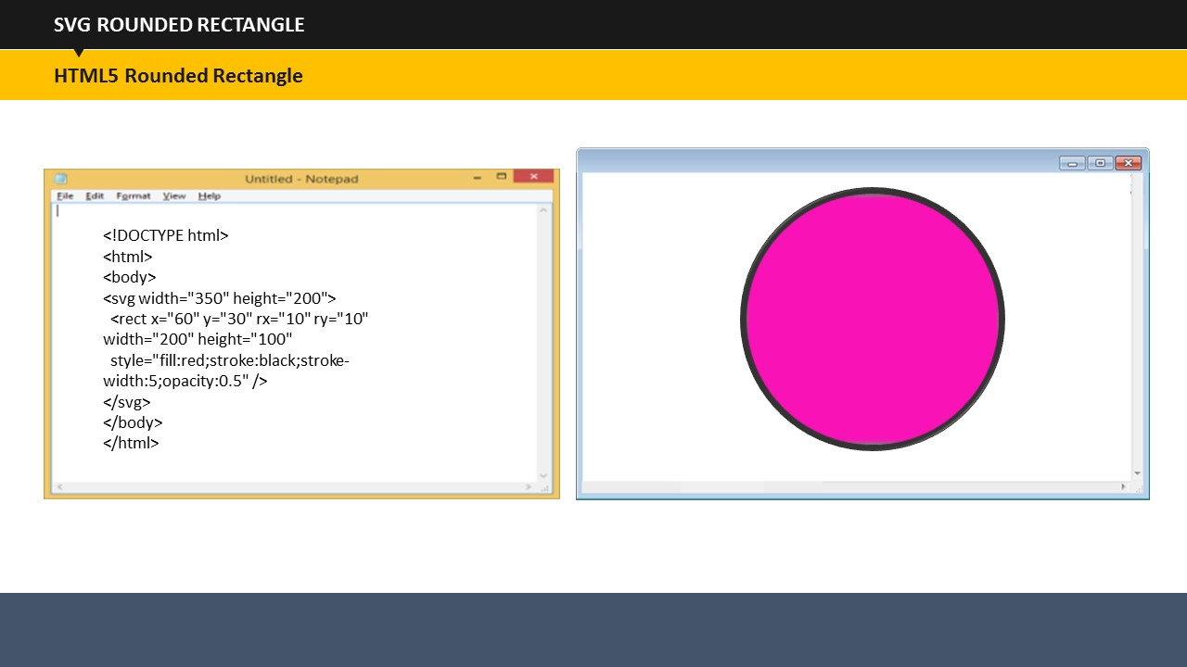

SUBTOPIC 6: SVG ROUNDED RECTANGLE

**Your Space:**

|  |
| --- |
|  |
|  |
|  |
|  |
|  |

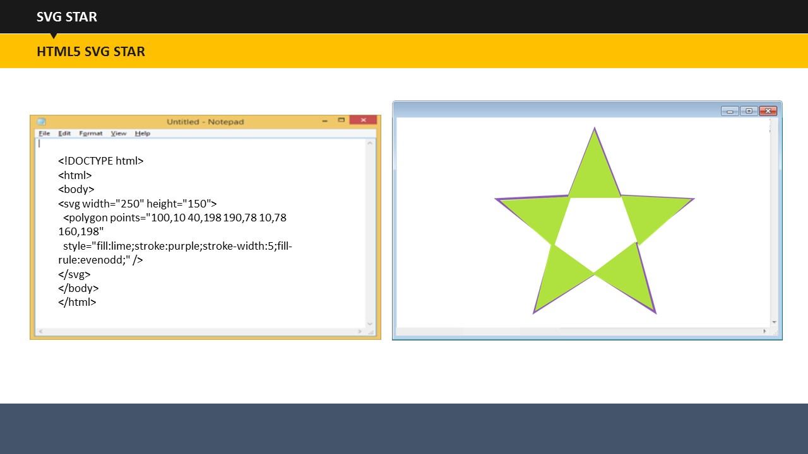

SUBTOPIC 7: SVG STAR

**Your Space:**

|  |
| --- |
|  |
|  |
|  |
|  |
|  |

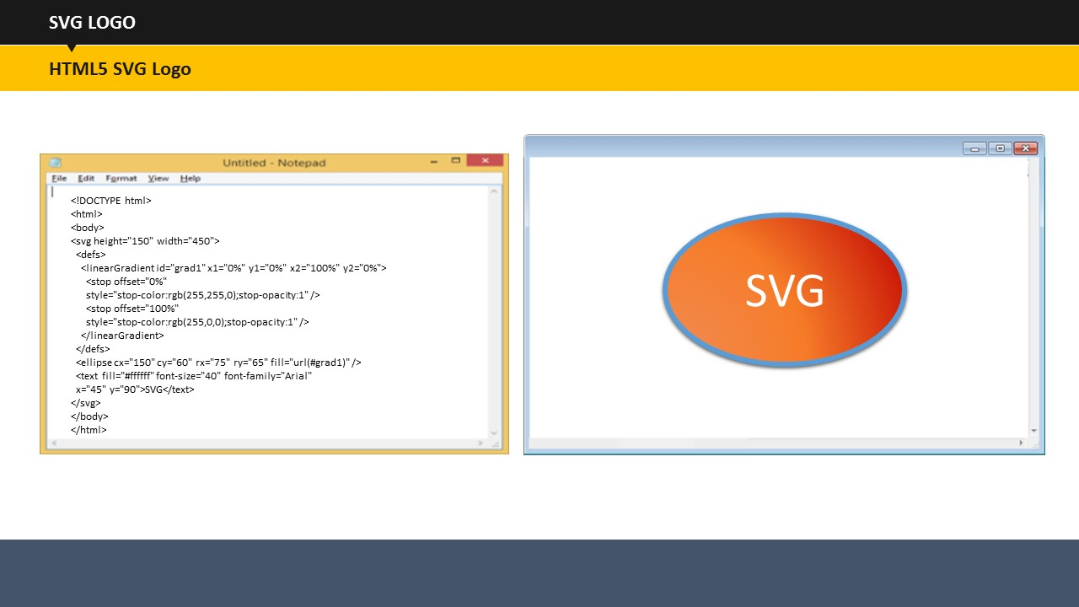

SUBTOPIC 8: SVG LOGO

**Your Space:**

|  |
| --- |
|  |
|  |
|  |

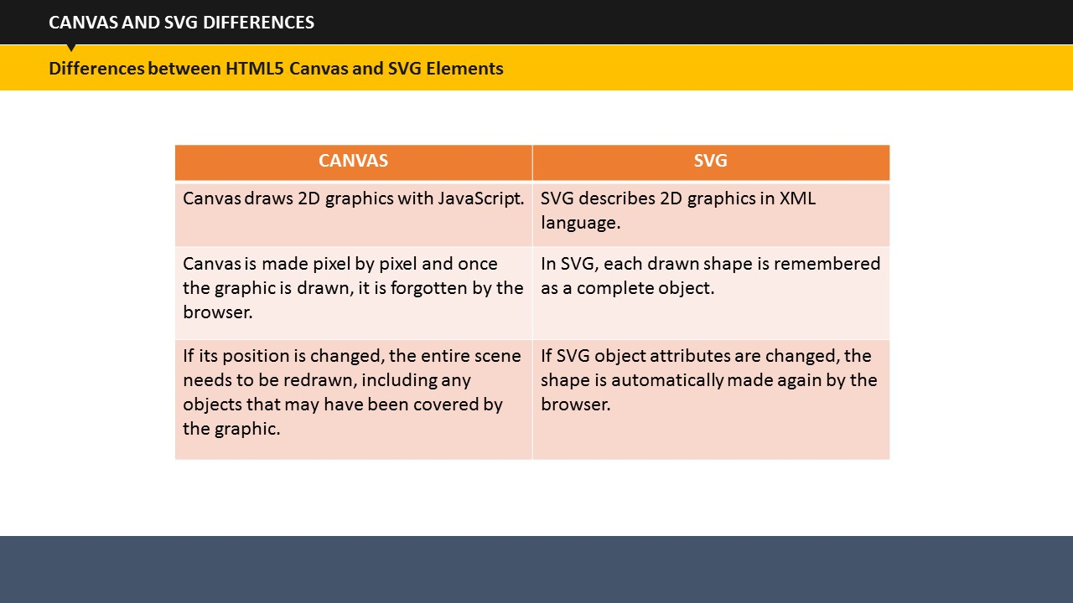

Let us now compare the HTML5 Canvas and SVG graphic elements.

SUBTOPIC 9: DIFFERENCES BETWEEN HTML5 CANVAS AND SVG ELEMENTS

Canvas draws 2D graphics with JavaScript.

Canvas is made pixel by pixel and once the graphic is drawn, it is forgotten by the browser.

If its position is changed, the entire scene needs to be redrawn, including any objects that may have been covered by the graphic.

SVG describes 2D graphics in XML language.

In SVG, each drawn shape is remembered as a complete object.

If SVG object attributes are changed, the shape is automatically made again by the browser.

**Your Space:**

|  |
| --- |
|  |
|  |
|  |

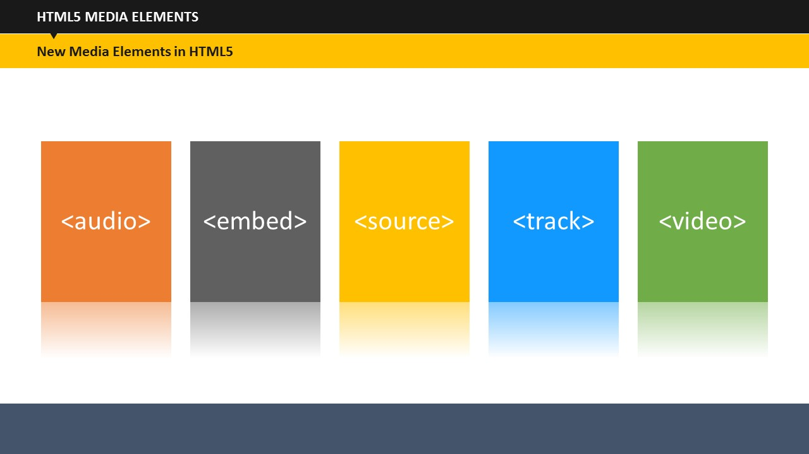The new HTML5 media elements are displayed on the screen.

SUBTOPIC 1: NEW HTML5 MEDIA ELEMENTS

TOPIC 22 – HTML5 MEDIA ELEMENTS

***<audio>*** defines sound or music content.

***<embed>*** defines holders for external applications, such as plug-ins.

***<source>*** defines several media resources for media elements, such as ***<video>*** and ***<audio>****.* Multiple ***<source>*** elements can link to different files. However, the browser uses the first recognized format.

***<track>*** defines text tracks in media players with ***<video>*** and ***<audio>*** elements.

***<video>*** defines video or movie content.

**Your Space:**

|  |
| --- |
|  |
|  |
|  |
|  |

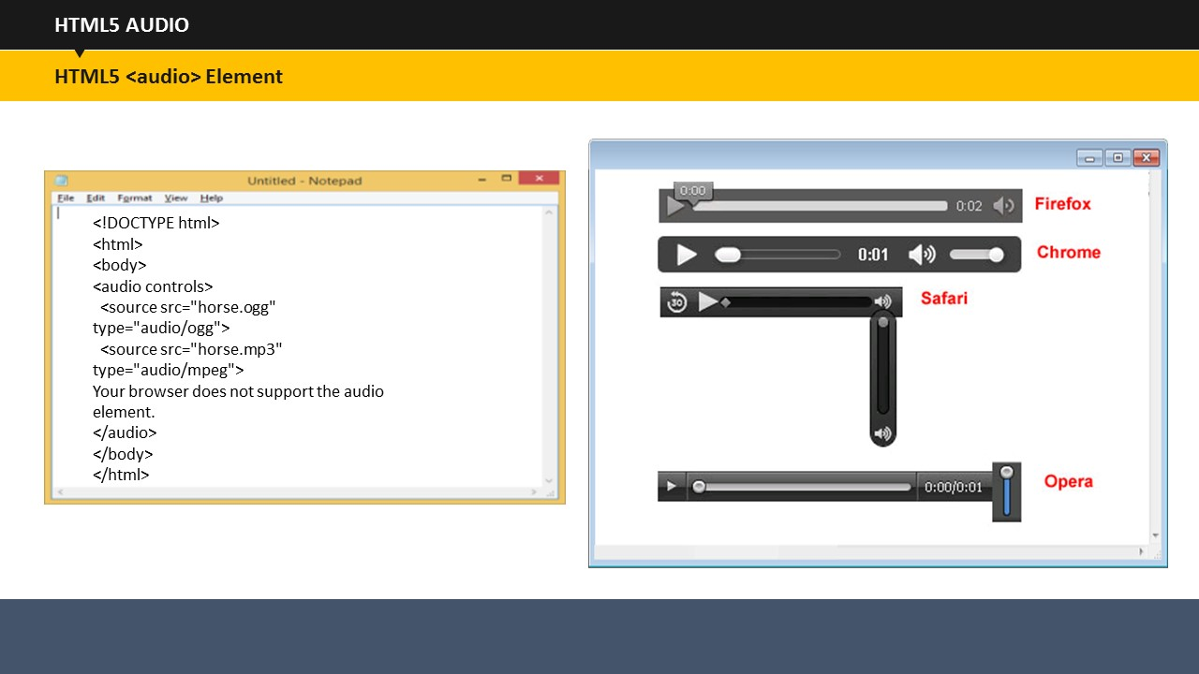

SUBTOPIC 2: AUDIO ELEMENT

HTML5 provides a standard for embedding and playing audio files in a Web page. Before HTML5, there was no standard for playing audio files on a Web page. Audio files could only be played with a plug-in, such as flash.

The ***controls*** attribute within the ***<audio>*** element adds audio controls, such as play, pause, and volume.

Browsers that do not support the ***<audio>*** element simply display the text between the ***<audio></audio>*** tags.

Currently, MP3, Wav, and Ogg are the three file formats of the ***<audio>*** element that are supported by Web browsers. Chrome, Firefox and Opera support all the three file formats; Safari supports MP3 and Wav formats; and IE supports only MP3.

**Your Space:**

|  |
| --- |
|  |
|  |
|  |
|  |

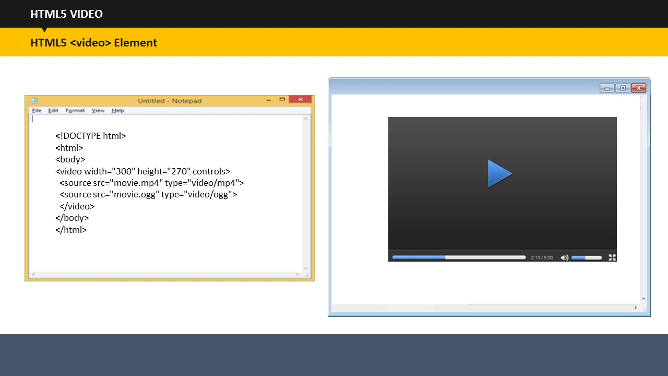

SUBTOPIC 3: VIDEO ELEMENT

In HTML5, you can use the ***<video>*** element to show a video on a Web page. Before HTML5, there was no standard for showing videos on a Web page and videos could only be played with a plug-in, such as flash. The HTML5 ***<video>*** element defines a standard to embed a video in a web page.

The ***controls*** attribute adds video controls, such as play, pause, and volume. It always helps to include ***width*** and ***height*** attributes too because if you do not set the height and width, the browser does not know the size of the video holder. And as a result, the page changes or flickers while the video loads.

As with the ***<audio>*** element, browsers that do not support the ***<video>*** element simply display the text between the ***<video></video>*** tags.

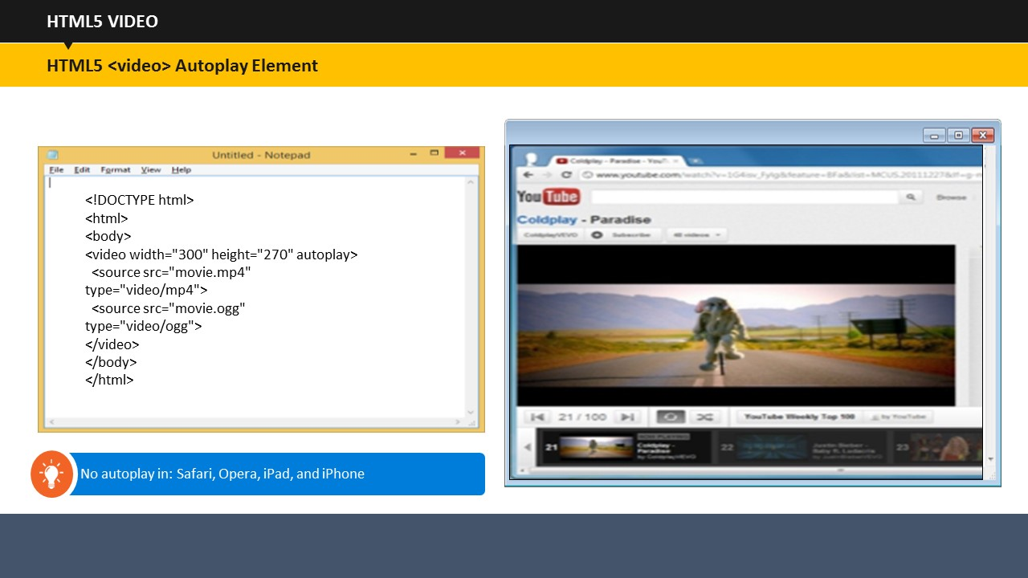**VIDEO AUTOPLAY ELEMENT**

To start a video automatically, you can use the ***autoplay*** attribute with the ***<video>*** element. The ***autoplay*** attribute does not work in Web browsers such as Safari and Opera. It also does not work on mobile devices, such as iPad and iPhone.

Currently, MP4, WebM, and Ogg are the three file formats of the ***<video>*** element that are supported by Web browsers. Chrome, Firefox and Opera support all the three file formats while IE and Safari only support MP4.

**Your Space:**

|  |
| --- |
|  |
|  |
|  |
|  |
|  |

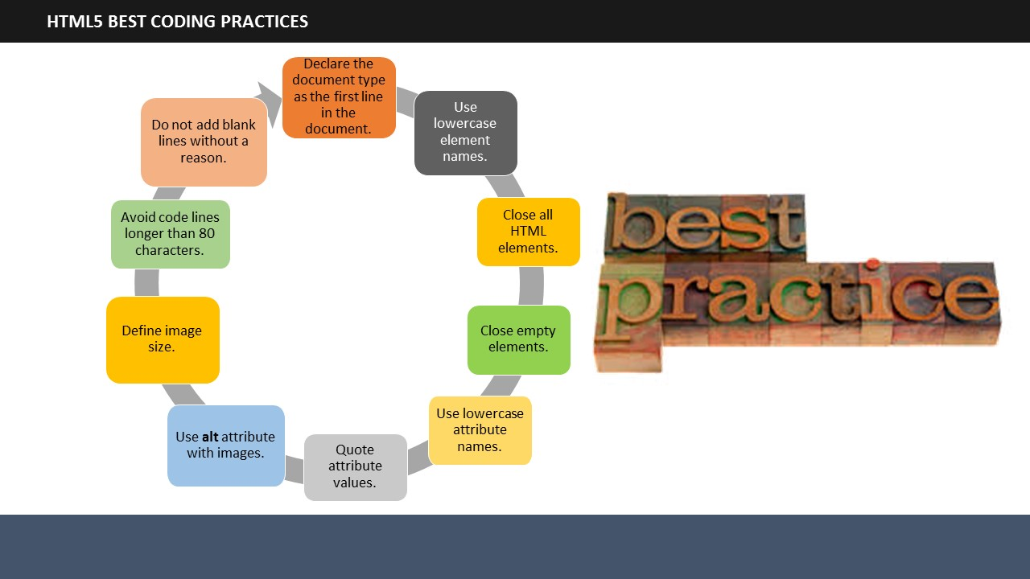

SUBTOPIC 1: BEST CODING RULES OF HTML5

TOPIC 23 – HTML5 BEST CODING PRACTICES

Some of the best coding practices or rules that you need to follow while using HTML5 are outlined here.

1. Always keep your coding style smart, clean, and well-structured.
2. Always declare the document type as the first line in your document.
3. Although HTML5 allows mixing uppercase and lowercase letters in element names, you should ideally use lowercase element names.
4. Although you don't have to close all elements (for example the <p> element) in HTML5, it is recommended that you close all HTML elements.
5. In HTML5, it is optional to close empty elements. However, it is a good idea to close empty elements too.
6. Although HTML5 allows mixing uppercase and lowercase letters in attribute names, you should ideally use lowercase attribute names.
7. Even though HTML5 allows attribute values without quotes. However, it is recommended that you quote attribute values.
8. You should always use the ***alt*** attribute with images. It is extremely important when the image cannot be viewed by the users.
9. Always define image size. This reduces flickering because the browser already reserves space for images before they are loaded.
10. Avoid creating code lines that use more than 80 characters.

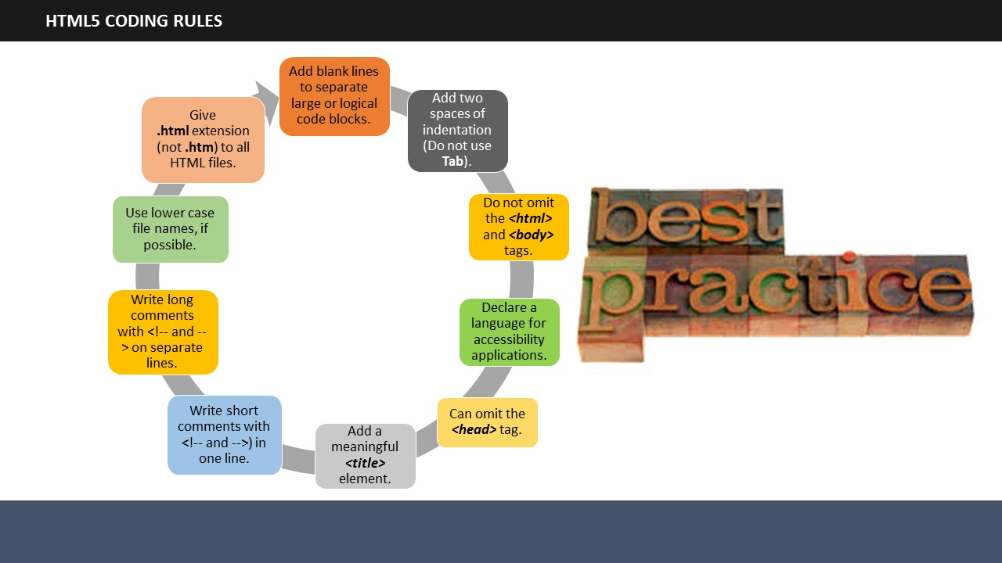

Do not add blank lines without a reason. Add blank lines to separate large or logical code chunks and add 2 spaces of indentation. Do not use Tab.

While using HTML5, the ***<html>*** and ***<body>*** tags can be omitted. However, omitting the ***<html>*** and ***<body>*** tags is not recommended.

It is important to declare a language for accessibility applications or screen readers as well as search engines.

In HTML5, the ***<head>*** tag can also be omitted. By default, browsers will add all elements before ***<body>***, to a default ***<head>*** element.

The ***<title>*** element is required in HTML5. You should make the title as meaningful as possible.

Short comments should be written in one line, with a space after <!-- and a space before --> Long comments, which include many lines, should be written with <!-- and --> on separate lines.

If possible, always use lower case file names.

HTML files should have ***.html*** as extension and not ***.htm***.

**Your Space:**

|  |
| --- |
|  |
|  |
|  |
|  |
|  |

|  |
| --- |
|  |

**Objectives Mapping Activity:**

**Duration:** 5 Minutes

You can refer to the checklist given here to map the objectives outlined at the beginning of the session with the learnings from this session. This will help you analyze whether the learning objectives have actually been met or not.

* What is Hypertext Markup Language or HTML5?
* Birth and growth of HTML.
* Important HTML components, such as tags, elements, and nesting.
* The steps that you need to perform to view HTML on the Web.
* Finally, the rules of HTML writing or coding, so that you will be able to create a simple Web page using HTML codes.

**Your Space:**

|  |
| --- |
|  |
|  |
|  |
|  |

# 

TOPIC 24 – MODULE SUMMARY

SUBTOPIC 1: RECAP

 **Duration:** 10 Minutes

It’s time to review what we have learned so far. Write in the space given in this guide, what you have learned today.

**Your Space:**

|  |
| --- |
|  |
|  |
|  |
|  |
|  |
|  |
|  |
|  |
|  |
|  |
|  |
|  |
|  |
|  |
|  |
|  |
|  |
|  |
|  |
|  |



SUBTOPIC 2: FINAL TIPS AND SUMMARIZATION

This is the end of this session on HTML. The next session will be on ‘CSS’, in which we will explain how to design your webpage.

**Your Space:**

|  |
| --- |
|  |
|  |
|  |
|  |



**ITES Functional Skills Training**

# LAB EXERCISES



* You may want to bring your Facilitator Guide to labs to refer to the content and examples.
* If the participants have a question, tell them that they can ask you for help, or look at their Participant Guide or lecture slides.
* Encourage the participants to talk to their classmates; tell them it is okay to share code and ideas during lab.
* Tell the participants that they are not expected to finish all the exercises. They simply need to do as much as they can in the allotted time. They don't need to finish the rest after they leave the lab.
* Before they leave, tell them to check in with you to get credit for their work.



As the first exercise today, you will create a basic "About Me" HTML page.

**Exercise 1**: **About Me page (10-15 minutes)**

Create a page aboutme.html that describes you. Include information such as:

* Your name
* A description of you in less than two sentences. Emphasize important word(s) in bold.
* A list of classes you are taking right now in college.
* Your three favorite movies, books, or TV shows, in order.

**Exercise 1**

This example page describes a person called Farheen.   
Look at the lecture slides about HTML to see examples of the right tags to use.

About Farheen

My name is Farheen and I am **smart**, **beautiful**, and **clumsy**.

My Classes This Semester

* Word Processing
* Spreadsheets
* Presentations
* Web Design

My Favourite Movies

1. Agnee
2. Hero: The Superstar
3. My Name is Khan

Now, it’s time to create your own Web page in HTML.